GIST completes 2021 Meeting of Start-up Companies in Specialized Fields of Preliminary Start-up Packages

- Recommendation system lectures for start-ups and business execution FAQ

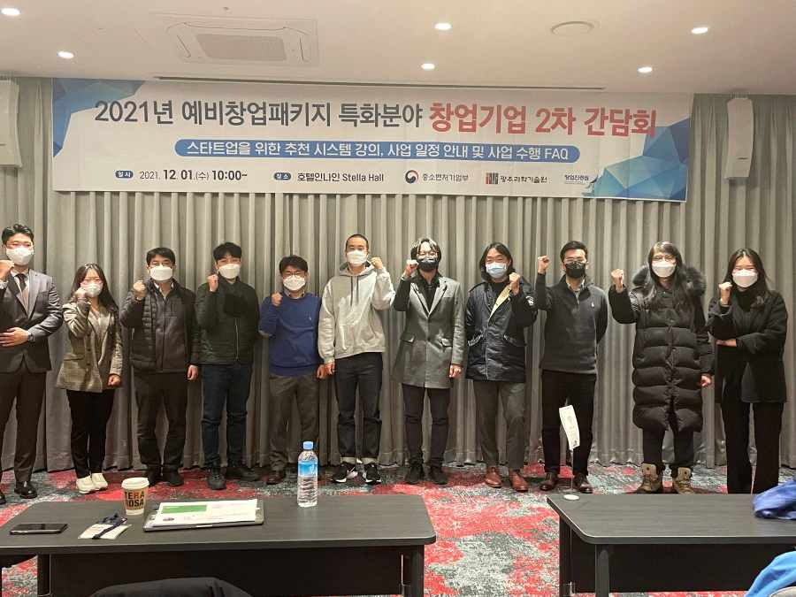
▲ 2021 Meeting of Start-up Companies in Specialized Fields of Preliminary Start-up Packages

GIST (Gwangju Institute of Science and Technology, President Kiseon Kim) successfully held the '2021 Meeting of Start-up Companies in Specialized Fields of Preliminary Start-up Packages' at Hotel Inna in Seoul on December 1.

GIST provides material and human resources to achieve business start-up commercialization by evaluating the excellence and commercialization potential of business plans with a focus on technology using artificial intelligence.

GIST is supporting and managing the pre-startup package special field (AI field) projects in 2021. On July 8, the first meeting was held online (non-face-to-face) targeting a total of 37 prospective entrepreneurs.

The first meeting mainly shared basic and important contents necessary for the project, such as the project implementation system, precautions for each item of commercialization support expenses, and the system user manual.

With the transition to 'living with COVID,' this meeting was held as a face-to-face event involving a total of 10 prospective entrepreneurs and included ▲ recommendation system lecture for startups ▲ description of the final inspection after the end of the contract period for start-ups on January 31, 2022 ▲ information on future business schedules and FAQs on business execution ▲ places for communication between start-ups.

GIST Business Incubator Director Byeong-kwan Cho said, "In the era of 'living with COVID,' we will thoroughly manage quarantine and provide networking opportunities to facilitate business promotion, such as strengthening exchanges between founders and resolving difficulties in business execution."

GIST is scheduled to hold the last meeting of this year at the Gwangju Holiday Inn Hotel for prospective founders in Gwangju and Jeollanam-do on December 8 (Wednesday).



