GIST conducts online overseas social contribution
activities at Koryo Hangul School in Kazakhstan

- Science education and Korean culture education programs held on November 20 and 27

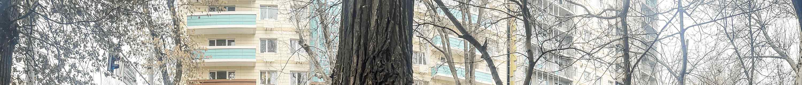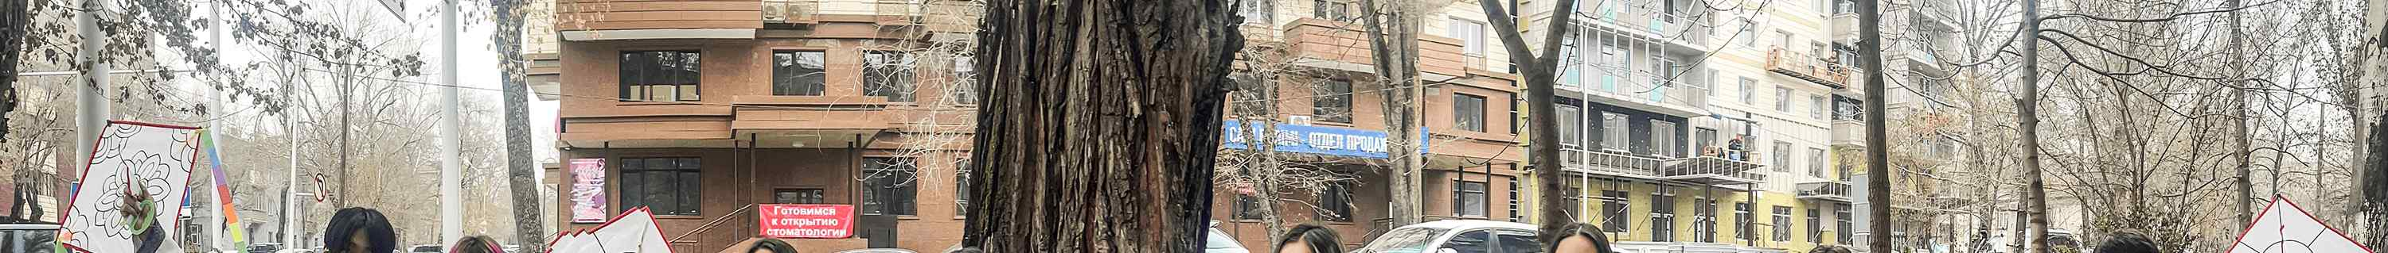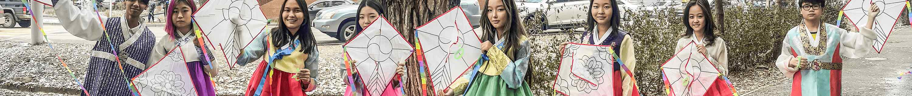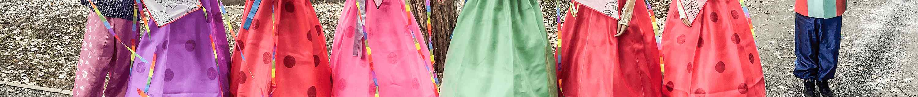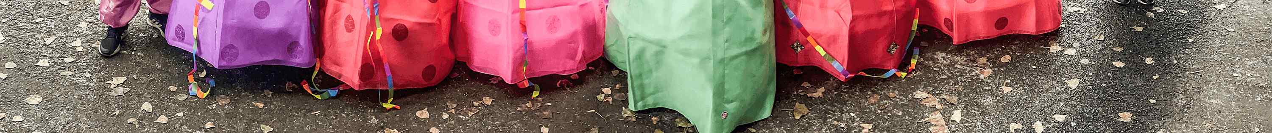
▲ Students of Koryo Hangul School in Almaty, Kazakhstan, who
participated in the GIST Overseas Social Contribution Program

GIST (Gwangju Institute of Science and Technology, President Kiseon Kim) was held online overseas social contribution activities on November 20 (Sat) and 27 (Sat) for the students of 'Kazakhstan Almaty Koryo Korean Language School (Saturday School)'.

Kazakhstan's Almaty Koryo Hangeul School aims to 'create creating a school that restores the spirit of ancestors' love for the country, Korean language, writing, and culture, and further fosters world-class students,' and the purpose is to 'establish the lessons of Hongik human beings, establish the identity of the Korean people, embrace cultural diversity, and foster people around the world with creative thinking.' Established on April 6, 2012, the goal was to hold Korean, Korean culture, taekwondo, and experience events for about 120 Goryeo students aged 9 to 15 every Saturday for four hours.

The 'GIST 2021 Overseas Social Contribution' operated a science education program on the 20th (Saturday) and a Korean culture education program on the 27th (Saturday) to contribute to fostering students through scientific and cultural activities and local education environment improvement projects for Korean compatriots living in underdeveloped countries.

The GIST Section of International Affairs delivered science kits, traditional toys, hanboks, Korean sweets, and cup noodles to local schools for all students, including class participants, to facilitate the program.

The science education program was conducted online in real time using Zoom. Undergraduate students So-eun Koh (School of Materials Science and Engineering) and Chae-rim Kim Chae Rim (Department of Chemistry) participated as mentors to deliver basic knowledge about the class topics 'cells' and 'DNA' and to create related kits (animal cell & plant cell model kit, DNA double helix kit, and ultraviolet luminous DNA bracelet kit). In particular, student Zarina Altybay (School of Life Sciences) who is from Kazakhstan served as a Russian interpreter, so all of the programs went smoothly.

As a Korean cultural education program, GIST employees directly participated in learning K-pop songs and dances, wearing hanbok, and learning traditional games (jegi-chagi, yut-nori, kite-making) and produced a video, and a K-pop dance was produced by the undergraduate student club 'Macmoo' and delivered to local teachers so that Kazakh students can easily follow and learn.

The students of the Korea Hangeul School who participated in the class said that the science experiment kit activity that they had not experienced before was fresh and fun and that it was really fun to learn K-pop dance while wearing a pretty hanbok and experiencing traditional games.

Local teachers also expressed their gratitude to GIST, saying that they were able to spend a rich and valuable time by actively supporting Korean snacks, ramen, school supplies, traditional games and science experiment items, and hanboks.

Meanwhile, GIST's overseas social contribution program has been conducted once a year under the name of Global Science Camp since 2018 in order to bridge the educational gap in underdeveloped countries and to spread science culture.

In 2018 and 2019, GIST researchers and student club members of JIU and Hanbithoe visited Laos National University to conduct scientific experiments and practice. Last year, it was temporarily suspended due to the spread of COVID-19, but this year it was held online. From next year, in line with the COVID-19 era, GIST plans to expand online and offline to find more efficient operation plans.



