GIST Academy held a breakfast forum in November
about 'How to come up with excellent ideas'

- Sungkyunkwan University Professor Young-taek Park
presents creative ideas and introduces examples

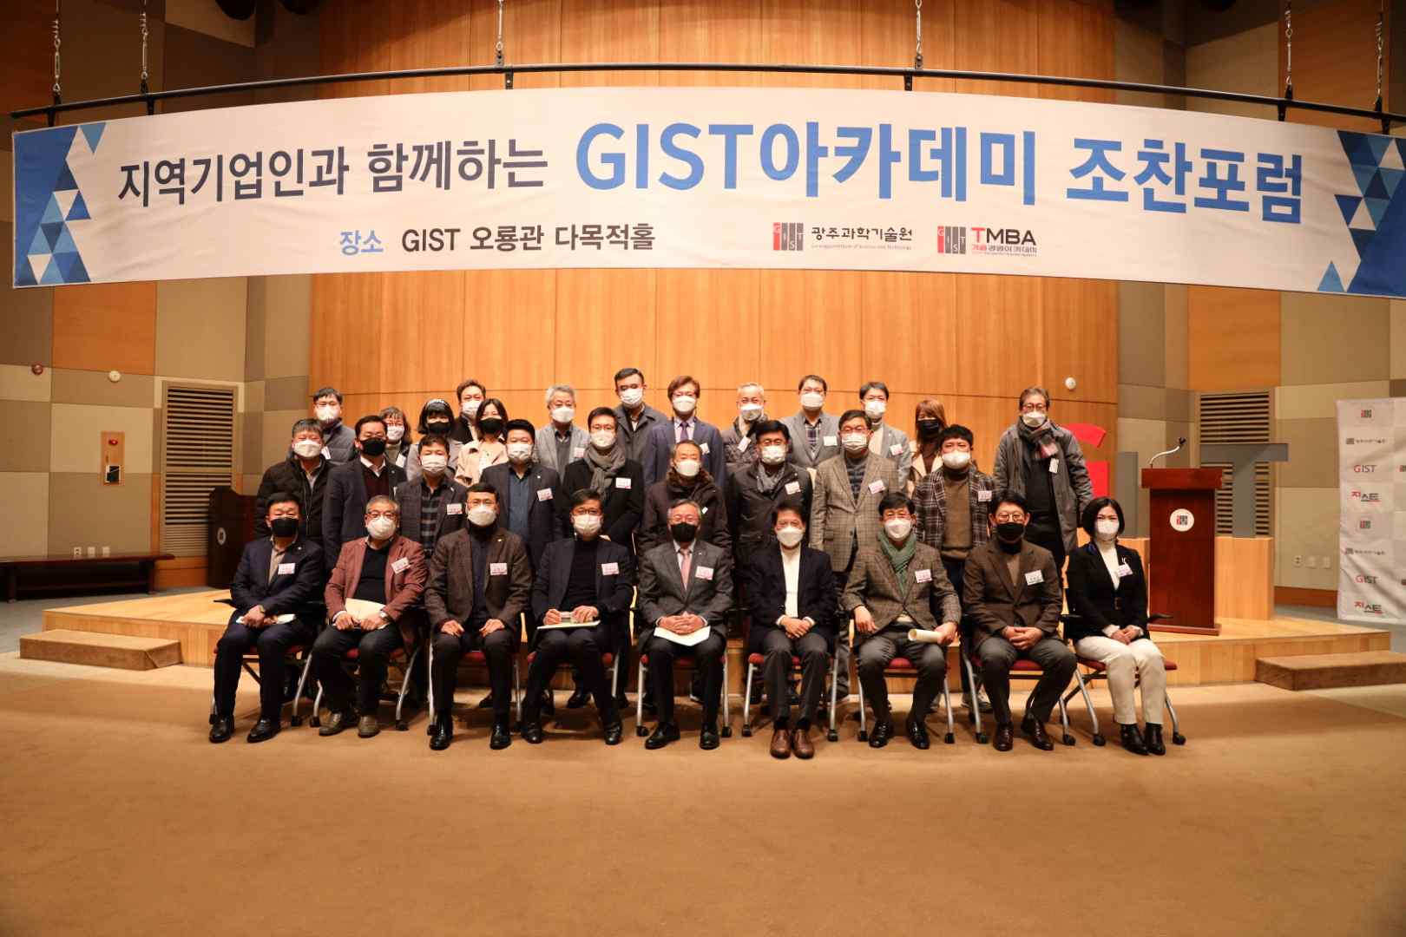
▲ GIST Academy November Breakfast Forum

GIST (Gwangju Institute of Science and Technology, President Kiseon Kim) Academy held a November breakfast forum under the theme of 'how great ideas come out' at Oryong Hall on November 29 (Mon) with about 40 company representatives from Gwangju and Jeollanam-do in attendance.

At the forum, Sungkyunkwan University Department of Systems Management Engineering Professor Young-Taek Park focused on introducing 'common patterns of creative thinking' and drew a lot of attention.

Professor Young-Taek Park explained the concept of "Smart Connection" and introduced six creative ways of thinking. Subtract, Multification, Attribute Change, Reversal, Task Unification, and Connection were presented, stressing that ideas were discovered by showing some examples of them.

Professor Park said, "We have moved from the 20th century, which maximizes productivity through manufacturing competitiveness, to the 21st century, where creativity is important. We need a way of thinking that can be put into practice rather than just talking about creative thinking."

On the last Monday of every month, the GIST Academy Breakfast Forum provides opportunities for awareness innovation, technology transfer, and industry-university cooperation through lectures by experts from various fields for alumni and local business executives.

GIST Academy operates two courses: GIST Technology Management Academy (opened in 2010) and GIST Climate Change Academy (opened in 2016). It is contributing to the vitalization of the local economy and industry-university cooperation by cultivating such skills and forming a wide human network.



