Signboard ceremony held for 'Department of Biomedical Science and Engineering, Jong Hyun Lee Studio'

- Professor Jong Hyun Lee's donation for development...
Creating a studio to revitalize online lectures and events

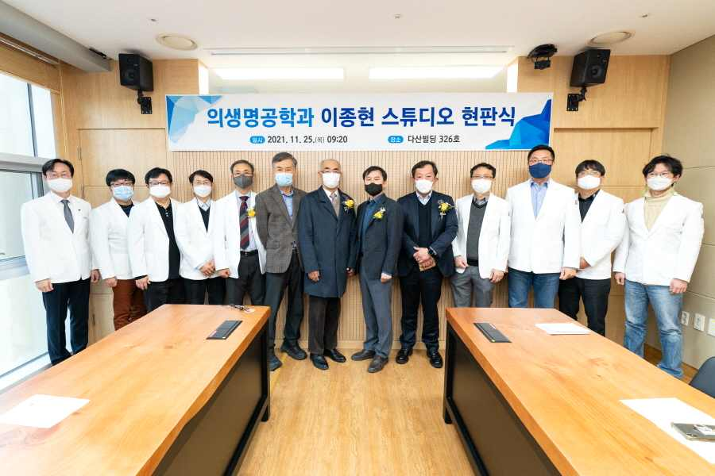
▲ Group photo: Signboard ceremony for 'Department of Biomedical Science and Engineering,
Jong Hyun Lee Studio' on the 25th (Thursday) at GIST's Dasan Building

GIST (Gwangju Institute of Science and Technology, President Kiseon Kim) built the 'Department of Biomedical Science and Engineering, Jong Hyun Lee Studio' using the development fund donated by School of Mechanical Engineering Professor Jong Hyun Lee, and a signboard ceremony was held on Thursday, November 25th.

The signboard ceremony was held at Dasan Building in the presence of key officials, including President Kiseon Kim, School of Mechanical Engineering Professor Professor Jong Hyun Lee, and Department of Biomedical Science and Engineering professors.

The Department of Biomedical Science and Engineering has recently established an international-level online studio as classes and events have been activated online due to the COVID-19 pandemic and named it 「'Department of Biomedical Science and Engineering, Jong Hyun Lee Studio' to honor the donor and spread the donation culture.

Professor Jong Hyun Lee said, "It is hoped that the online studio will be used well for the Department of Biomedical Science and Engineering to cultivate convergence leaders with global competitiveness through high-quality education and research."

President Kiseon Kim said, "I would like to thank Professor Jong Hyun Lee for his warm heart in nurturing juniors. GIST will make further efforts for the advancement of science and technology by nurturing future-leading R&D and convergence science specialists."



