GIST welcomes the French Ambassador to Korea to
strengthen cooperation for internationalization

- Expectations for high-tech research exchange and cooperation in education,
such as a visit to the IBS Center for Relativistic Laser Science

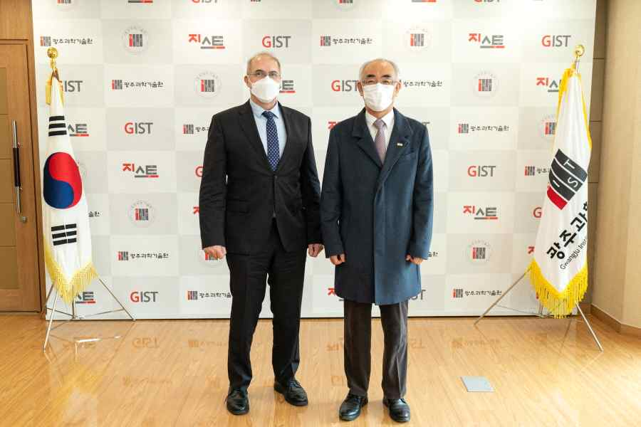
▲ From left: French Ambassador to Korea Philippe Lefort and GIST President Kiseon Kim

French Ambassador to Korea Philippe Lefort and other visitors from the French Embassy in Korea visited GIST (Gwangju Institute of Science and Technology, President Kim Kiseon) on the 24th (Wednesday) to hold cordial discussions on research and academic cooperation and exchanges between GIST and French universities.

The meeting was held in the president's office with President Kiseon, IBS Center for Relativistic Laser Science Director Chang Hee Nam (Department of Physics and Photon Science, professor), and International Environmental Research Institute Director Kyoung-Woong Kim (School of Earth Science and Environmental Engineering, professor).

After the conversation, the visiting group from the French Embassy in Korea visited the IBS CoReLS, a GIST campus research center for the Institute for Basic Science, and visited the ultra-short ultra-powerful laser facility with the world's highest output 4 petawatt (PW) laser, which is 1,000 times the world's power generation capacity.

Ambassador Philippe Lefort said, "I was very impressed with GIST's excellent research achievements. In particular, the research results of the world's highest-intensity ultra-powerful laser are very surprising. We look forward to cooperation between Korea and France in various ways such as digital fields, semiconductors, and eco-friendly energy sources."

President Kiseon Kim said, "GIST is strengthening its scientific capabilities and steadily growing through international research and academic exchanges in many academic fields, including super-powerful lasers. I hope to achieve practical cooperation with France in more diverse fields in the future, including human exchanges with France's National Institutes of Science and Technology (INSA)."

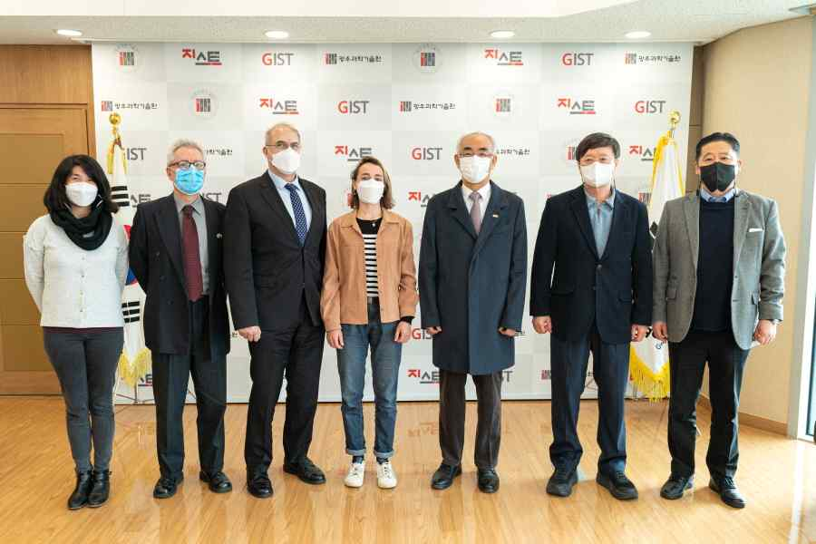
▲ From left: French Embassy in Korea Economic Counselor Adline-Lin Cobb, Science/University Officer Denis Purmo, Ambassador Philippe Lefort, INSA Lyon/GIST exchange student Morshe Louise, GIST President Kiseon Kim, IBS Center for Relativistic Laser Science Director/GIST Professor Chang Hee Nam, International Environmental Research Institute Director/GIST Professor Kyoung-Woong Kim

Currently, GIST has exchange programs with several universities in France, including INSA (Institut National des Science Appliquées), University of Tours, Sorbonne University, and Pôle Universitaire Léonard de Vinci. GIST has established a cooperative relationship with European universities and plans to gradually expand exchanges with European universities.

GIST has attracted 11 French exchange students this year, starting with a partnership with the French National Institute of Applied Sciences (INSA) in 2018, and more French students are expected to visit GIST in the spring semester of next year. In addition, GIST students are also scheduled to be dispatched to INSA Lyon next year, so exchanges are expected to flourish.

A French student who participated in the spring semester program said, "It was a meaningful opportunity to experience various academic and cultural experiences at GIST. In particular, all the subjects I took were conducted in English, so there was no problem taking the class."

Meanwhile, since 2015, the Department of Physics and Photon Science has been actively conducting joint research activities with the Sorbonne University in France, making mutual visits at least twice a year, mainly performing surface/interface research on catalysts and energy materials and has published seven joint papers so far.

In addition, with the Department of Physical Chemistry (Laboratoire de Chimie Physiqes Matiere et Rayonnement) of the Sorbonne, the Korea-France STAR Program* is being operated in 2020 and 2021. In the spring semester of next year, two Sorbonne college students will perform internships in Professor Bongjin Simon Mun's laboratory.

* Korea-France STAR (Science and Technology Amicable Relationship) Program: 'Korea-France Cooperation Foundation Project' hosted by the Korea Research Foundation



