GIST delivers donated goods to elementary and middle schools in Jangseong through environmental contributions

- Visiting the Jangseong Office of Education to deliverdonations of eco-friendly organic women's products - Held a walking campaign for the environment as part of social contribution activities

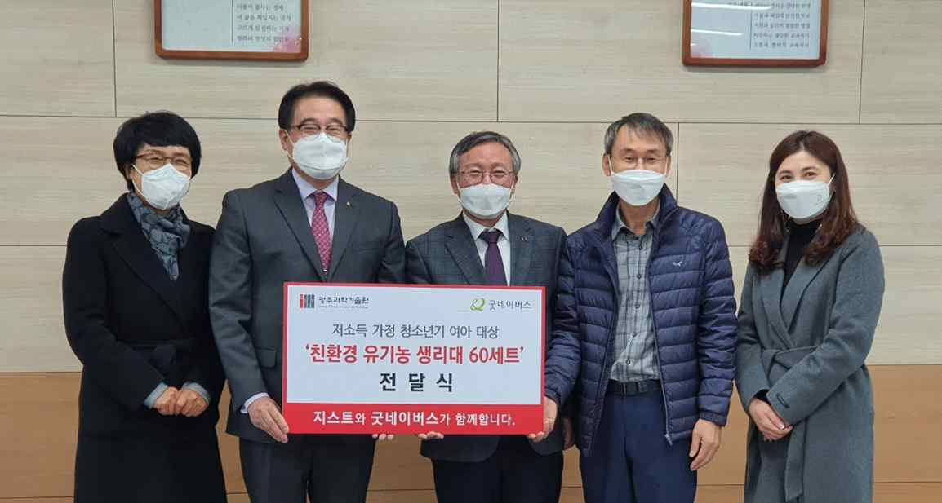
▲ GIST held a donation ceremony at the Jangseong Office of Education

GIST (Gwangju Institute of Science and Technology, President Kiseon Kim) held a walking campaign to take small actions for the environment as part of its social contribution projects. The 'Environmental Walk Challenge' was held for a month from October 12th to November 12th.

In particular, the 'Environmental Walk Challenge' was a walking campaign to save the planet and was designed as a donation program for low-income children. It is significant in that about 550 people who were interested in walking donation program, including GIST members and their families, participated.

GIST Office of International and Public Affairs (Vice President Young-jip Kim) visited the Jangseong Office of Education on November 23 (Tuesday) and delivered 60 sets of eco-friendly organic women's products to girls in elementary and middle schools in the Jangseong area and delivered daily necessities.

The items donated through this delivery ceremony were provided to elementary and middle schools located far from Jangseong, such as Jangseongbuki Elementary School (Principal Kyung-ran Heo), Jangseong Halryong Middle School (Principal Jong-seo Kim), and Jangseong Samseo Middle School (Principal Hwa-sil Park), that were recommended by the Jangseong Office of Education.

Vice President Young-jip Kim said, "We hope that valuable donations will be used meaningfully as GIST that promotes sharing with local residents. In addition to donations for win-win growth, we will continue to engage in activities to create a donation culture to nurture future students who will lead the era of the 4th industry."



