GIST demonstrates V2X-based
platform development technology

- Expected to strengthen future mobility capabilities through DNA (Data-Networking-AI) research for automobile artificial intelligence and accident prevention technology in bad weather

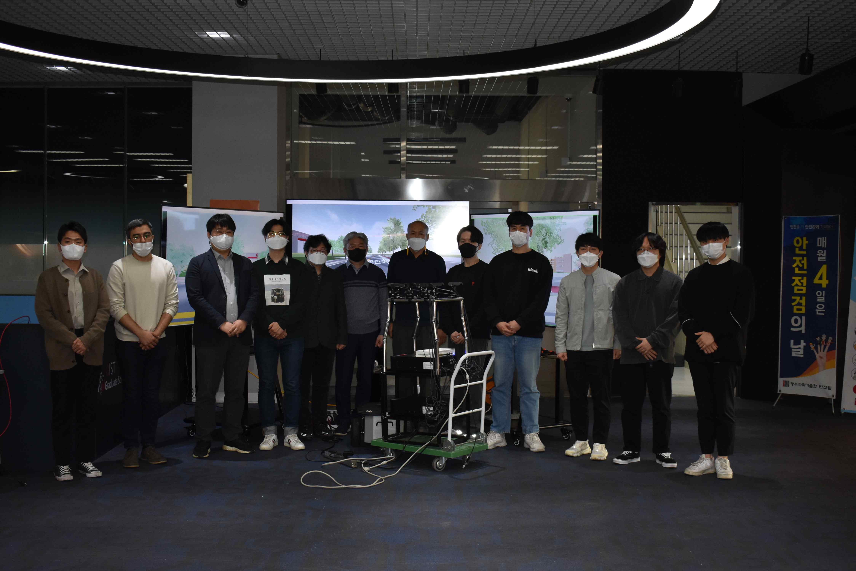
▲ Demonstration site of V2X-based connected platform technology

GIST (Gwangju Institute of Science and Technology, President Kiseon Kim) AI Graduate School (Dean JongWon Kim) with Etipos (CEO Yong-Jae Lim), Kookmin University (Professor Gu-min Jung), and Tenergy Soft (CEO Chun-seok Jeon) publicly demonstrated vehicle-to-machine (V2X)*-based platform technology, which is a next-generation item and a key element of autonomous vehicle infrastructure.

* vehicle to everything communication (V2X): It is a technology that connects cars and everything, and it is considered as a core technology for autonomous vehicles and next-generation intelligent transportation systems because it enables communication between various elements in the car and road environment. It is mainly used to notify the front traffic condition or vehicle approach, communicate with traffic infrastructure such as traffic lights or speed limit sections, or support information about pedestrians in the vicinity.

This technology aims to research and develop V2X-based connected platform technology that can respond to external environments such as bad weather and was held in November under the name of '2021 Hybrid V2X Demo Day.' At the demonstration site, officials from four research teams, including GIST, Kookmin University, Etipos, and Tenergy Soft, participated in a technology demonstration and with meetings on related topics.

GIST research team 1 conducted a demonstration for the integrated control of distributed AI-DCU (AI response data concentrator). SmartX MultiSec was developed to support the visibility of complexly transmitted data traffic within the distributed AI-DCU and V2X Car Edge cloud.

In this demonstration, collecting, analyzing, and visualizing data traffic information from distributed DCUs using SmartX MultiSec was conducted.

A research team at Kookmin University conducted a demonstration of a SW prototype of a V2X-based positioning function. The vehicle-to-machine communication-based positioning SW prototype developed jointly with Etipos can estimate the location based on communication when the autonomous driving sensor does not work in weather conditions such as snow or rain or when the GPS performance in the city center is poor.

The Etipos research team conducted a demonstration of Dual Mode V2X equipment that can operate both the WAVE method, the current Korean C-ITS V2X communication standard, and the C-V2X method, which is the latest technology in V2X.

Tenergy Soft research team and GIST research team 2 jointly conducted a demonstration of a construction environment that can collect and verify HiLS (Hardware-in-the-loop) data for AI-DCU. GIST research team 2 conducted a demonstration of recognizing objects by collecting objects displayed on the Tenergy Soft research team's virtual test driving road with 8 cameras using a mobile station equipped with two AI-DCUs.

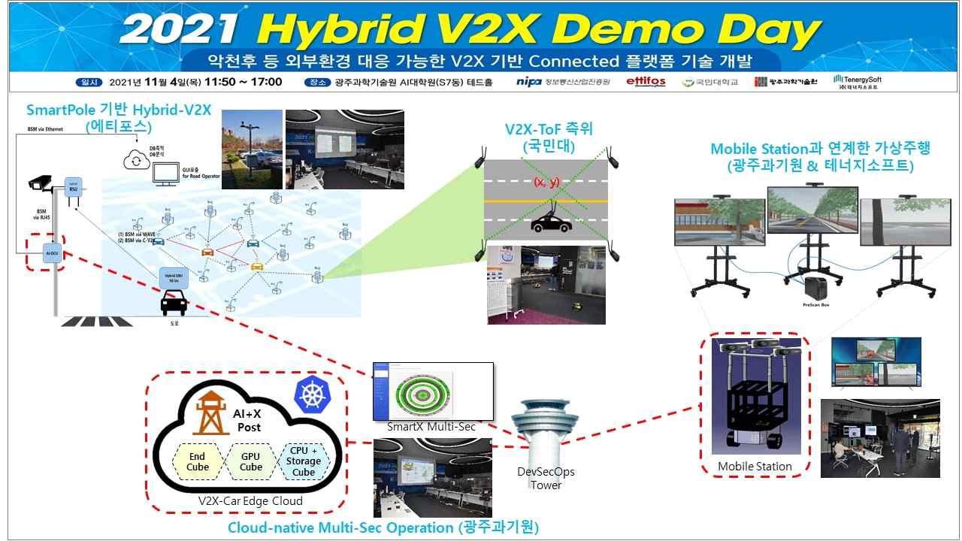
▲ 2021 Hybrid-V2X Demo Day integrated scenario

The research team plans to conduct public demonstrations periodically during the research period as well as a second public demonstration this year. In the future, the demonstration will be carried out in connection with the demonstration complex and data center to be built in the Gwangju artificial intelligence-centered industrial convergence complex.

The automobile AI convergence project is a research and development project for the artificial intelligence-centered industrial convergence center project supervised by the Ministry of Science and ICT and the Information and Communication Industry Promotion Agency. It plans to conduct research and development on Hybrid-V2X communication platform, high-precision positioning technology, distributed XAI-DCU prototype, and driving simulator hardware-in-the-loop (HILS) interworking technology.



