GIST exhibits 2021 Craft Trend Fair,
an AI-based craft creation support system

- Providing opportunities to experience smart craft
technology that converges 4th industrial technology

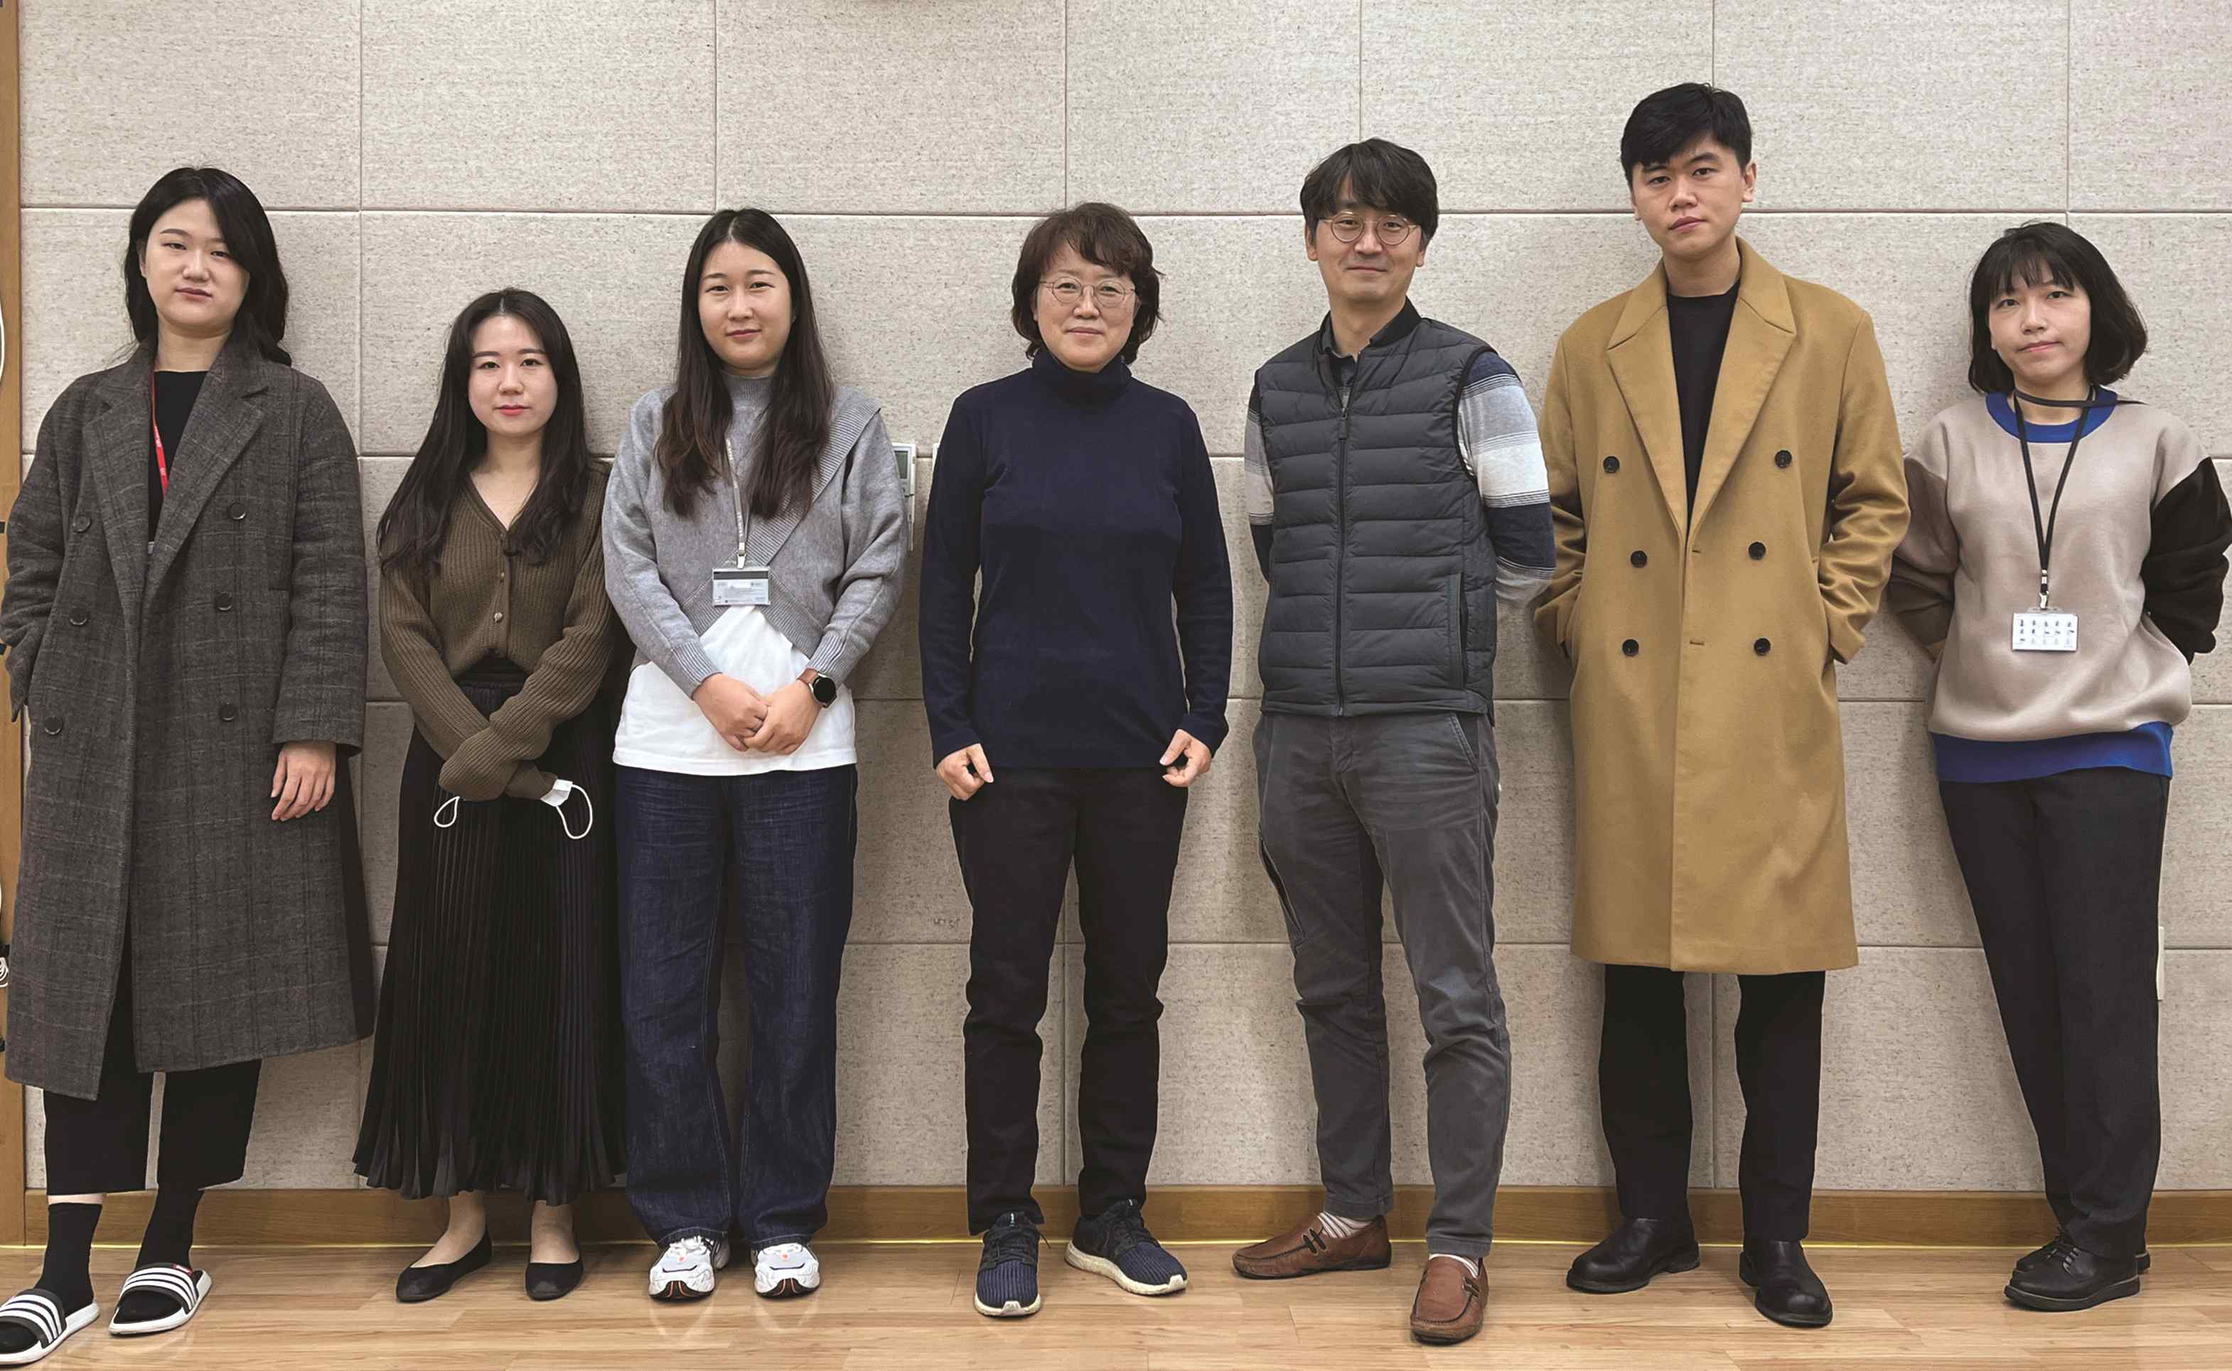
▲ Research team of Professor Ji Hyun Yi (fourth from left)
and Professor Jin Hyuk Hong (fifth from left)

GIST (Gwangju Institute of Science and Technology, President Kiseon Kim) researchers of Professor Ji Hyun Yi and Professor Jin Hyuk Hong of the Cultural Technology Program of the Interdisciplinary Faculty of Convergence Technology are building craft big data. Based on this, an artificial intelligence (AI) smart craft creation support system and a craft original authentication distribution system that combines block chain technology will be introduced at the '2021 Craft Trend Fair.'

The achievements introduced in this exhibition are organized by the Ministry of Culture, Sports and Tourism (Minister Hee Hwang) and the Korea Creative Content Agency (Director Hyeon-Rae Cho) and is the result of the second year of 'Cultural Technology R&D Designated Project for 2020, technology development for creative support based on original certification and distribution of crafts (project period: 2020-2022, R&D cost: KRW 2,200,000).'

In addition to the research teams of Professor Ji Hyun Yi and Professor Jin Hyuk Hong of GIST, who are experts in cultural technology and artificial intelligence, a joint research team of Professor Hyun-Soo Lee’s team at the Department of Ceramics at Hanyang Women’s University, Eun-Jong Lee’s team at the Department of Content Convergence Design at Handong Global University, Yun-Ju Jeong's researchers at the Gwangju Institute of Design Promotion, Team Leader, Blockchain-based Various researchers in the fields of art and design culture, AI and block chain technology, such as M2Cloud, which developed the vaccine management system, are organically participating in the development.

Based on the craft data built by applying the metadata system to the collected data, the researchers automatically analyze the formative elements of crafts using data search using images, keywords, and relational analysis, data visualization technology and AI technology and are developing a smart craft creation support system to create new crafts by synthesizing various crafts, and some of them will be revealed through this exhibition.

At the 2021 Craft Trend Fair, visitors can interactively search for craft production processes and production methods in all fields or experience data visualization tools that show the relationship between crafts in the form of webs based on craft metadata systematically labeled creative processes such as colors, materials, uses, production methods, and decorative techniques.

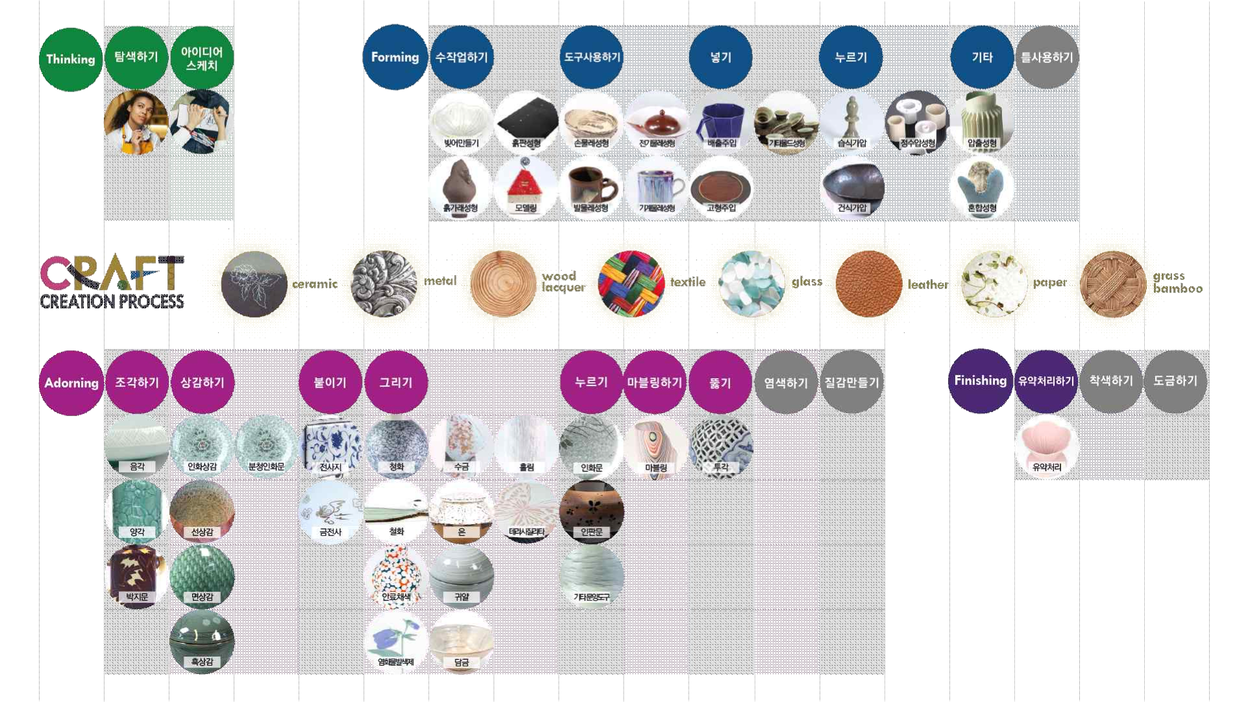
▲ Interactive craft information explorer

In addition, a sketch tool that uses AI technology to sketch and search for a craft image and similar crafts appear, and a tool that selects and synthesizes two crafts to create a new craft. The smart culture Lens is a tool to analyze the formative elements of ceramics.

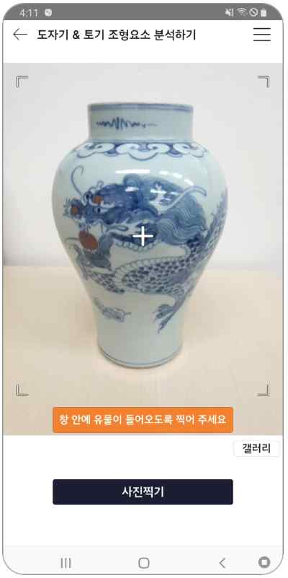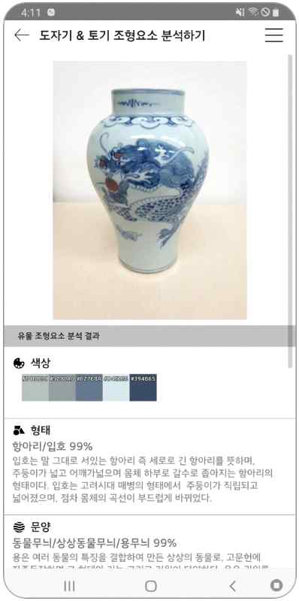
▲ Smart culture lens is a tool to analyze the formative elements of ceramics

Professor Ji Hyun Yi, the research director, said, "The research results introduced in this exhibition will show good examples of convergence of art, culture, and technology in the 4th industrial era. In particular, it is expected that the digital fingerprint technology of crafts, which will be a solution to the problem of copying domestic crafts, and the blockchain-based distribution system will provide new experiences to visitors."

The '2021 Craft Trend Fair,' the largest craft festival in Korea, is celebrating its 16th anniversary this year and will be held from November 19 (Fri) to 21 (Sun) at COEX Hall C under the theme of various colors.



