GIST held a ceremony to celebrate its 28th anniversary

- Since its opening, responding quickly to the diverse needs of regions
and countries... Playing a key role in AI research and education

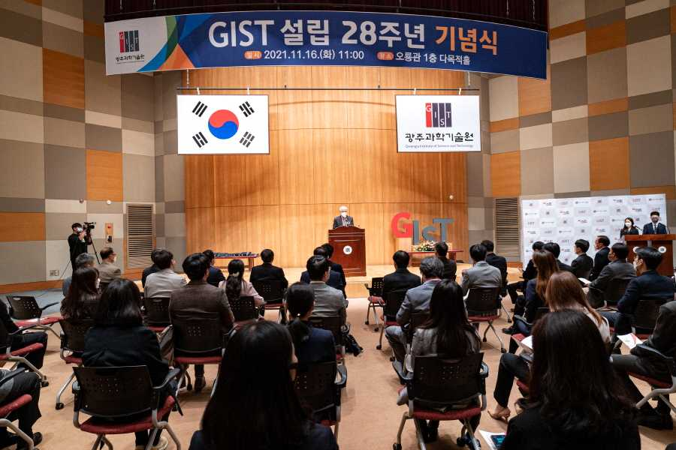

GIST (Gwangju Institute of Science and Technology, President Kiseon Kim) held a ceremony at Oryong Hall on the 16th (Tuesday) to commemorate the 28th anniversary of its establishment on November 17th, and it was attended by about 80 people including major officials, faculty, and students.

This year's event, like last year, was held on a small scale with an online live broadcast and major winners to prevent the spread of COVID-19 and was for encouragement and appreciation of GIST members who devoted themselves in various fields to share GIST's future vision and develop the organization.

President Kiseon Kim delivered a commemorative speech, saying: "Since its opening, GIST has been quick to respond to the diverse needs of regions and countries. The AI Graduate School, Energy Convergence Graduate School, and AI Research Center play a key role in AI research and human resource training. We are doing our best to revitalize the local economy and create a successful model for Gwangju AI clustering. In the future, GIST will make more efforts to foster convergence science specialists, innovate the economy through start-ups, and create jobs. A trusted GIST will always communicate and make an effort to become the pride of the region as a public institution that shares with the people."

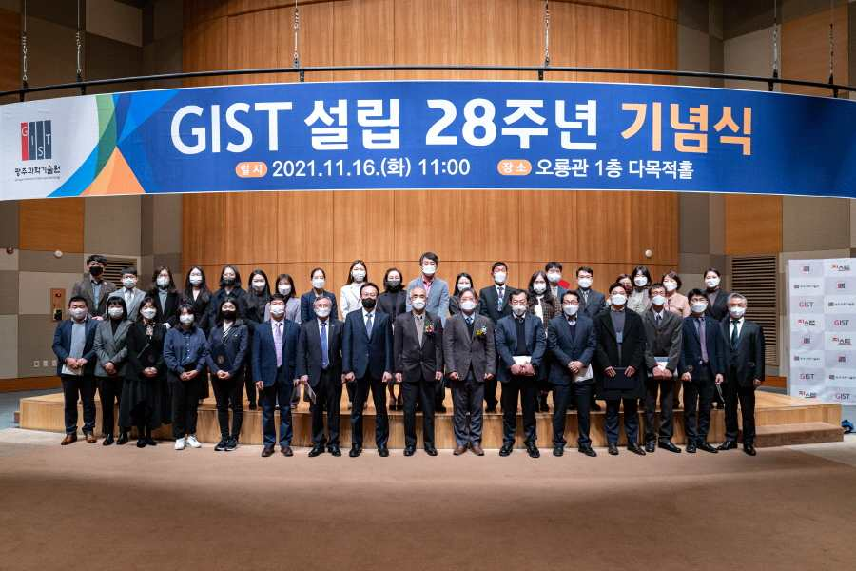

GIST was established in 1993 for the purpose of nurturing advanced scientific and technological specialists, conducting basic and applied research for national research and development, and revitalizing the Gwangju advanced science industrial base. It started as a master's and doctoral graduate program in 1995 and opened a bachelor's program in 2010, establishing itself as a successful model for innovative small-scale science and engineering education."

GIST substantially contributes to the construction of industrial convergence complex centered on artificial intelligence. Through artificial intelligence, GIST is striving for regional innovation, job creation, and nurturing advanced AI specialists.



