2021 AI Testbed Korea successfully
hosts Industrial Intelligence (AI+X) Contest

- Supports creation and commercialization of new business models by combining
Gwangju City’s strategic industries and artificial intelligence technology

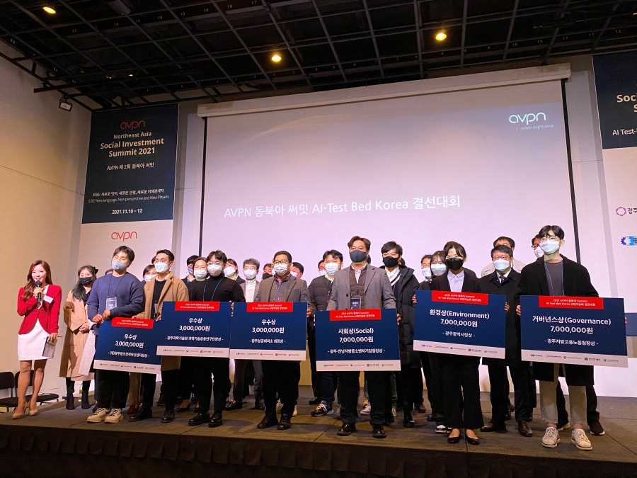
▲ Group photo of participants of the 2021 AI Testbed Korea
Industrial Intelligence (AI+X) Contest

GIST (Gwangju Institute of Science and Technology, President Kiseon Kim) successfully held the 3rd AI Testbed Korea Industrial Intelligence (AI+X) Contest on November 12 (Fri).

This competition was prepared to create a new business model and support commercialization by combining the 11 strategic industries of Gwangju Metropolitan City with artificial intelligence technology. It was co-hosted by seven organizations, including GIST, Gwangju Metropolitan City, Gwangju Regional Labor Office, Gwangju Jeonnam Small and Medium Venture Business Administration, Gwangju Creative Economy Innovation Center, Korea Artificial Intelligence Association, and the Gwangju Chamber of Commerce and Industry. The event was sponsored by the Asian Venture Philanthropy Network.

The final final stage was held in conjunction with the main event on the third day of 2021 AVPN's North East Asia Summit at Understand Avenue Art Stand Hall in Seongsu-dong, Seoul. In particular, the six winning companies plan to continue business connection, technology exchange, and cooperation in the future so that the business model discovered this time can be commercialized without ending the competition.

In addition, they will receive various follow-up support such as systematic management and investment attraction from jointly-hosted institutions and will introduce artificial intelligence (AI) to strategic industries to create a society with more economic value. Participants can discover practical business models and materialize skills and experiences through autonomous teams (matching), and opportunities to network with investors and companies are provided.

This year, E (environmental), S (social), and G (governance) awards were given by reflecting the new management trend of ESG. ▲ Environmental award was given to the 'Big Wave AI (artificial intelligence-based integrated water management monitoring system' team) ▲ Social award was given to the 'Oden (aquaculture farm step-by-step monitoring and big data-based marine data platform' team) ▲ Governance award was given to the 'Voltwin (Digital Twin & AI-based battery diagnosis and monitoring solution)' team.

In addition to the ESG awards, three excellent teams were awarded the GIST Science and Technology Application Research Center Award, the Gwangju Creative Economy Innovation Center Award, and the Gwangju Chamber of Commerce Chairman's Award, in order: ▲ 'Avirtual (space quarantine robot, alpha robot to establish a regular quarantine system)' team ▲ 'SSOG (reasonable food recommendation shopping platform based on price analysis)' team ▲ 'Neton (artificial intelligence-based real-time quality defect detection) monitoring platform)' team were honored with awards.

GIST Business Incubator Director Byeong-kwan Cho said, "GIST is a research institute that has the AI Graduate School and the GIST Institute for Artificial Intelligence. Through this competition, GIST will take the lead in creating an ecosystem for technology start-ups by continuously discovering and supporting artificial intelligence business models."

After this contest, the winning teams have prepared support for cooperative projects through business matching, and they can apply for the startup support program planned in 2022.



