GIST Korea Culture Technology Institute
hosts ACC Creative Creation Forum

- Live online broadcast November 17 to 18 from the Asia Culture Center

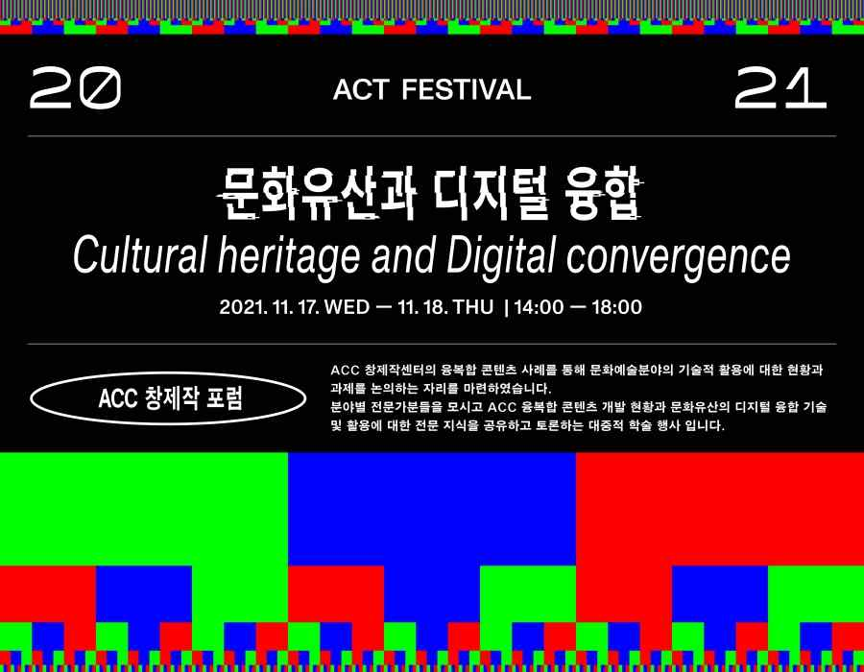

GIST (Gwangju Institute of Science and Technology, President Kiseon Kim Kisun) Korea Culture Technology Institute (Director Moongu Jeon) will hold the 'ACC Creation Forum' for two days on November 17 (Wednesday) and 18 (Thursday) at the Asian Culture Center International Conference Room.

This forum is part of the Art & Creative Technology Festival (ACT Festival) held at the Asia Culture Center and is co-hosted by the GIST Korea Culture Technology Institute and the Asia Culture Center.

The theme of the forum was 'Cultural heritage and Digital convergence' and was prepared to share examples of contents combining digitization of cultural heritage and immersive media technology and to explore the direction of future creative production projects.

The first day of the forum introduces the content development process and discusses future tasks, centering on the presentation of realistic content cases supported by the Asia Culture Center.

GIST Korea Culture Technology Institute is planning to present 3D data and digital heritage in relation to the immersive content <Asia Maritime Silk Road and Sinan Ship> that is currently being developed.

On the second day of the forum, experts in each field will present cultural technologies for cultural heritage utilization and artificial intelligence-based cultural technologies.

Konkuk University Professor Dong-hwan Yoo will present 'The paradigm shift of digital museums, exhibition contents of intuition and realism,' and speakers, including Dr. Jin-ho Park, a digital restoration expert, and Wigiwick Studio Director Ki-joo Park will present cultural heritage reproduction and future prospects using artificial intelligence technology.

Those who wish to participate in the ACC Creative Forum can apply through the Asia Culture Center website (www.acc.go.kr), and it will be broadcast live through the ACC YouTube channel.



