GIST hosts 'International Culture Night' as
a venue for multicultural exchange

- Providing a venue for understanding and harmony with cultures of various nationalities

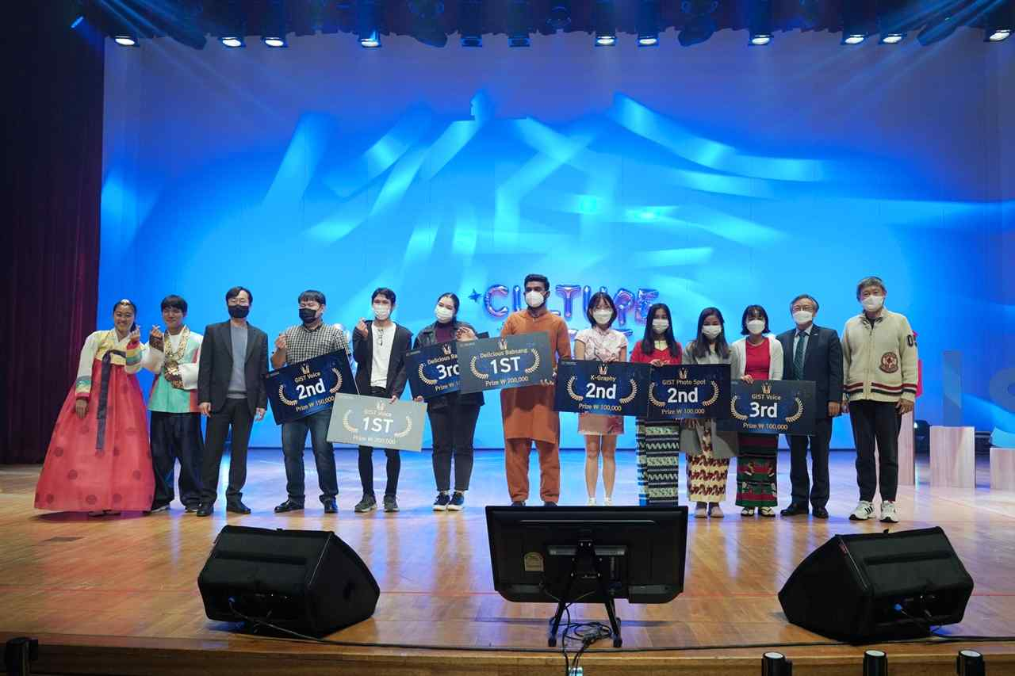
▲ Group photo of the winners of the GIST Voice Contest

This event was held online and offline this year as a venue for cultural exchange where GIST international students and their families participate every year to introduce the traditional culture of each country and to enjoy various performances not only with GIST members but also with local residents.

Offline events were held in advance: ▲ Find GIST Attractions (two people in a group wearing traditional clothes, one with a hanbok and one person with national traditional costume - take photos on camps and submit) ▲ Delicious Table (traditional food cooking tutorial video production and food submission) ▲ Show Me Your K-Graphy (Korean proverb calligraphy contest - calligraphy kit provided) ▲ Online Stamp Tour (50 Korean souvenirs on a first-come-first-served basis when 5 missions are completed).

As an online event on the 12th (Friday), ▲ GIST Voice (singing contest) was watched on-site and was broadcast on YouTube in real time so that many people could join enjoy online.

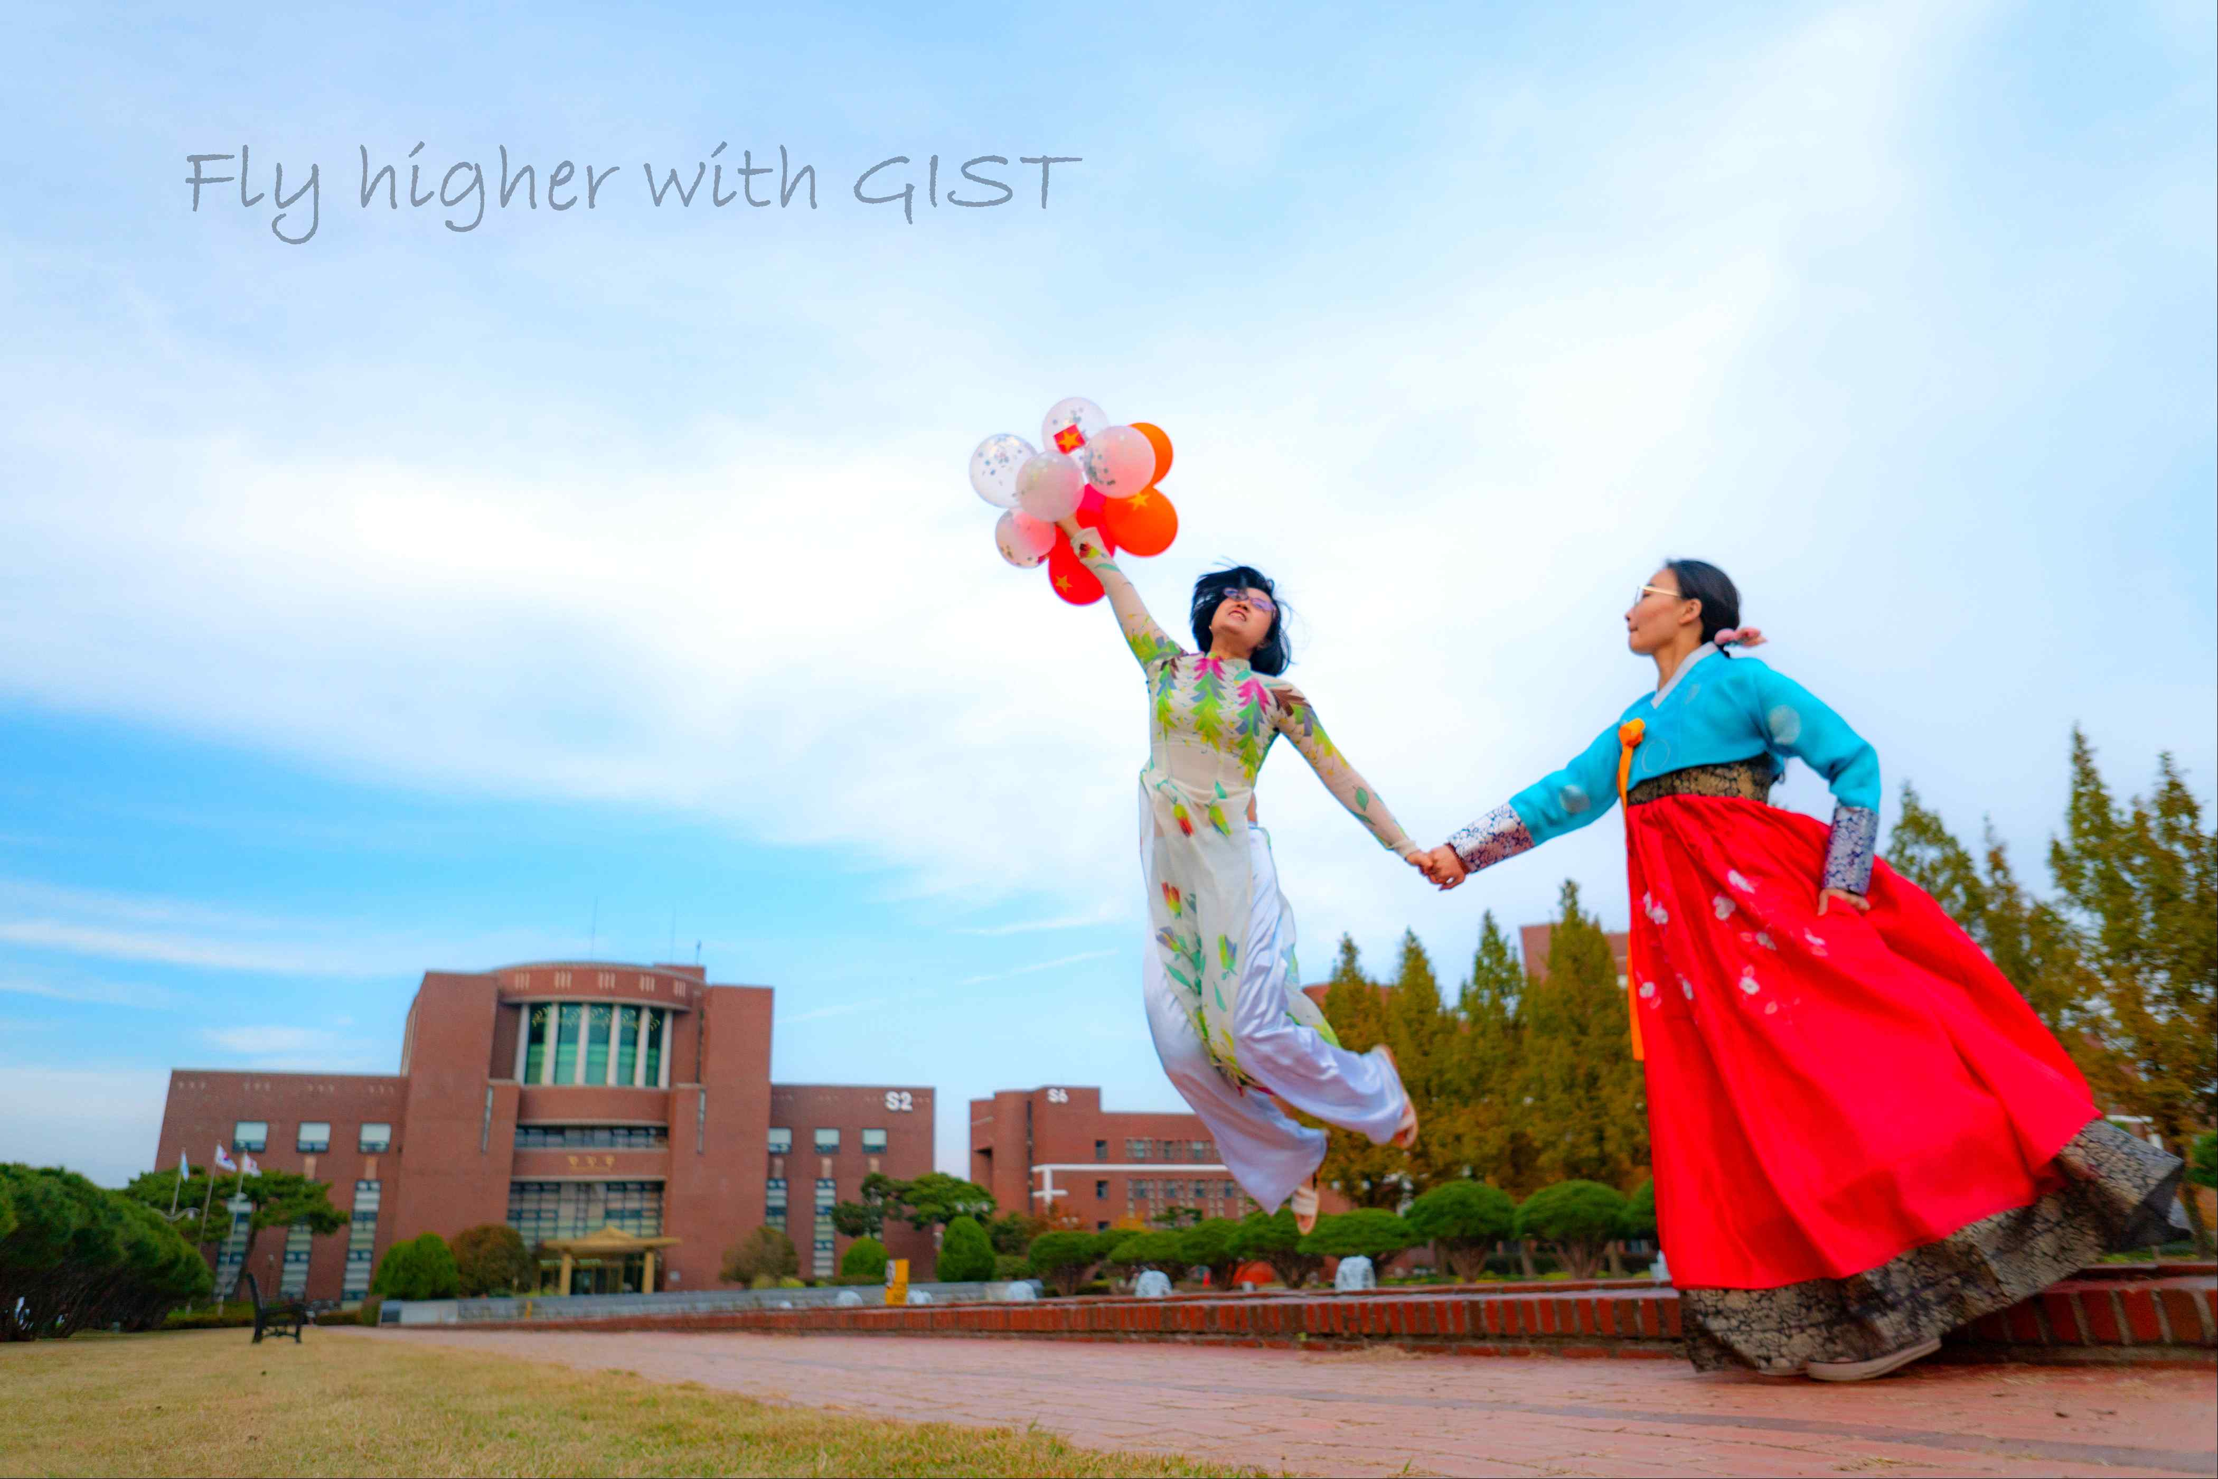
▲ Photo contest grand prize winner 'Fly Higher with GIST'

For GIST Voice, international students at GIST who wanted to participate selected a song in advance, either pop, K-pop, or world music genres, and filmed and submitted a video.

The winners in each category are as follows:
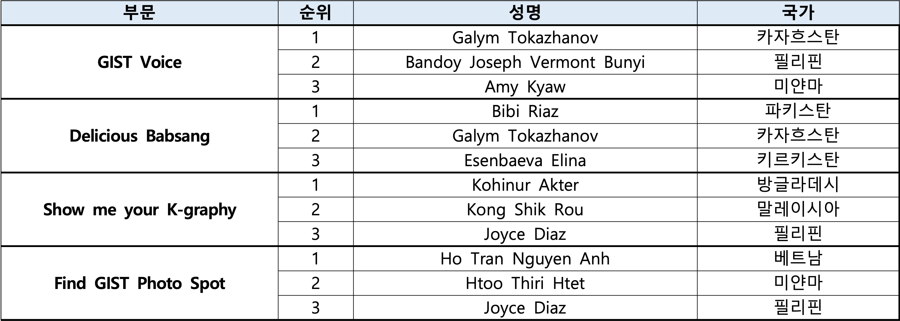

The winning works of 'Find GIST Attractions' and Show Me Your K-Graphy' will be exhibited at the library cafe exhibition room for 5 days starting on November 15 (Mon).



