GIST Development Fund receives 200 million won from Mujin Service Co., Ltd., Chairman Eun-mo Choi and held donation ceremony and signboard unveiling ceremony

- For the development of science and technology in
Korea and fostering global convergence specialists

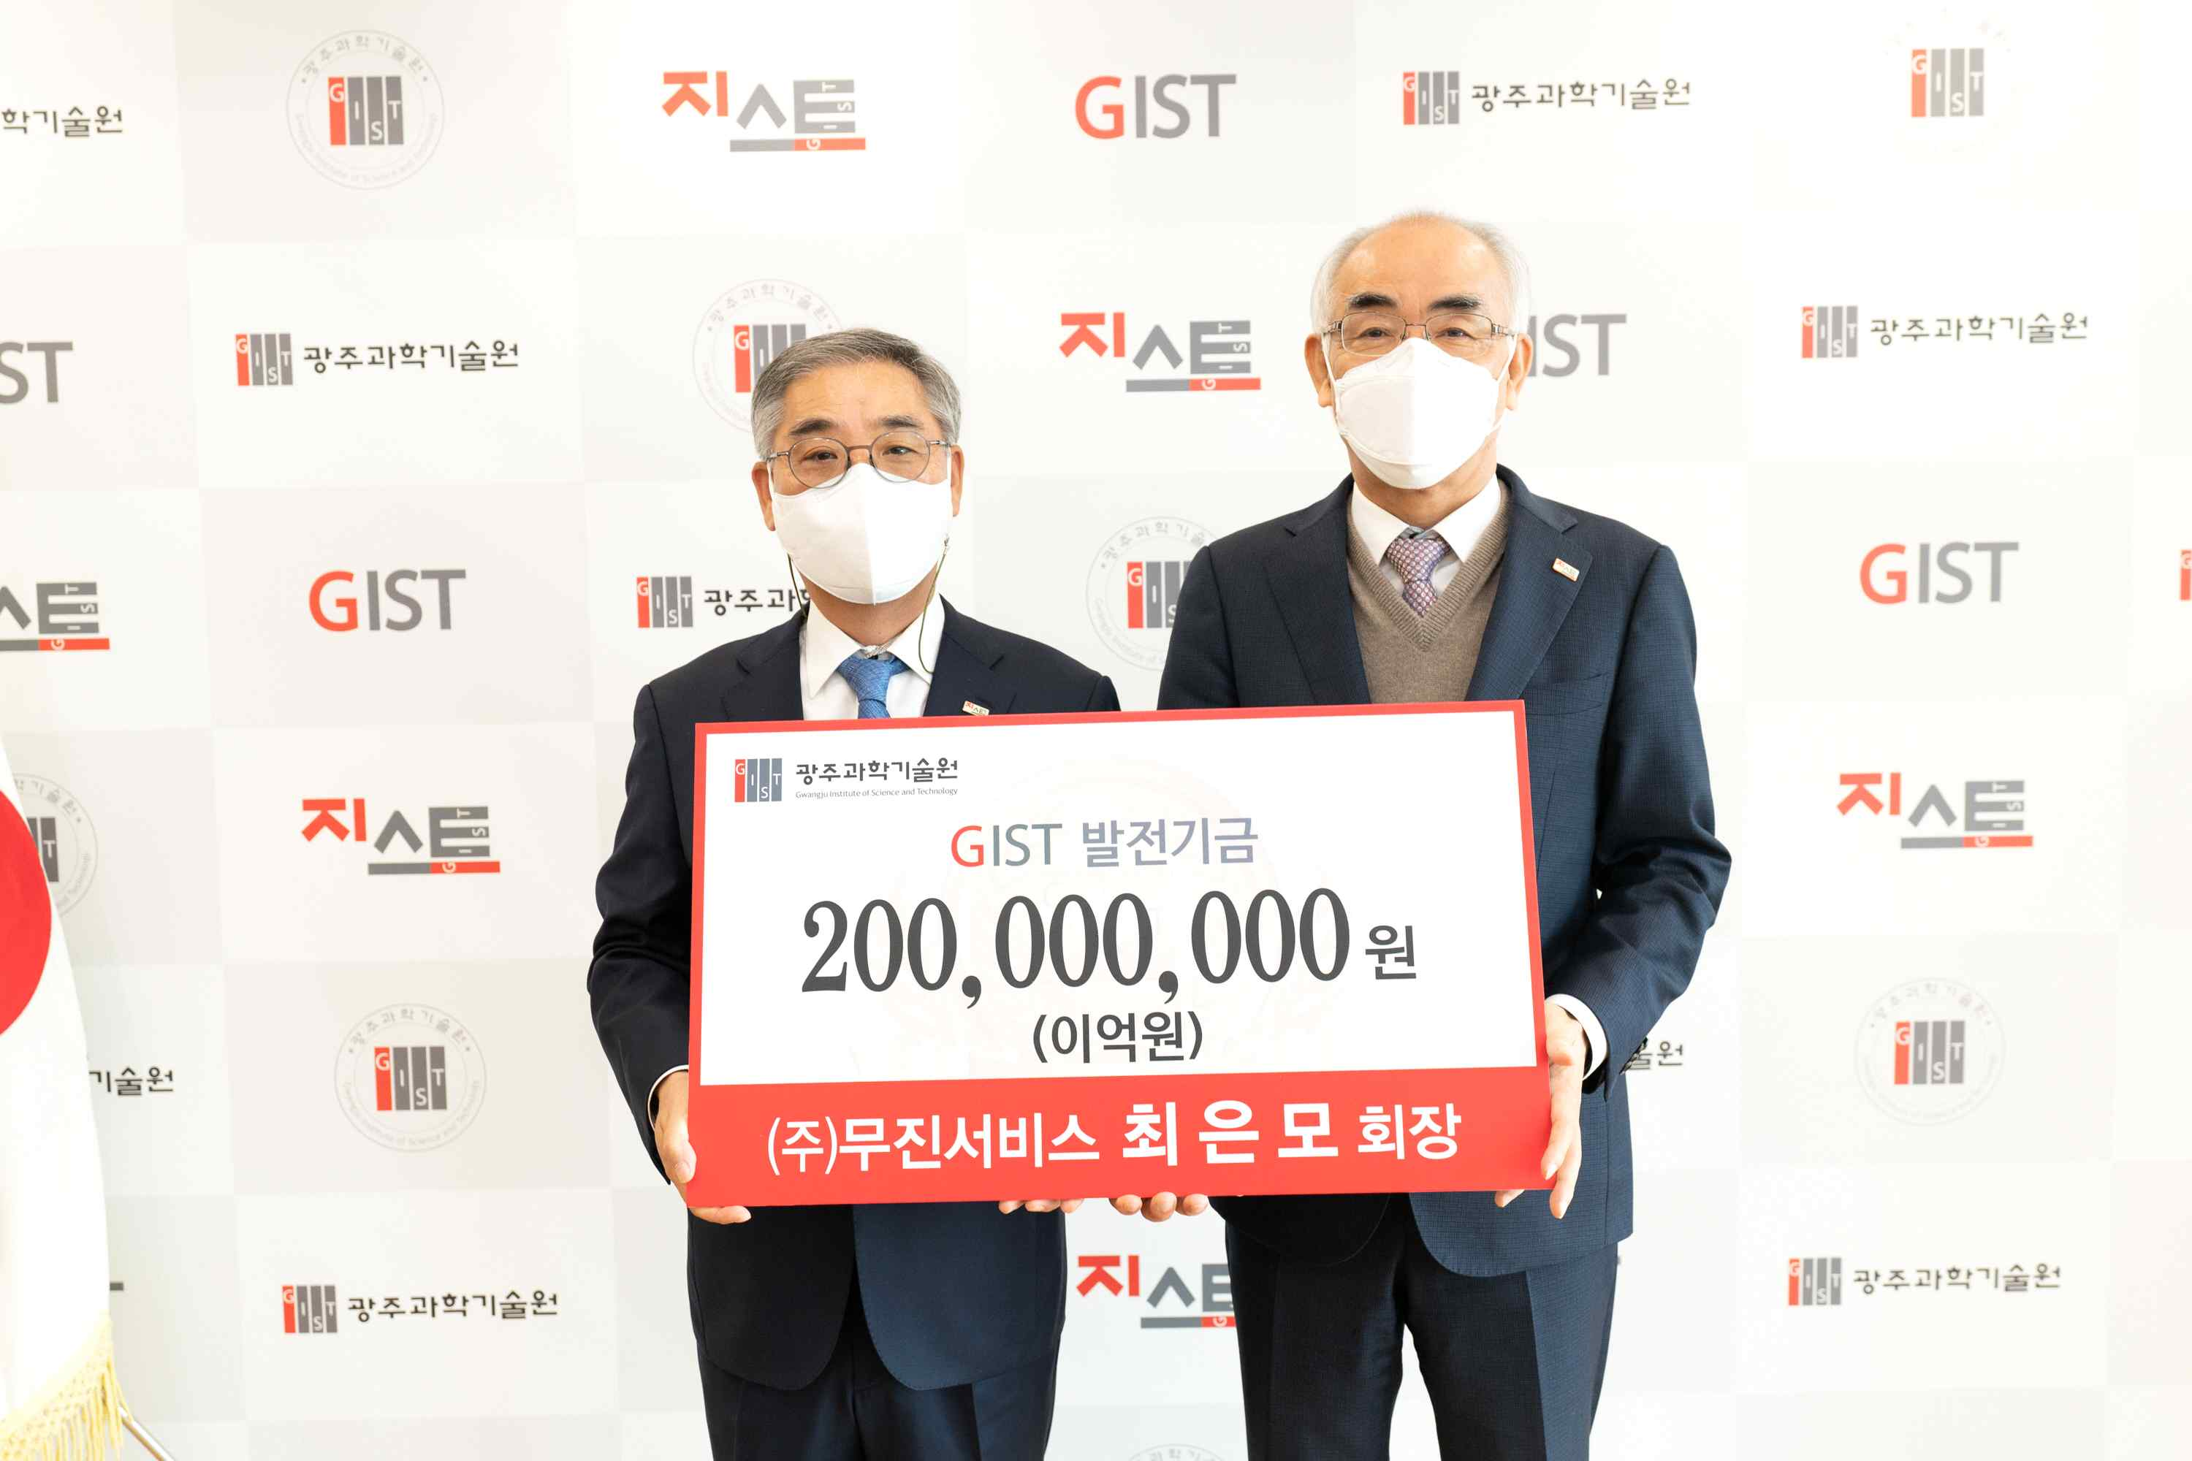
▲ Commemorative photo of Chairman Eun-mo Choi (left), next to
President Ki-seon Kim, donating to the GIST Development Fund

GIST (Gwangju Institute of Science and Technology, President Kiseon Kim) Development Fund received 200 million won from Mujin Service Co., Ltd., Chairman Eun-mo Choi for use in the development of science and technology and to foster global convergence specialis.

The donation ceremony was held on November 11 (Thursday) in the President's Office in the presence of President Kim Kiseon, Vice President for Public Affairs Young-jip Kim, and GIST Development Foundation Chairman Jung-ju Ko.

Chairman Eun-mo Choi is a director of the GIST Development Fund. Following the 100 million won previously he donated to GIST, an additional 200 million won was donated, resulting in a total donation of 300 million won.

Mujin Service Co., Ltd., is achieving steady growth in battery production and automation equipment production, and is evaluated as the best exporter in Gwangju as the proportion of exports in sales is over 80%. Chairman Eun-mo Choi is a skilled engineer and entrepreneur with 45 years of experience in the field of battery manufacturing equipment, which has brought Korea's battery manufacturing equipment technology to the top three in the world.

At the donation ceremony, Chairman Eun-mo Choi said, "I think that GIST plays a big role in the local community, and I hope that GIST will contribute to the development of science and technology in Korea by nurturing global convergence specialists. I hope all of you find happiness through this donation."

GIST President Kiseon Kim said, "I would like to express my gratitude to Chairman Eun-mo Choi, who is a member of the GIST family, for the donation. We will use the generous fund so that GIST can stand at the center of the world through scientific and technological development and human resource development that contributes to the nation."

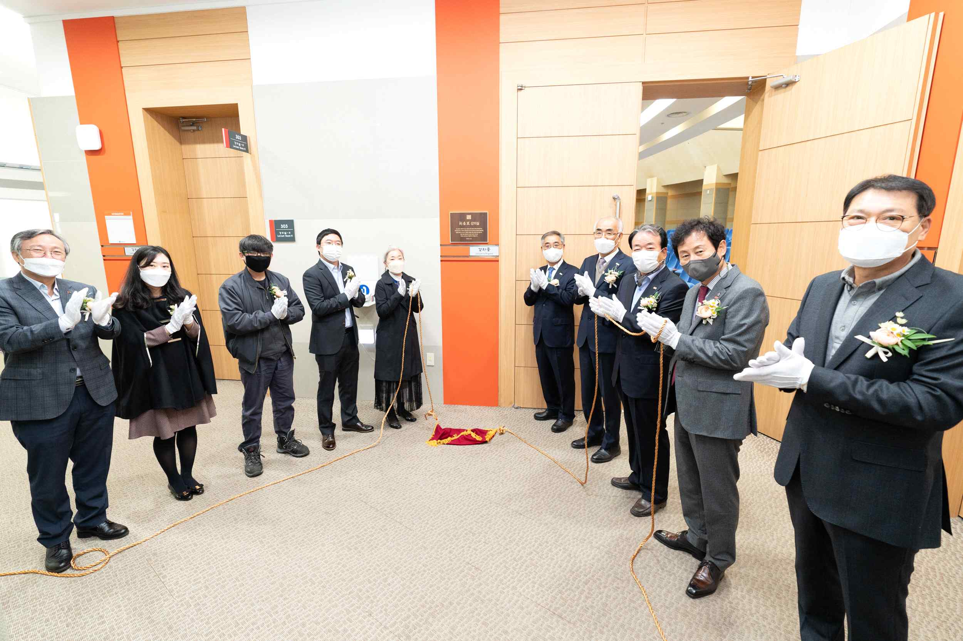
▲ Commemorative photo during the signboard unveiling
ceremony of Eun-mo Choi's classroom GIST's Oryong Hall

If someone donates more than 100 million won to the Development Fund, there is a courtesy program that allows lecture room naming as well as in-house sports facilities and libraries.



