GIST Social Contribution Group hosts Science Camp in Hampyeong for 2021

- GIST Pium Team visits Sonbul Middle School in Hampyeong and
conducts science camp with an AI coding pack sponsored by KT

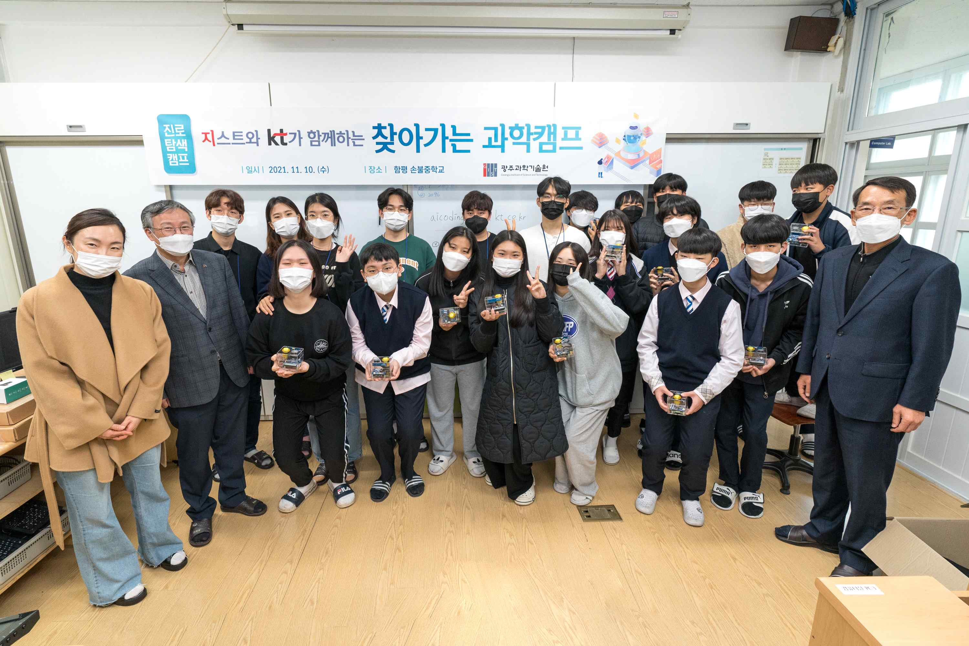
▲ Group photo: GIST Pium visiting the science camp

GIST (Gwangju Institute of Science and Technology, President Kiseon Kim) cooperated with the local community and practiced the spirit of sharing science and learning with youth in underprivileged areas. Following Bongsan Middle School in Gwangju, the third 'Visiting Science Camp' was held on November 10 (Wednesday) at Sonbul Middle School in Hampyeong.

For this 'Visiting Science Camp,' the GIST Social Contribution Team directly visited the school to provide coding education and mentoring using the AI coding pack kit (100 sets) sponsored by KT.

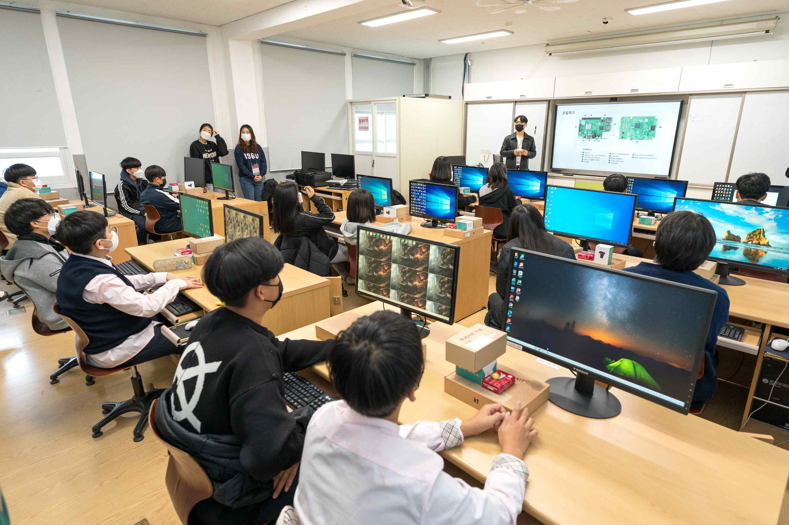
▲ GIST Pium science camp experience program

Since 2010, GIST has been conducting various science camps and learning education services for elementary, middle, and high school students. From this year, GIST's social contribution and career mentoring programs have been integrated and expanded to seek systematic and more efficient operation methods.

The GIST knowledge sharing program includes three formats ▲ LAN mentoring: online learning and career mentoring using Zoom so that students can participate anytime, anywhere ▲ Visiting camp: mentoring by visiting middle and high schools ▲ GIST Science Camp: A science camp conducted by inviting students to GIST (GIST teacher lecture program, GIST research institute and experience program).



