GIST opens 'Space Laser Research Center'

- Development of high-performance laser technology
for precision space surveillance system for the space age

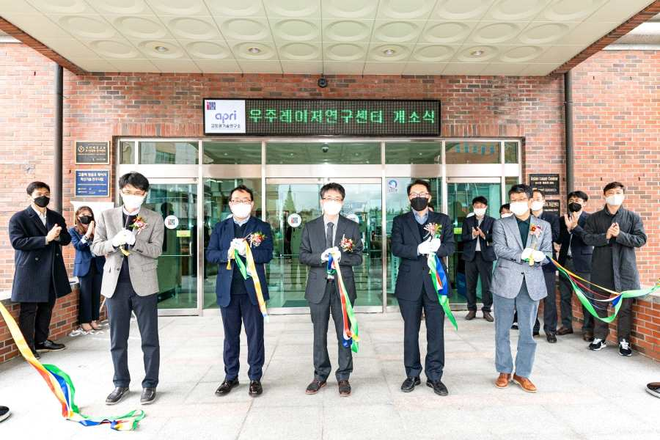
▲ From left: Defense Industry Technology Support Center Director Eui-seung Son, Hanwha Systems Chief Su-hyeong Jo, GIST Space Laser Research Center Director Seong Ku Lee, GIST Acting Research Dean Kihong Park, GIST APRI Director Yeung Lak Lee

GIST (Gwangju Institute of Science and Technology, President Kiseon Kim) held an opening ceremony for the 'Space Laser Research Center (Director Seong Ku Lee, Chief Researcher)' at the Advanced Photonics Research Institute on November 9, 2021.

The opening ceremony was attended by GIST officials including Acting Research Dean Kihong Park and Center Director Seong Ku Lee, as well as Hanwha Systems and Defense Industry Technical Support Center officials.

Recently, as human activity has expanded into space, such as the launch of the Nuri rocket in Goheung, Jeollanam-do, the number of satellites passing over the Korean peninsula has increased to about 1,000 a day, raising concerns about collisions between artificial satellites and space objects and the crash of space objects onto land.

To avoid such collisions and to minimize damage by predicting crash sites, it is necessary to secure a space monitoring system that tracks accurate orbital information of artificial satellites and space objects. For this reason, research on the development of high-performance laser technology is absolutely necessary.

The research center plans to actively utilize the ultra-short and high-power laser technology accumulated by the Advanced Photonics Research Institute with the goal of securing future advanced laser technology necessary for space development and space defense required in the future space age.

Accordingly, there will be ▲ development of nanosecond and picosecond lasers for precise distance measurement of space objects ▲ development of artificial lasers to acquire images of space objects ▲ development of high-quality, high-power lasers in the mid-infrared and visible regions ▲ development of cosmic laser core technology (extreme environment, lightweight).

▲ GIST Space Laser Research Center commemorative photo at the opening on November 9, 2021

11 researchers from the Advanced Photonics Research Institute, who are experts in high-power solid-state lasers and fiber lasers, will participate in this research center that will be composed of four sub-core groups: ▲ precision distance measuring laser research ▲ artificial laser research ▲ fiber optic laser research ▲ mid-infrared laser research. From this year to 2025, it will receive a research grant of 6.9 billion won for five years.



