GIST successfully completes open intensive education in the field specializing in preliminary start-up packages

- Various programs are provided to strengthen the capabilities of prospective entrepreneurs and create synergies

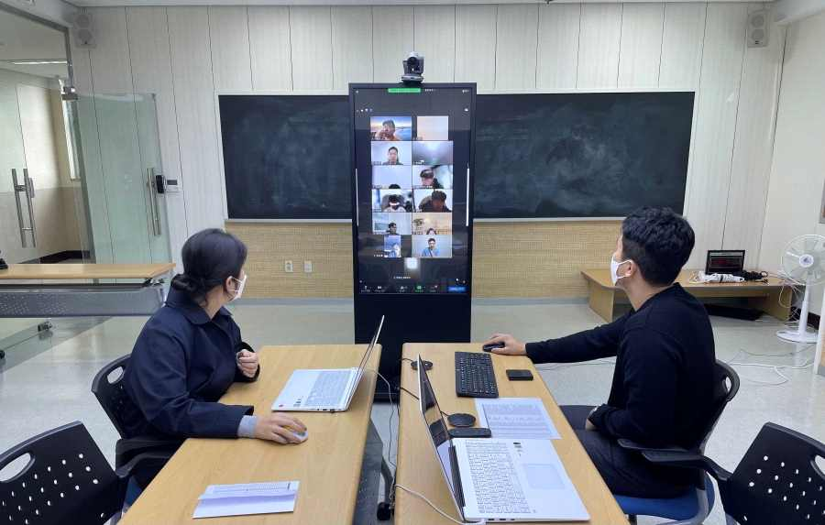
▲ 2021 Preliminary Start-up Package open intensive education

GIST (Gwangju Institute of Science and Technology, President Kiseon Kim) successfully utilized the in-house infrastructure to complete the '2021 Preliminary Start-up Package Open Intensive Education' on November 9, 2021.

GIST is supporting and managing the special field (AI field) project for preliminary start-up packages in 2021. For a total of 37 selected prospective founders, following the customized intensive education held on October 1st, the open intensive course was conducted as a non-face-to-face lecture.

GIST provides material and human resources to achieve business start-up commercialization by evaluating the excellence and commercialization potential of business plans with a focus on technology using artificial intelligence.

The open education was conducted in a way that (preliminary) entrepreneurs selected from 24 leading institutions nationwide for the preliminary start-up package were autonomously selecte. The training took a total of 8 hours and conducted between mentors and mentees to include ▲ explainable AI (artificial intelligence modeling methodology, business model cases related to AI services) ▲ machine learning for startup business (machine learning model operation flow, machine learning model learning/evaluation/inference, data set construction and management) ▲ artificial intelligence technology development (artificial intelligence development direction, IOT, block chain, security, connection with metaverse, 4th Industrial Revolution technology and commercialization, and best practices of artificial intelligence companies).

GIST Business Incubator Director Byeong-kwan Cho said, "We will do our best to support prospective entrepreneurs who are preparing to start a business in a difficult time through various open start-up education so that they can achieve successful start-up commercialization."

As follow-up training, IR competency enhancement programs, IR pitching competitions, and 2021 COEX Soft Competition exhibition support programs will be held for founders in the 2021 preliminary start-up package-specialized field from late November to early December.



