GIST awards certificate of appointment
to 'Student Ombudsperson'

- Expected to receive complaints from students as part of a communication link

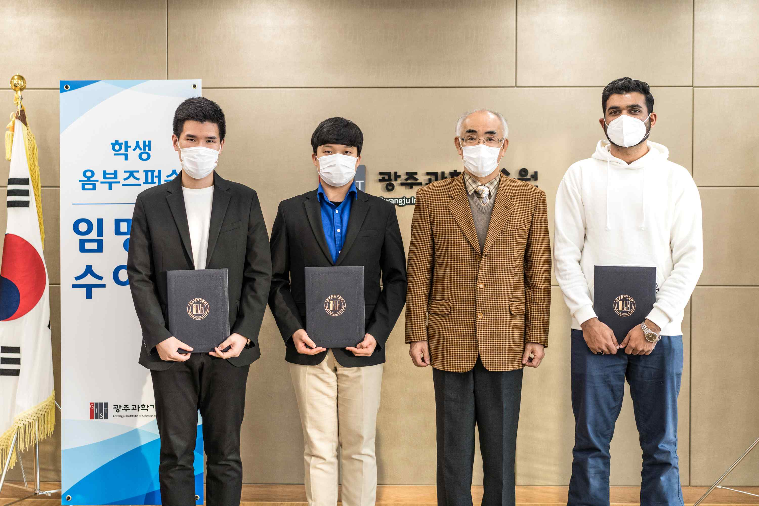
▲ From left: Se-hyun Park, Sun-woo Park, President Kiseon Kim, and Junaid Dar

GIST (Gwangju Institute of Science and Technology, President Kiseon Kim) Office of GIST Welfare selected student ombudspersons and held a certificate of appointment award ceremony on November 5, 2021.

Student ombudspersons, whose activities start for the first time this year, will listen to the grievances of GIST students and share them with the president and related departments to resolve complaints received.

Se-hyun Park of the Division of Liberal Arts and Sciences was selected as the undergraduate representative, Sun-woo Park of the School of Materials Science and Engineering was selected as the graduate representative, and Junaid Dar of the School of Mechanical Engineering was selected as the international representative.

Students' concerns and grievances can be submitted to the Student Ombudsperson's official e-mail address (student-ombuds@gist.ac.kr), and the contents of counseling are strictly confidential. The counseling window is open to all GIST students, and counseling is also possible through e-mail or interview with the student ombudspersons.



