GIST Nobel Amano Center for Advanced LEDs
hosts '4th ACALED Symposium'

- Conducted international joint research on micro LED displays and nanostructure nitride semiconductors with Professor Dong-Seon Lee's team and Nobel Laureate Professor Amano's team

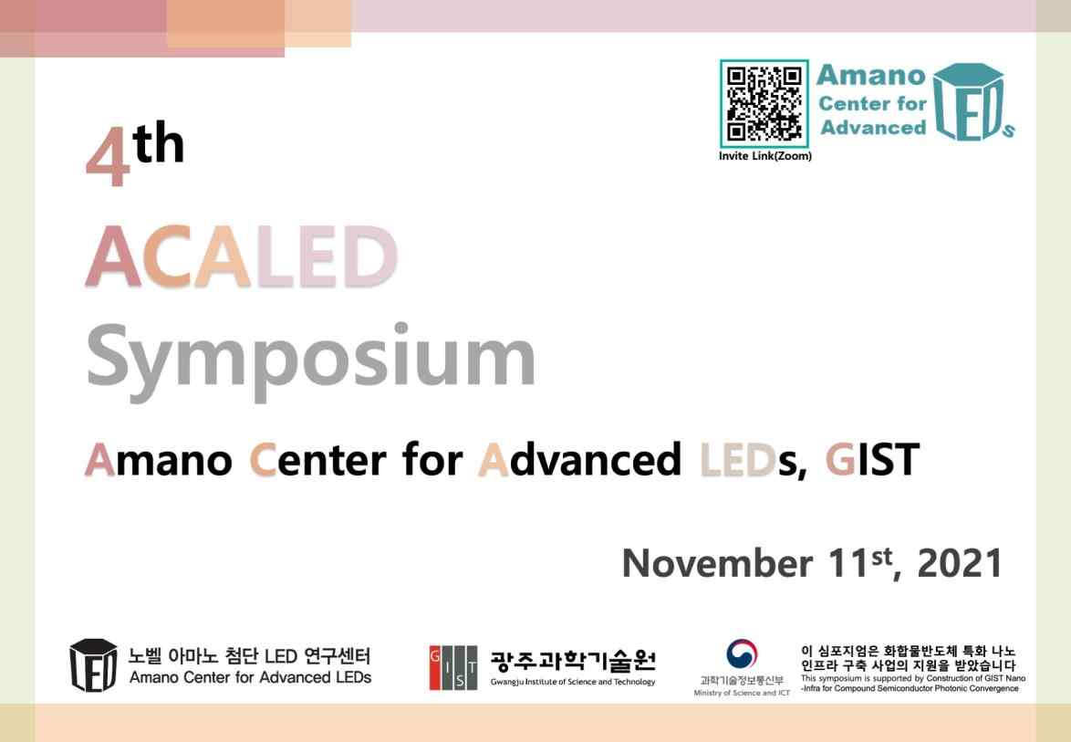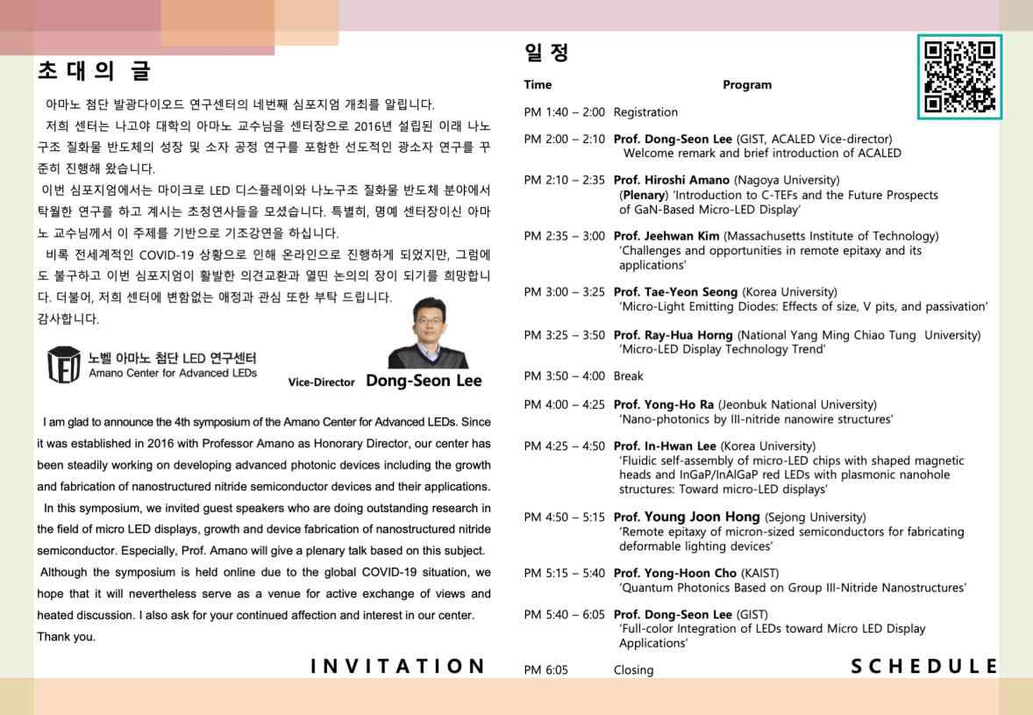
▲ 2021 4th ACALED Symposium pamphlet

GIST (Gwangju Institute of Science and Technology, President Kim Kiseon) Nobel Amano Center for Advanced LEDs (ACALED, Director Nagoya University Professor Hiroshi Amano, Deputy Center Director GIST School of Electrical Engineering and Computer Science Professor Dong-Seon Lee) hosted the online '4th ACALED' on November 11, 2021.

The GIST Nobel Amano Advanced LED Research Center, which opened in 2016 to develop advanced devices based on nanostructure technology of nitride semiconductors and secure global research capabilities and technology, is conducting joint research with 2014 Nobel Prize winner Professor Amano of Nagoya University, who is the highest authority and expert in this field.

Through annual international seminars and symposiums, the research center provides an opportunity to exchange information with advanced researchers and students on the development of advanced LEDs, including micro LEDs, and the challenges faced by nitride semiconductors.

By inviting speakers who are conducting outstanding research in the field of micro LED display and nanostructure semiconductor research, the symposium held nine leading domestic and foreign researchers' seminars, including 'Introduction to C-TEFs and the future prospects of GaN based Micro-LEDs displays' by Professor Hiroshi Amano, the center's director.

GIST Professor Dong-Seon Lee, the deputy director of the center, said, "Although this symposium will be held online to prevent the spread of COVID-19, it is expected that it will become a venue for more active exchange of opinions and heated discussions than any other year. We hope that this event will make a small contribution to the development of this field, and we ask for your continued interest and support for our center and research fields."

Currently, about 15 researchers at GIST Nobel's Amano Center for Advanced LEDs are continuously conducting joint research with Professor Amano's research team, and they are aiming to develop nanostructure-based LEDs and micro LEDs in the future and develop technologies to apply them to displays.

Recently, Professor Amano, Professor Dong-Seon Lee (co-corresponding author), and Ph.D. student Jeong-hwan Park of the Department of Electrical Engineering at Nagoya University, supported by the Amano Center for Advanced LEDs, published the research results (the paper's title: The stability of graphene and boron nitride for III- nitride epitaxy and post-growth exfoliation) in Chemical Science, an internationally renowned journal.



