GIST Korea Culture Technology Institute exhibits
realistic content 'Hyecho's Silk Road'

- Maximizing exhibition immersion using artificial intelligence-based experiential
interaction technology... providing opportunities to enjoy unique culture and art

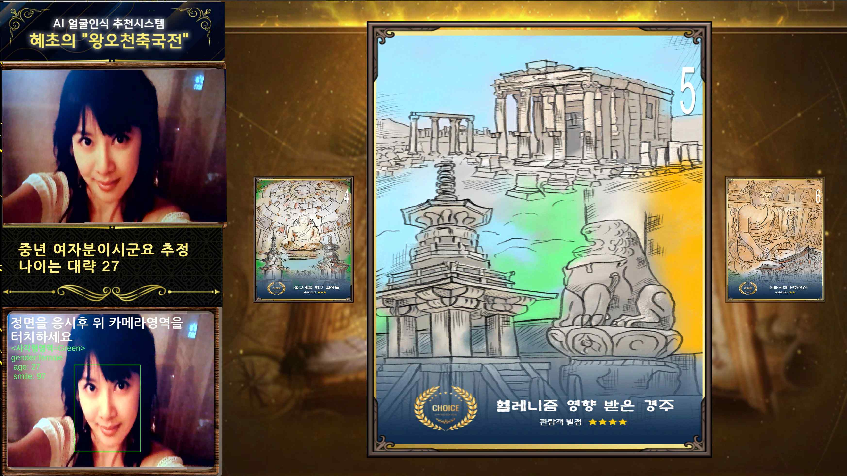
▲ Facial recognition content recommendation system using AI

GIST (Gwangju Institute of Science and Technology, President Kiseon Kim) Korea Culture Technology Institute (Director Moongu Jeon) and the Gwangju Cultural Foundation (CEO Pung-nyeon Hwang) exhibited the 'Interactive immersive smart media wall platform – Hyecho’s Silk Road' from November 9 to 20 at Media 338 (exhibition room) on the 2nd floor of Bitgoeul Art Space.

'Hyecho's Silk Road,' which incorporates immersive smart media wall platform technology, is an expanded theme from 'Asian Culture Map – My Way of Ramayana,' an exhibition from the previous year which used the Asian cultural resources of the Asian Culture Center (ACC). The historical flow centered on Southwest Asia and the national cultural heritage is visualized in three dimensions.

In particular, in this exhibition, a user-customized recommendation system using artificial intelligence (AI) facial recognition technology is used for the first time in Korea. An artificial intelligence creative video that has been creatively reinterpreted by artificial intelligence will be introduced as a cultural relic. In general, interactive content technology that can be used by several people at the same time, rather than content used by one person, is applied.

At the end of the exhibition space, the augmented reality 3D cultural relics realized in the metaverse are implemented so that users can directly manipulate and touch them so that visitors can experience a higher-level and different experience.

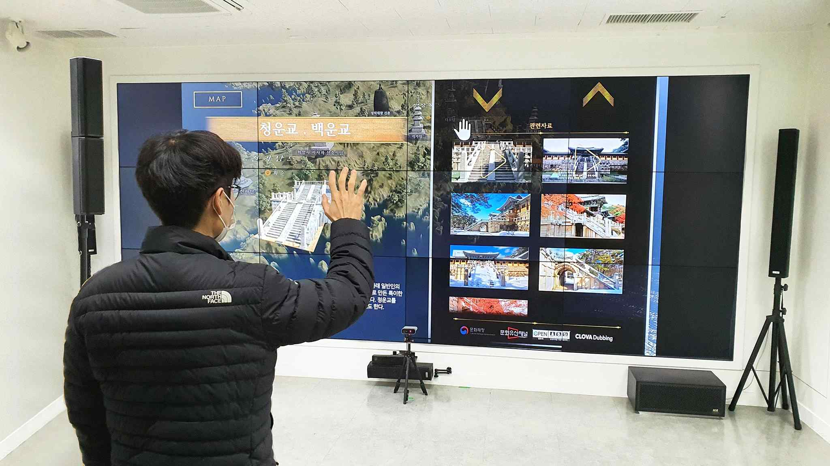▲ Two-way interactive content using 3D gesture recognition

Korea Culture Technology Institute Director Moongu Jeon said, "The purpose of 'Hyecho's Silk Road' is to develop technology to provide a new exhibition experience in which ordinary citizens can understand and actively participate in cultural and artistic contents in various ways. In the future, we will try to study various cultural technologies that can provide an opportunity to enjoy different cultures and arts."

The Korea Culture Technology Research Institute was selected last year for the cultural technology R&D (period: April 2020 ~ December 2022) for the development of realistic smart media wall platform technology, and it will develop exhibition archive DB visualization and interaction technology of various cultural and art spaces. Research using the technology is in progress.

In addition to the cultural technology research and development policy designated by the Ministry of Culture, Sports and Tourism, the institute is carrying out a number of projects such as realistic contents utilizing cultural heritage, cooperative planning projects to support convergence art creation, and AI-based media façade mapping technology development. It is concentrating on research and development of cultural technology to drive industrial development.



