GIST holds "Imagination Narae - Into the Future"
science story contest

- Planning a program to stir interest in science to foster
future science and technology specialists in the region

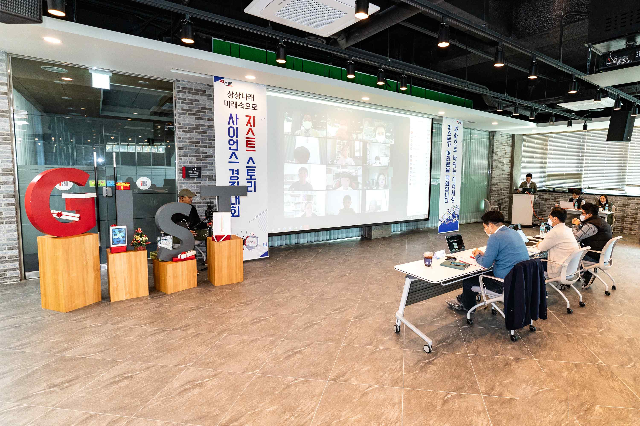
▲ GIST "Imagination Narae - Into the Future" science story contest

GIST (Gwangju Institute of Science and Technology, President Kiseon Kim) held the 'Sangsangnarae-Into the Future' GIST Story Science Contest online on Saturday, November 6th (Sat) for elementary, middle, and high school students in Gwangju and Jeollanam-do.

This contest was held to nurture future science and technology students by stimulating their interest in science by having them freely imagine and tell a story under the theme of 'The Future World Changed by Science.'

In this competition, about 40 students participated in the preliminary round with nine participating in the final round. The students' creativity and fresh ideas for the future could be glimpsed.

The elementary school grand prize was awarded to a student named Han-ul Joo, a 5th grader at Jeongam Elementary School, who wrote about 'a hyper-connected world where a healthy and clean environment is possible.' The middle school grand prize was awarded jointly to Yun-seo Lee, 2nd year at Sungil Middle School in Gwangju, who wrote about 'artificial intelligence zoo using a 3D printer and AI,’ and ▲ Si-wan Ryoo, a 1st year at Yongjeong Middle School, who about 'room.' The grand prize winners were presented with the GIST President's Award and a MacBook Air as a prize.

GIST President Kiseon Kim said, "GIST will work together to make the future imagined by all the students who participated in this contest into reality. GIST will continue to contribute to nurturing future science and technology students in the region through various programs."


