GIST Science and Culture Week hosts '2021 CEO Forum'

- Expanding the entrepreneurial atmosphere and
seeking ways to revitalize technology start-ups

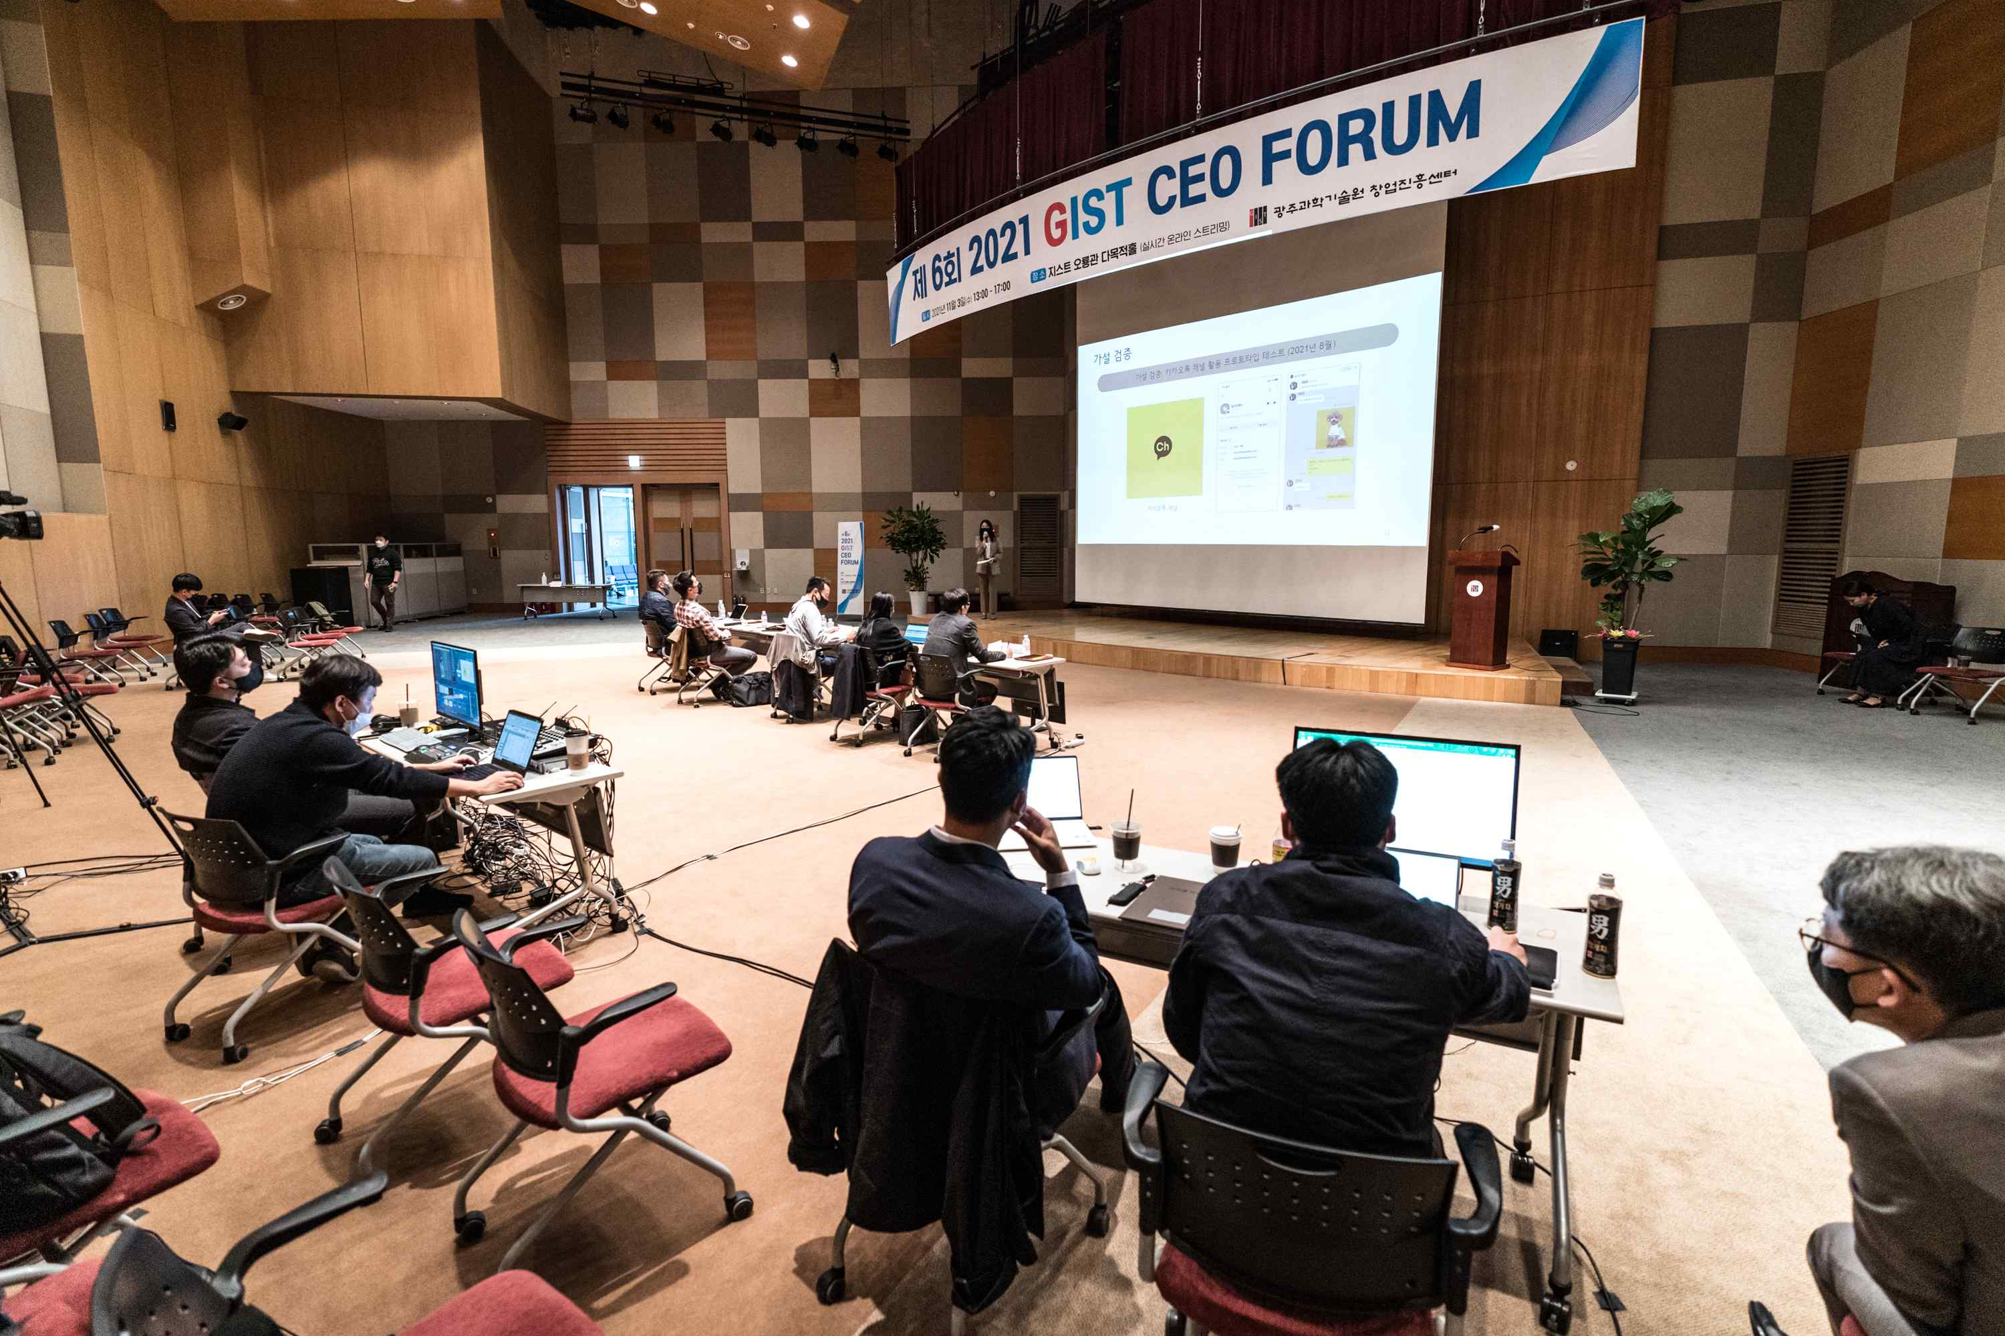
▲ GIST CEO Forum Real-time Online Streaming IR Competition (Venue: Oryong Hall)

GIST (Gwangju Institute of Science and Technology, President Kiseon Kim) held the '2021 GIST CEO Forum' at Oryong Hall on November 3 (Wednesday) to celebrate the '2021 GIST Science and Culture Week.'

This forum, which marks its 6th anniversary this year, was prepared to gather the excellent capabilities of local start-up-related institutions and to seek ways to revitalize technology start-ups. It is a beneficial start-up festival where people could meet CEOs who are leading science and technology, start-ups, and the local economy.

This year, to prevent the spread of COVID-19, it was conducted through real-time online streaming. For the mock crowdfunding of the investment company briefing session (IR), participants were recruited in advance using the Eventus platform, and about 220 people applied, confirming their high interest in starting a business.

A total of five professional investors from Logan Ventures, E&Venture Partners, K-Clavis Investment, Rising S Ventures, and Daedeok Venture Partners were invited to the IR as judges, and presentations were made by external market experts to GIST professors. A total of seven teams including students (preliminary) entrepreneurs introduced various topics: ▲ 'Development of stem cell therapy using reduced graphene oxide-alginic acid hydrogel technology' ▲ 'Development of CBW quantum sensor module for quantum lidar, the core function of autonomous driving' ▲ 'Development of filter for hemodialysis and water purification device for dialysis' ▲ 'Digital sleeping pills that induce sleep using near-infrared light' ▲ 'Data-based team building platform for start-ups' ▲ 'AI dog clothes platform application' ▲ 'Prostate cancer multi-diagnosis sensor that can be used in the field.'

The grand prize was selected by a total of 73 mock crowdfunding and awarded to ▲ prospective student founder Ho-yeon Lee (GIST Department of Chemistry) who proposed the 'cancer multi-diagnosis sensor that can be used in the field.' The Excellence Award was awarded to ▲ GIST School of Electrical and Electronic Computer Science Professor Byoung Seung Ham who proposed 'Development of CBW quantum sensor module for quantum lidar, the core function of autonomous driving.' Lastly, the Encouragement Award was awarded to ▲ Joo-young Hong, CEO of Sigorjav, who proposed 'AI Dog Clothes Platform Application.'

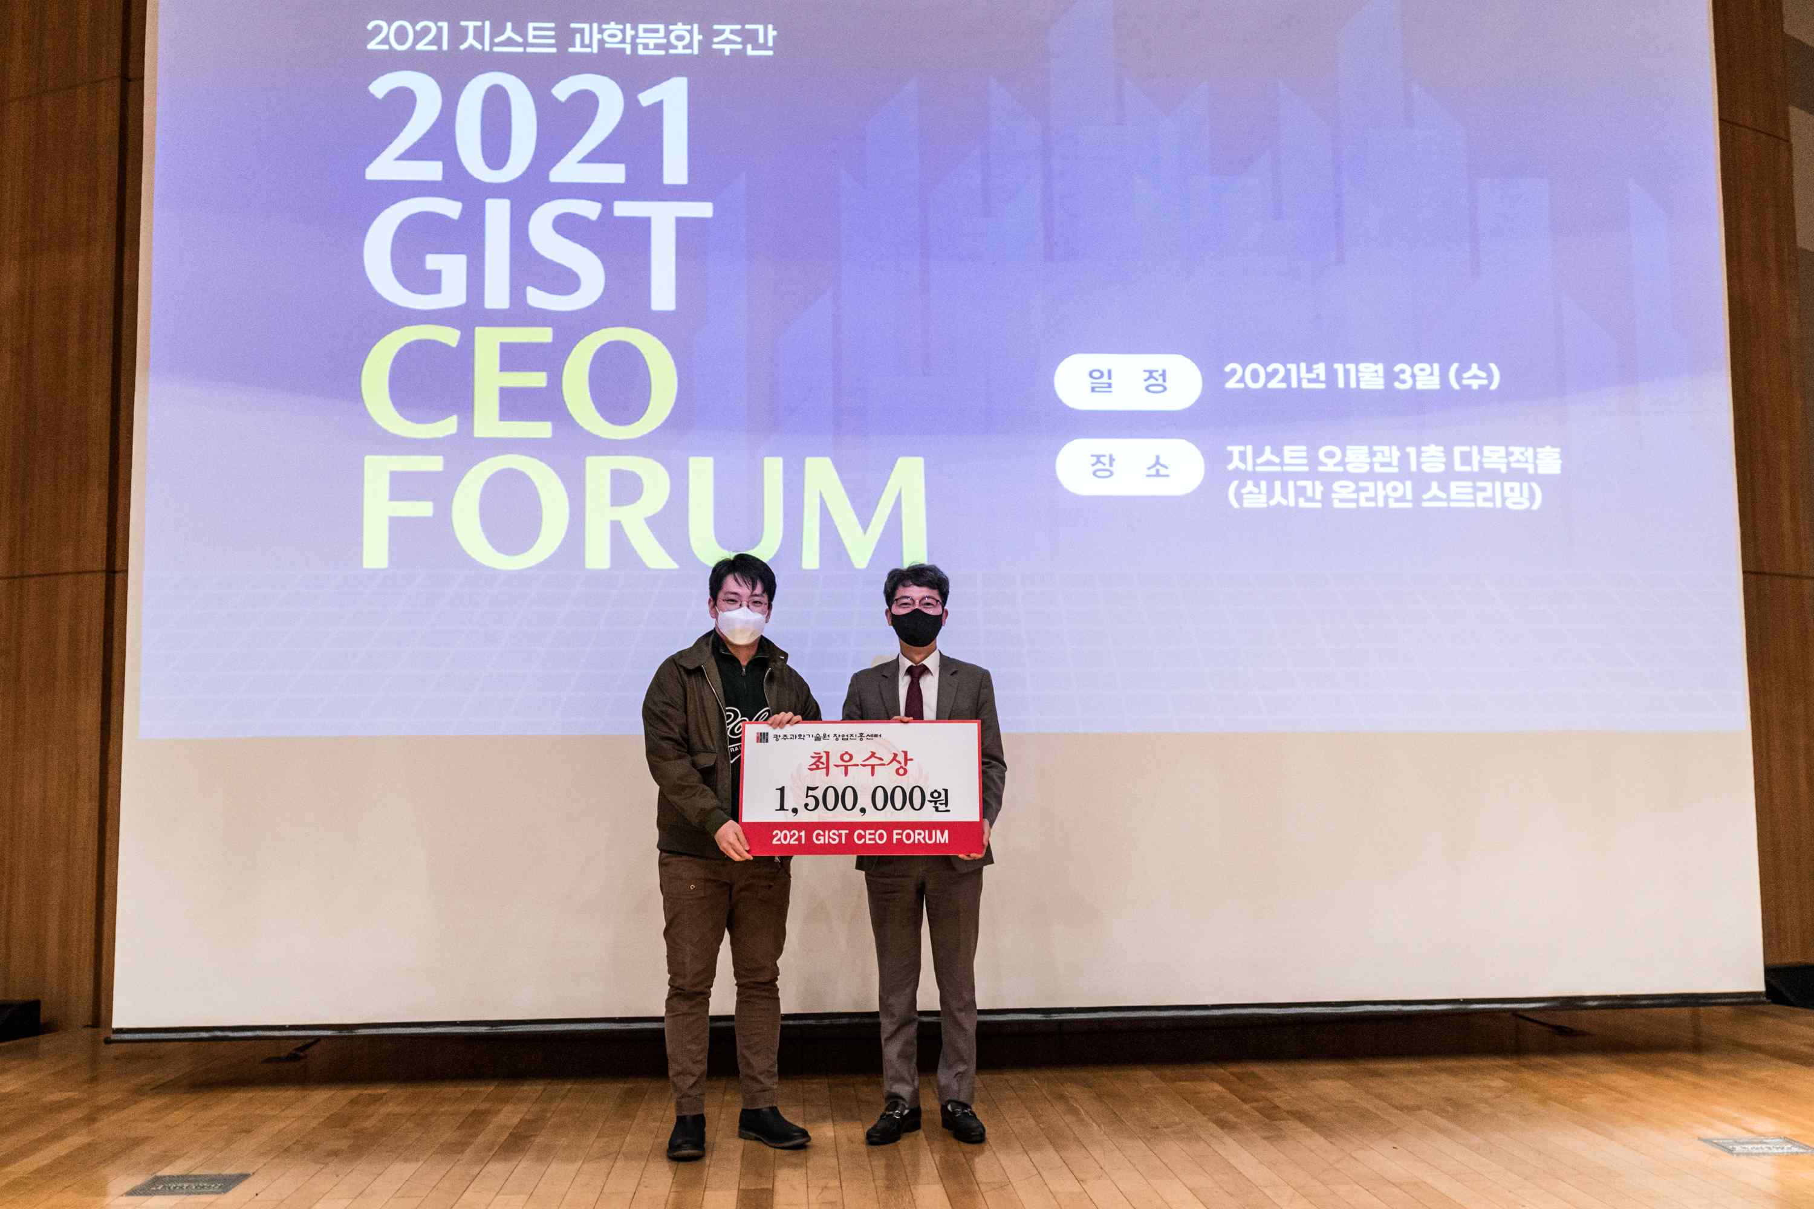
▲ GIST CEO Forum Grand Prize Award

Prizes of KRW 1.5 million, KRW 1 million, and KRW 500,000 were awarded to the winning teams, respectively.

GIST Business Incubator Director Byeong-kwan Cho said, "We will spare no effort to support this forum so that it can become a place of communication for startups by organically connecting CEOs of technology start-ups with excellent regional capabilities centered on GIST. In particular, we will do our best to revitalize the local economy by intensively nurturing artificial intelligence start-ups and discovering successful models."



