GIST Professor Seung-Hyeon Moon publishes 'Electrochemical Processes of Ion Exchange Membranes'

- Covers the basics of ion exchange membrane for
eco-friendly water treatment and renewable energy

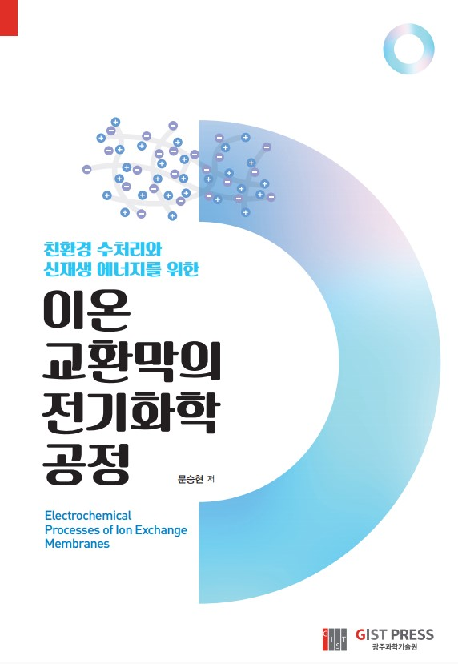

GIST (Gwangju Institute of Science and Technology, President Kiseon Kim) School of Earth Science and Environmental Engineering Professor Seung-Hyeon Moon (former President of GIST) published an academic book entitled Electrochemical Processes of Ion Exchange Membranes through GIST PRESS on October 25, 2021.

In a situation where scientific and technological methods are required for greenhouse gas reduction and a carbon-neutral society, this book was written to help students understand basic knowledge such as terms and principles needed to start research in the fields of water treatment processes or energy conversion processes using ion exchange membranes.

In addition, this book introduces technologies that have not yet been put to practical use, particularly laboratory research devices and research methods, to help researchers and technicians operating the ion exchange membrane process solve environmental and energy problems.

Ion exchange membranes have been used in electrodialysis to desalinate seawater or produce salt from seawater, but their application has been extended to a core material for fuel cells that generate electricity for spacecraft.

Today, the demand for ion exchange membranes is increasing in numerous water treatment processes and energy processes. As applications have diversified, the terminology also change, which is causing difficulties for researchers in the field.

The author, Professor Seung-Hyeon Moon, mentions the urgent need to present scientific and technological alternatives to reduce greenhouse gas emissions and realize a carbon-neutral society, and said, "I hope that the ion exchange membrane will be used as a means to solve environmental and energy problems."

Professor Moon worked at the Argonne National Research Institute in 1991 before moving to the GIST School of Earth Science and Environmental Engineering in 1994 where he is still serving as a professor. His main research interests are the manufacturing of ion exchange membranes and the application of energy and water treatment processes.



