GIST Korea Culture Technology Institute exhibits
media work dealing with maritime issues

- Participation in the 2021 Sea Art Festival... Unveiling 'The Ocean Machine,' a work that visualizes a story created by weaving artificial intelligence and traditional tales

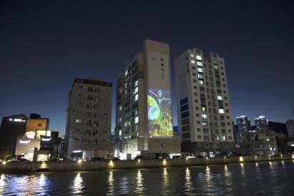
▲ The Ocean Machine, 2021 Ilgwang Beach installation

GIST (Gwangju Institute of Science and Technology, President Kiseon Kim) Korea Culture Technology Institute (Director Moongu Jeon) research team (Researcher Anna Kim) will present 'The Ocean Machine,' a video work dealing with marine pollution issues, at the '2021 Ocean Art Festival'.

'The Ocean Machine' tells the story of an invention that can solve the microplastic problem in the ocean by combining the latest artificial intelligence technology with the story of the Dragon Goddess in traditional tale.

The research team has been studying participatory interactive storytelling works using natural language generated artificial intelligence since last year to raise public awareness of marine pollution and has produced this work as an extension.

Artificial intelligence outputs various descriptions of the appearance and operation of the invention, and the research team visualized an invention called the 'The Ocean Machine' based on this. The 'The Ocean Machine,' in a combined form of marine life and machinery, forms a symbiotic relationship with the Dragon Goddess in traditional Korean folklore and removes marine plastics.

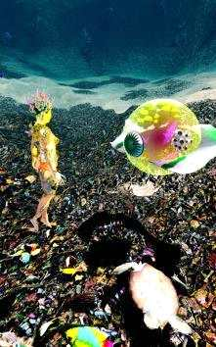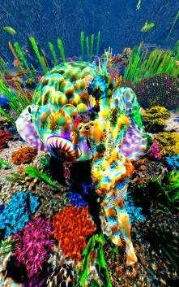
▲ The Ocean Machine, 2021 screen captures

As the '2021 Sea Art Festival' is focuses on works with lighting on Ilgwang Beach as the stage, the media work 'Ocean Machine' shines especially bright at night. A large-scale project mapping has been utilized on the outer wall of the Sunriseville building next to Ilgwangcheon and can be viewed from 6 pm to 9 pm, and it can also be viewed at the Eurasia Platform Media Art Wall at Busan Station.

Korea Culture Technology Institute Director Moongu Jeon said, "This media work reflects the problems of reality by combining the artificial intelligence IT technology pursued by our research institute with materials from traditional Korean stories. It is very meaningful in that human beings, technology, and nature are in solidarity and seek symbiosis through virtual reality."

The '2021 Sea Art Festival,' co-hosted by Busan Metropolitan City and the Busan Biennale Organizing Committee, has 36 artists participating from 13 countries under the theme 'Human and Non-Human: Assemblage (NON-/HUMAN ASSEMBLAGES), and 22 works will be displayed until November 14.



