GIST successfully completed the
8th Creative Space G A.I&IoT Makerton

- An open event for the general public to lead the 4th Industrial
Revolution and inspire a healthy start-up culture

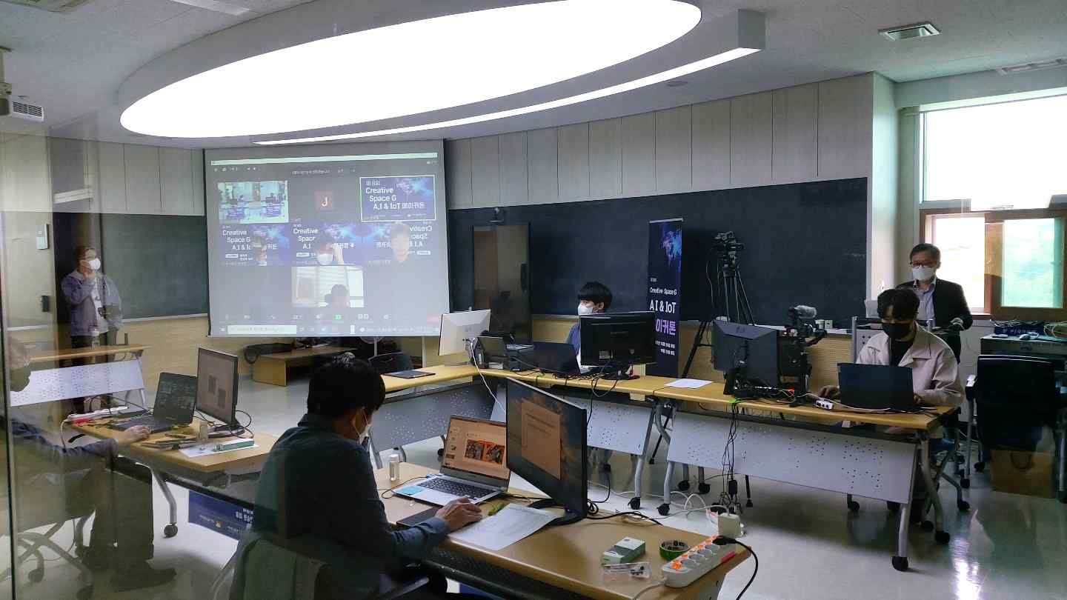
▲ The 8th Creative Space G A.I&IoT Makerton Final Presentation Contest

GIST (Gwangju Institute of Science and Technology, President Kiseon Kim) has successfully completed the '8th Creative Space G A.I&IoT Makerton' in which the general public from all over the country participates to lead the 4th Industrial Revolution and to inspire a healthy start-up culture in the region and campus.

Starting in 2018, this event is held twice a year (the first half and the second half of the year). In the first half of 2021, an idea hackathon competition was successfully held, and in the second half of this year, a makerton competition was held to realize or create ideas.

The makerton competition was held for 5 days from October 25 (Mon) to 29 (Fri) in connection with the '2021 Technology Commercialization Start-Up Investment' event held in Gwangju. To prevent the spread of COVID-19, team mentoring and development meetings were held non-face-to-face.

In particular, for the production of products for the makerton event, the space was actively supported so that products could be manufactured in Seoul's Makerspace, Suncheon's Makerspace, and GIST's Creative Space G.

College students from all over the country, including KAIST, Chonnam National University, Chosun University, Gwangju University, Korea University of Science and Technology, and Kangwon National University participated in this competition and showed enthusiasm for entrepreneurship. Initially, a total of 45 people from ten teams started the competition with the number of participants, and seven teams held the final presentation competition after the five-day event.

The grand prize was awarded to ▲ the 'Plastic Stop' team (Han Industrial Technology University, Heechul Ahn, Youngjun Kim, Wooin Kim, Bogyu Hwang) who proposed the 'Pet Bottle Sorting Robot.' The Excellence Award ▲ 'WonQ' team (Woosong University graduate Min-gyu Park, Seojun University graduate Won-chan Choil, Kwon-dong Kim from Woosong University, Shin-Young Park from Hanbat University, and Ye-jin Song from Seoul Women's University). Lastly, the Encouragement Award went to ▲ the 'Ingoing Chun' team (Kangwon National University Hee-jin Kim, Yuna Kang, and Ji-hyeon Hwang) who announced 'a wireless posture measuring device that helps in rehabilitation treatment.'

GIST Business Incubator Director Byeong-kwan Cho said, "Through the 2021 makerton event, a program to discover excellent ideas and produce prototypes was conducted to induce interest in startups, and we plan to link various items and support teams to start-up projects next year."



