GIST 'Science and Culture Week' events held

- From November 1st to 12th, a variety of scientific and cultural events for everyone
- A walking donation campaign using an app and a metaverse virtual campus event
created by students themselves!!

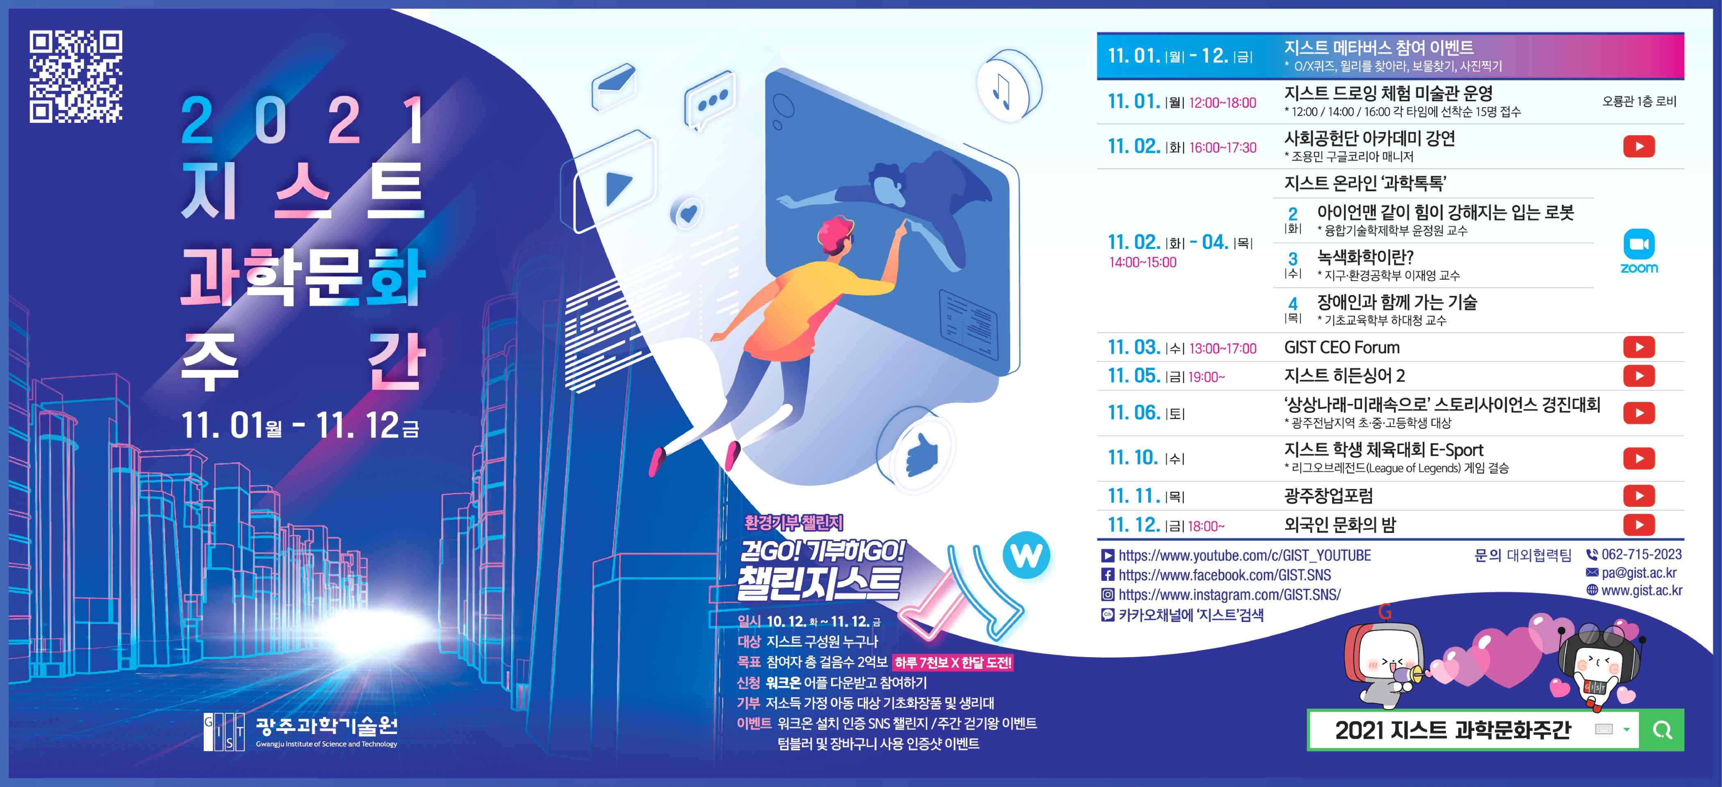

GIST (Gwangju Institute of Science and Technology, President Kiseon Kim) will hold the '2021 GIST Science and Culture Week' event for 12 days from November 1 (Mon) to 12 (Fri) to communicate with the local community and spread a healthy science culture.

This year's Science and Culture Week has organized programs and colorful events that can be enjoyed not only by GIST members but also by elementary, middle, and high school students in Gwangju, prospective entrepreneurs, scientists, and engineers to comfort tired minds due to the prolonged COVID-19 pandemic and to deliver a message of hope.

To prevent the spread of COVID-19, most events are held non-face-to-face, such as YouTube live broadcasting, videos, and Zoom lectures. In particular, during this Science and Culture Week, GIST, Good Neighbors, and Onsaemi Ro (student club) are co-hosting a walking donation campaign at the same time. If you participate in the walking donation campaign and achieve your goal, you can donate basic cosmetics and sanitary napkins to children from low-income families.

In addition, this year the ▲ GIST Virtual Campus, which GIST students have created themselves since August, will be unveiled. Participation in the GIST Virtual Campus event is random during the event period, and anyone can participate through the event website (sc.gist.ac.kr).

The first week of the event, from November 1 (Mon) to 6 (Sat) will host the ▲ 'GIST Drawing Experience Museum Event' and social contribution expert invitation, with Google Korea Manager Yong-min Cho and ▲ the 'Society Contribution Academy Lecture.'

From November 2nd (Tuesday) to 4th (Thursday) for a total of 3 days, students can learn science easily through Zoom lectures for middle and high school students who are interested in science: ▲ 'GIST Online Science Talk Talk' will be held on the 3rd (Wednesday)to meet with science and technology start-ups and CEOs ▲ 'GIST CEO Forum' will be held on the 5th (Fri) ▲ 'GIST Hidden Singer 2' will determine the best singer at GIST. The next day, the 6th (Sat), is a festival where you can see the creativity of elementary, middle, and high school students in Gwangju and Jeollanam-do: ▲ ‘Imagination Narae-Into the Future' Story Science Contest (finals).

During the second week of the event, November 10 (Wednesday) is an online game: ▲ the 'GIST Student Athletic Competition E-Sport (final)' will be held on the 11th (Thursday and ▲ the 'Special lecture on investment at the Gwangju Startup Forum' will be held. On the last day, the 12th (Friday), the event concludes with a place of harmony to understand the cultures of various nationalities and form a consensus through the ▲ 'Online Foreign Culture Night' event led by GIST foreign students.

President Kiseon Kim said, "I hope that the members of GIST will enjoy the beneficial events that have been painstakingly prepared, and that they will give them some comfort from their weary daily life. We will open the door wide and work together so that GIST can play a central role in the development and growth of the region."



