GIST ECOSysChem Research Center opening ceremony

- Secure source technology to solve social problems through eco-friendly
treatment of urban waste and development of upcycling technology

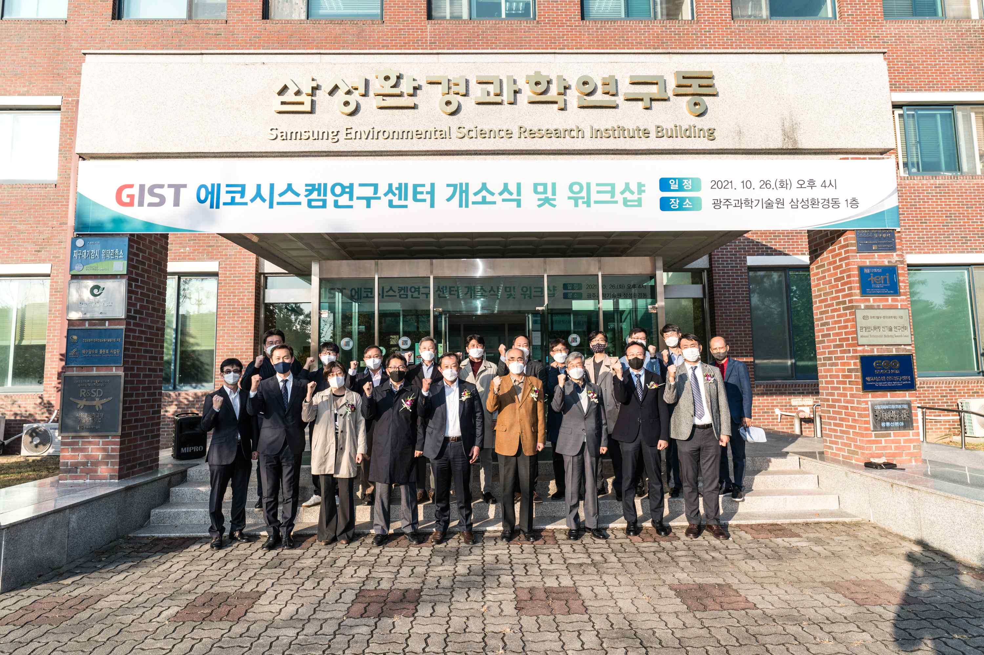

GIST (Gwangju Institute of Science and Technology, President Kiseon Kim) held an opening ceremony or the ECOSysChem Research Center (Director In Seop Chang, a professor at the School of Earth Science and Environmental Engineering) was held on October 26 (Tuesday) with about 20 people in attendance at GIST Samsung Environmental Science Research Institute Building.

The opening ceremony was held in the presence of GIST officials and members, including GIST President Kiseon Kim, former President Seung-hyeon Moon, College Dean Chung-Hee Cho, Dean of Research Kihong Park, and Dean of Planning Zee-Yong Park as well as officials from the Korea Institute of Energy Research.

Municipal solid waste (MSW) is the third largest source of greenhouse gas in Korea and is currently being incinerated due to a ban on reclamation, but it is emerging as a social issue that causes a shortage of incinerators and conflicts between local governments.

Gasification is being proposed as a future technology to replace incineration, and it is urgent to secure the source technology for the utilization of gaseous substances generated after the gasification reaction to reduce carbon dioxide emission and recover energy and resources from waste.

The GIST ECOSysChem Research Center (Innovative Energy and Carbon Optimized Synthesis for Chemicals (Inn-ECOSysChem) Research Center) aims to secure source technology to solve social problems through the development of eco-friendly treatment and upcycling technology for municipal solid waste (MSW). Research on biotechnology for conversion of syngas-type total gas derived from MSW, catalyst for conversion of residual carbon dioxide after reaction of syngas, development of reaction technology, recovery of organic and inorganic by-products derived from syngas, stabilization, and development of high-addition technology will be researched.

Director In Seop Chang said, "This research center will do its best to secure original technology for the purpose of developing technologies that can achieve innovative transformation of urban solid waste gasification materials. By capturing carbon dioxide, it can be expected to have a positive effect of reducing emissions, carbon upcycling, and improving the carbon dioxide control system."

The center will include 11 GIST professors and the Gwangju Bioenergy R&D Center of the Korea Institute of Energy Research, and consists of three core groups: ▲ bio-source technology for converting gasified substances derived from MSW waste ▲ catalyst for conversion of residual CO2 after conversion of MSW-derived gasified substances, and reaction source technology ▲ MSW-derived organic and inorganic by-product recovery, stabilization, and high value-added technology. From this year to 2028, it will receive a research grant of KRW 13.5 billion for seven years.



