GIST Academy hosts 'Hydrogen Electric
Cycle Technology' breakfast forum in October

- Seoul National University Professor Sang-Gyu Kang emphasizes the importance
of revitalizing the hydrogen economy and fostering the hydrogen industry

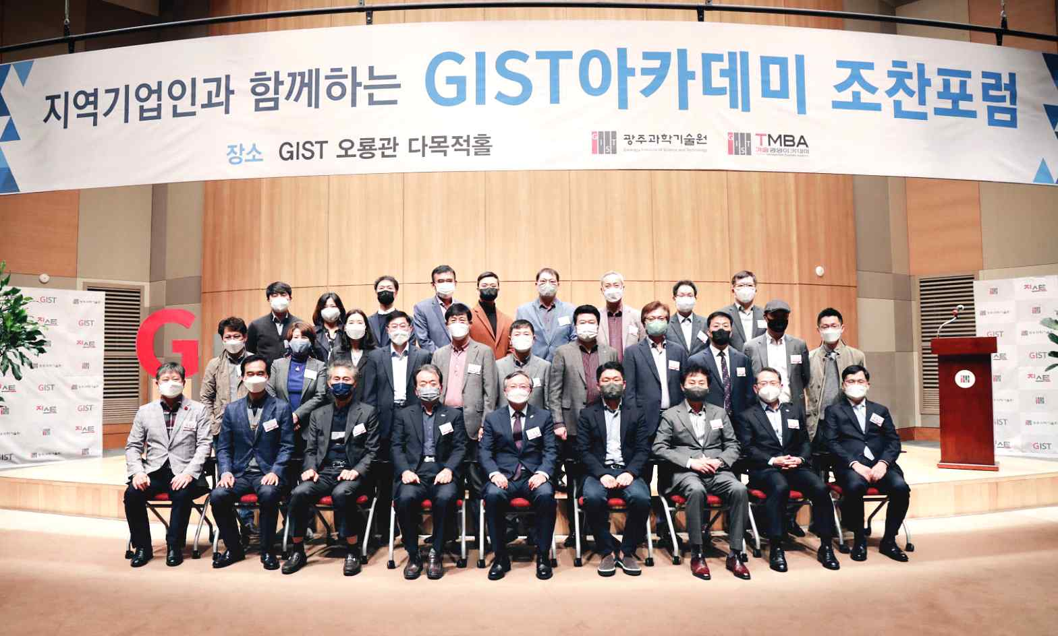
▲ GIST Academy's October Breakfast Forum

GIST (Gwangju Institute of Science and Technology, President Kiseon Kim) Academy hosted the October Breakfast Forum at Oryong Hall on October 25, 2021, about 'Hydrogen Electric Cycle Technology' with about 40 representatives from companies attending from Gwangju and Jeonnam.

At the forum, Seoul National University Department of Shipbuilding and Marine Engineering Professor Sang-Gyu Kang explained the characteristics of hydrogen, the entire hydrogen cycle, and the future hydrogen society, which attracted more interest by introducing how to secure competitiveness in the hydrogen market.

Professor Sang-Gyu Kang emphasized the importance of government policies for the economic feasibility of hydrogen and for the stability of hydrogen energy, and presented a goal for transportation. In particular, the government needs to advance gas storage and transportation technology and promote technology development for liquid hydrogen and liquid hydride storage and transportation to achieve hydrogen supply and supply price targets.

In addition, Professpr Kang said, "It is necessary to complete the infrastructure for hydrogen life cycle technology development in 30 years by using the fuel cell system to prevent overlapping investment and induce price reduction by localizing highly exclusive parts."

Meanwhile, on the last Monday of every month, the GIST Academy Breakfast Forum provides opportunities for awareness innovation, technology transfer, and industry-university cooperation through lectures by experts from various fields for alumni and local business executives.

GIST Academy operates two courses: GIST Techno Management Business Academy (opened in 2010) and GIST Climate Change Academy (opened in 2016). It is contributing to the vitalization of the local economy and industry-university cooperation by cultivating the local economy and forming a wide human network.



