GIST presented a plaque of appreciation at a luncheon for Chairman Eok-geun Oh, the founder of Shinseon Seolnongtang

- Shinseon Seolnongtang Chairman Eok-geun Oh provided funds for a faculty center
when GIST first opened... to create opportunities to spread a culture of sharing

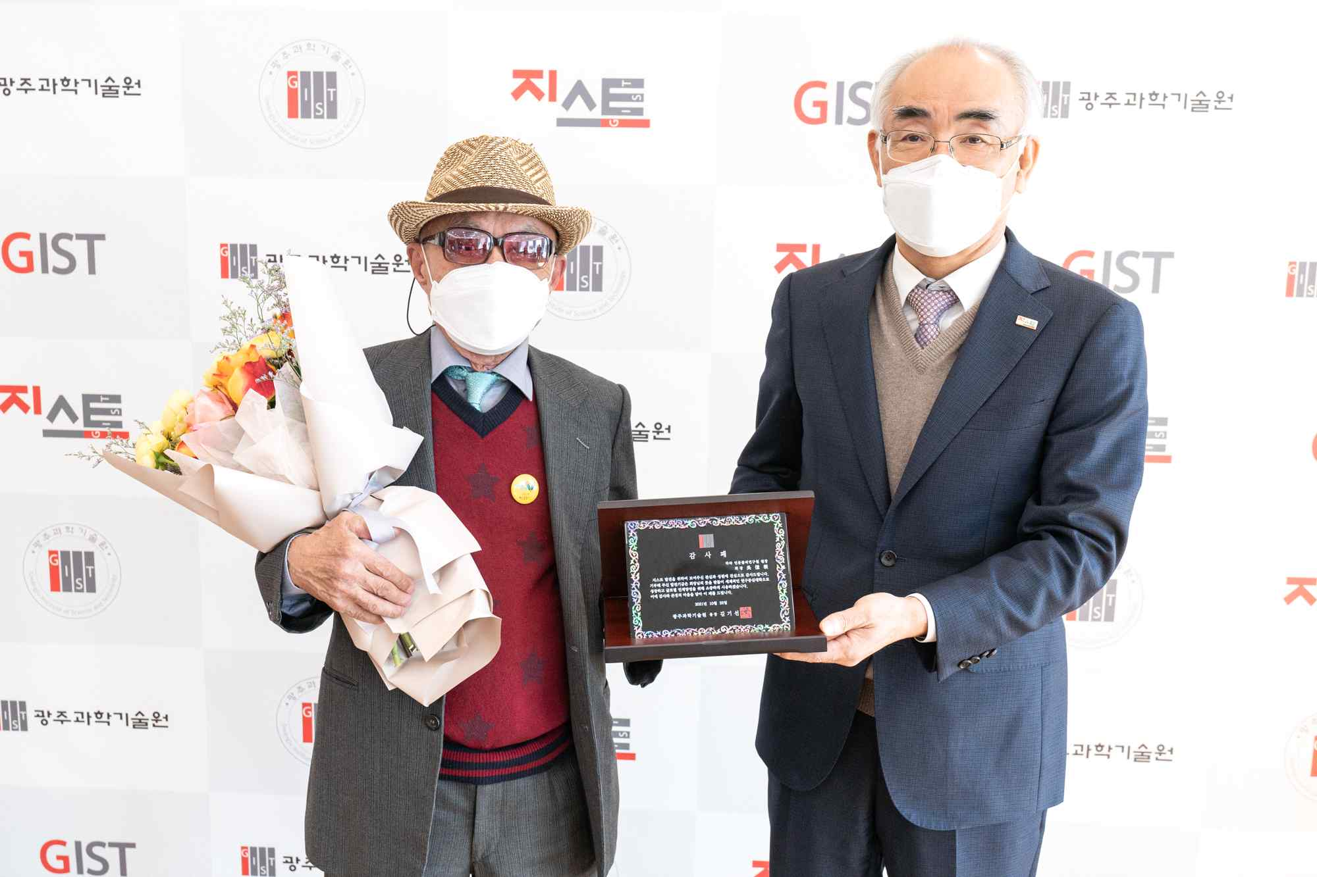
▲ President Kiseon Kim delivers a plaque of appreciation to Chairman Eok-geun Oh.

GIST (Gwangju Institute of Science and Technology, President Kiseon Kim) held a thank-you luncheon for donors of the 'Faculty Hall Construction Fund' on October 22 (Fri) and expressed gratitude to the donors.

In particular, this luncheon was attended by Shinseon Seolnongtang Chairman Eok-geun Oh who generously donated a large amount of money to support local science and technology development and research from the very beginning when GIST opened.

Chairman Eok-geun Oh was born in 1932 in Jijuk-ri, Pyeongdong-myeon, Naju-gun, Jeollanam-do (currently Gwangsan-gu). Because his family was poor, he moved to Seoul at the age of 15 and wanted to work in the automobile industry, but getting a job in a Chinese restaurant became his lifelong career. He started by washing dishes in Chinese restaurants, and he learned to cook and saved money, and decided to become independent at the age of 30.

He opened a Chinese restaurant "Inhwawon" on Bogwang-dong 3-way street and thought it would do well after six months, but the owner of the building asked me to vacate the store, so he moved the store. Since then, after surviving business failures, the Seolleongtang restaurant was opened at Daelimjang in Jamwon-dong, and today it has been reborn as Shinseon Seolnongtang. Currently, it operates several chain stores in the metropolitan area.

Chairman Eok-geun Oh, who had laid the foundation, left the restaurants to his son, CEO Chung Oh, and started studying. Chairman Eok-geun Oh's will to learn has expanded to book management that makes his employees read books. Shinseon Seolnongtang was selected as an excellent workplace in the 2014 Korea Reading Competition hosted by the Ministry of Culture, Sports and Tourism and the Korea Publishing Culture Industry Promotion Agency for its book management.

Those who know what Chairman Oh is like don't just call him a businessman. As a supporter who generously supported scientific and technological research for regional and national development, he is literally referred to as a donor angel.

Chairman Oh is famous for not spending money on himself. Instead, he directly visited researchers who were in difficulties due to lack of research funds and spared no expense in providing financial support. He has also generously supported research on 2-Tessler superconducting MRI of Dr. Jang-hee Cho (Director of the Brain Science Research Institute at Gachon University of Science).

In 1998, GIST also received his help. At that time, GIST was in a situation where there was no suitable place to serve meals to foreigners who visited the institution immediately after its opening. After hearing about the organization's circumstances, Chairman Eok-geun Oh willingly donated 150 million won to fund the establishment of a foreign restaurant. This has allowed researchers to focus solely on research.

Chairman Eok-geun Oh said, "Thank you for providing such an event. I'm happy to have been of some help to the development of GIST."

President Kiseon Kim said, "I would like to express my gratitude to Chairman Oh for the warm encouragement he provided GIST, and I will do my best to help GIST contribute to the development of the region and the nation."

Meanwhile, Chairman Eok-geun Oh is working as a YouTuber for 'Hara's Humanities and Physics' and has about 40 videos. The 150 million won donated by Chairman Eok-geun Oh to GIST from 1998 to 1999 is now more than 300 million won including the interest accrued to date.



