GIST Korea Culture Technology Institute implements
Korean sign language services for the deaf at museums

- Developing technologies to provide universal services
by lowering cultural barriers for the disabled

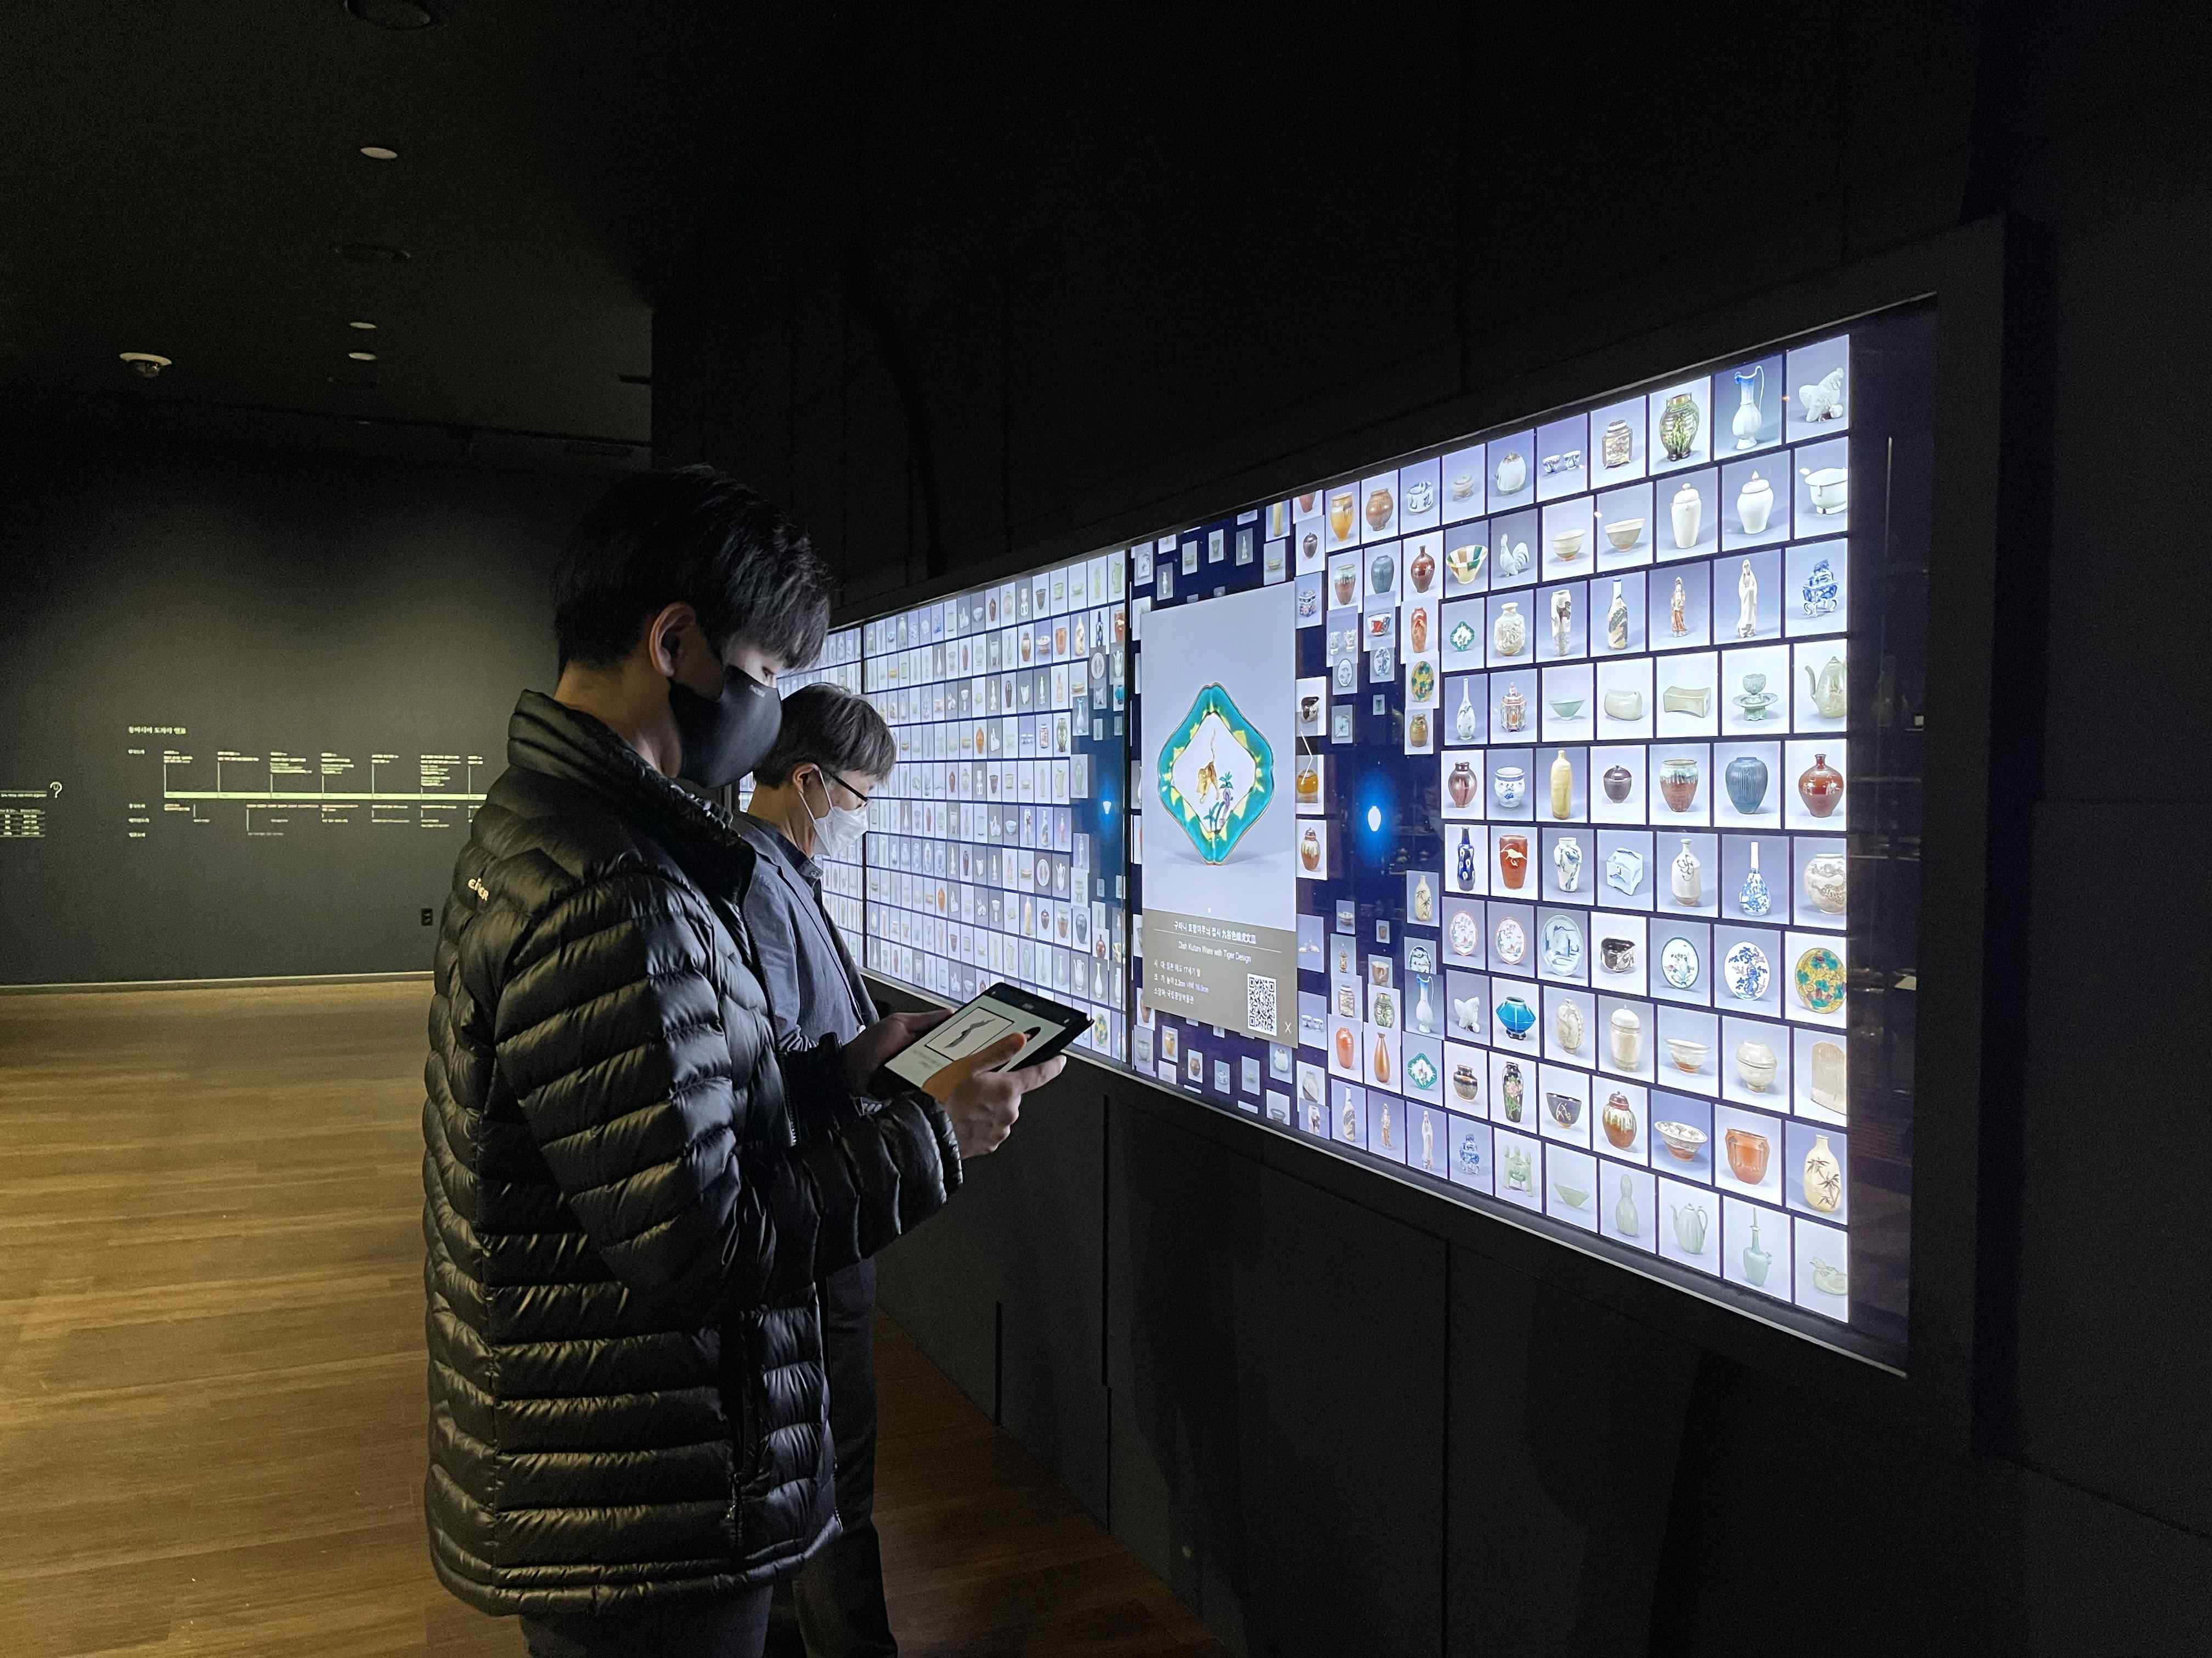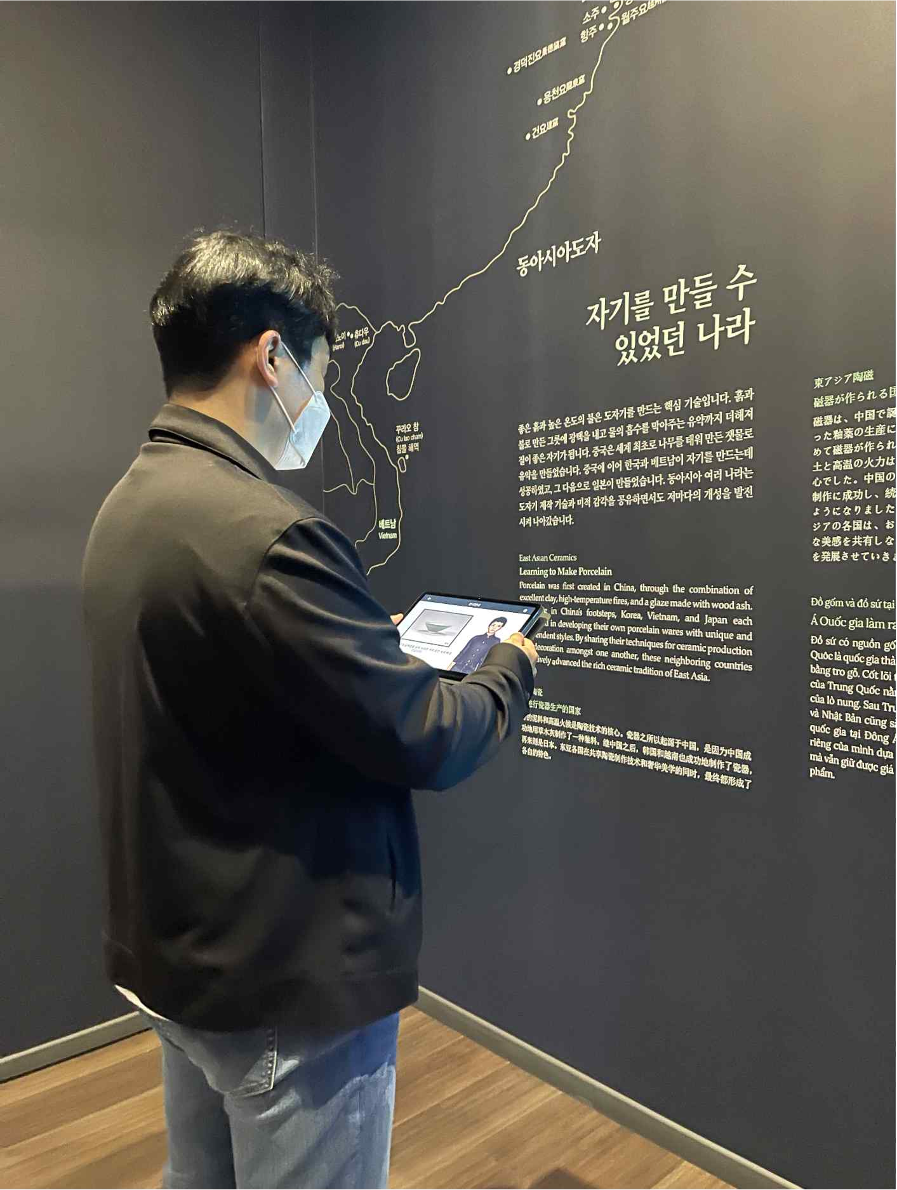
▲ Sign language translation pilot program in the Asian Ceramics
Culture Room, 1st floor of the Gwangju National Museum

GIST (Gwangju Institute of Science and Technology, President Kiseon Kim) Korea Culture Technology Institute (Director Moongu Jeon) demonstrated a 'museum for the hearing impaired' from October 26 to November 7 at the Asian Ceramics Culture Room on the 1st floor of the National Gwangju Museum (Director Sumi Lee) by implementing a pilot program to 'translate explanatory text into Korean sign language translation pilot service.'

The research institute was selected for cultural technology R&D (period: April 2020 ~ December 2022) for the development of subtitle texts and Korean sign language animation conversion technology for descriptions of exhibitions (audio guides) as well as announcements at major cultural facilities.

Accordingly, the Korea Culture Technology Institute has signed a business agreement with the Gwangju National Museum and is promoting a pilot project necessary to develop AI-based cultural infrastructure service technology platform for the hearing impaired.

By constructing a cultural infrastructure sign language DB for sign language translation and 3D motion correction technology developed by the GIST Korea Culture Technology Institute, it succeeded in collecting and implementing accurate sign language motion data, and the result was confirmed through the pilot service.

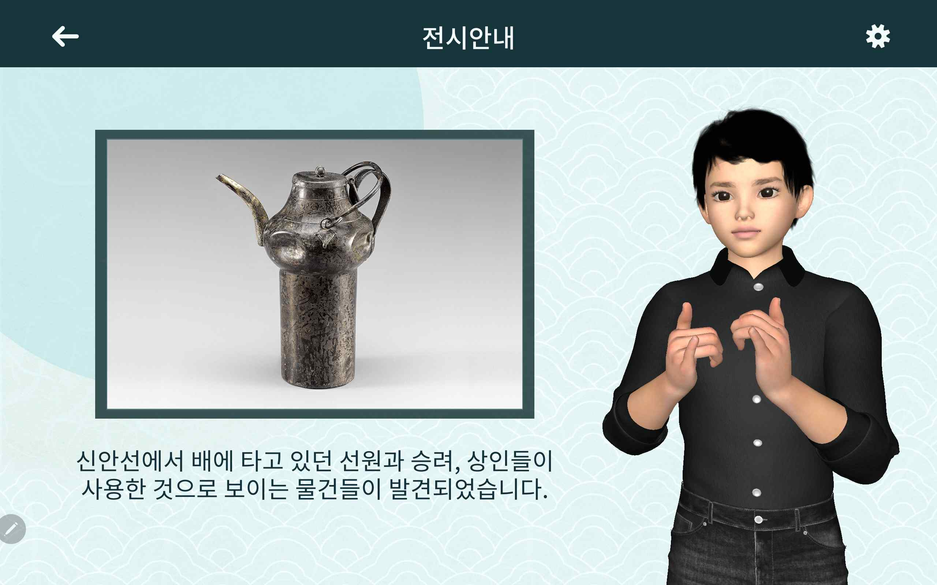
▲ Museum Korean sign language translation application screen

Korea Culture Technology Institute Director Moongu Jeon said, "The purpose of this pilot service at the Gwangju National Museum is to develop technology to provide universal services so that hearing impaired people can enjoy cultural experiences such as museums, art galleries, and exhibition facilities. It is expected that through various cultural services, anyone can enjoy culture without being alienated."

Meanwhile, the GIST Korea Culture Technology Institute provides realistic contents utilizing cultural heritage, including cultural technology research and development policy-designated tasks of the Ministry of Culture, Sports and Tourism and carried out a number of projects such as AI-based art convergence creation and media façade mapping technology and is concentrating on research and development of core cultural technologies to lead the development of the national cultural industry.



