GIST successfully completes preliminary start-up package
for human resources and labor education in the
field of artificial intelligence

- Various programs to strengthen the capacity of
prospective entrepreneurs and create synergy

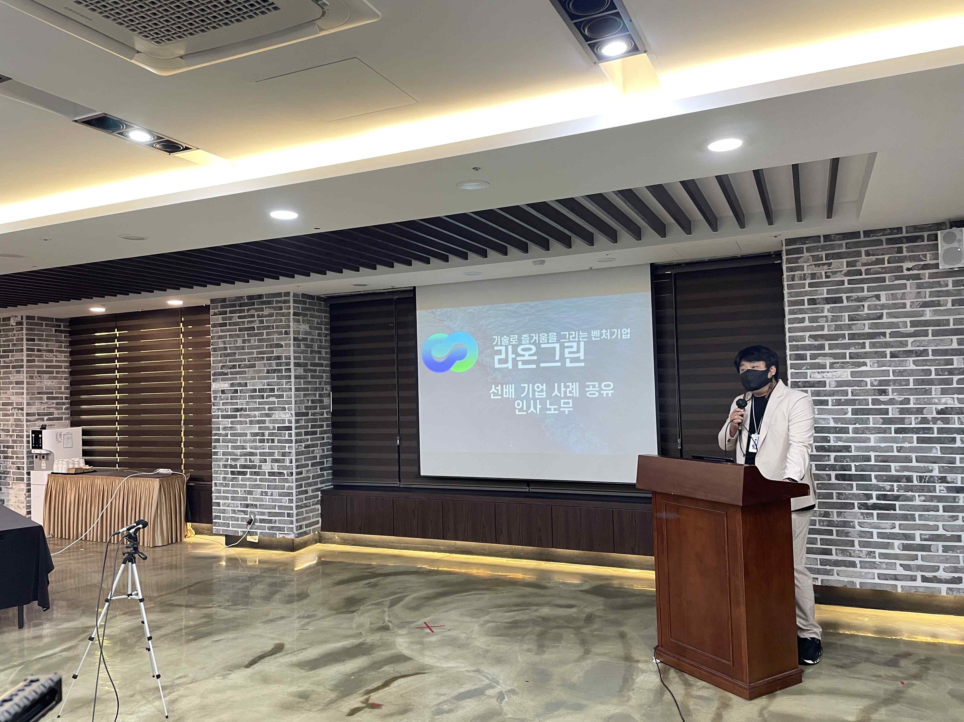
▲ Sharing of human resources and labor practices at
Raon Green as a special lecture for senior companies

GIST (Gwangju Institute of Science and Technology, President Kiseon Kim) successfully hosted the '2021 Preliminary Start-up Package Support Project for Human Resources and Labor Education Seminar' along with four organizations in Honam and Chungbuk regions and the Jeonnam Creative Economy Innovation Center.

In particular, GIST provides preliminary start-up packages specializing in the excellence of business items, focusing on technology using artificial intelligence (AI). By evaluating the possibility of commercialization, GIST provides material and human resources to realize the commercialization of start-ups.

GIST conducted non-face-to-face personnel and labor education necessary for commercialization of start-ups on October 18 and 19, which followed financial and credit education held on September 15 and 16 for a total of 37 prospective start-ups in the field of artificial intelligence.

This training was divided into ▲ human resources and labor management ▲ four major insurance-related regulations and contents that companies should know ▲ special lectures for senior companies ▲ employee management and networking through seminars. The training seminar received a high response from the participants.

GIST Business Incubator Director Byeong-kwan Cho said, "We will do our best to support prospective entrepreneurs until the last training to accelerate their start-up commercialization and serve as a guide to successful start-ups so that prospective entrepreneurs can quickly succeed by reducing trial and error."

As follow-up education, in-depth education for the opening of the Preliminary Start-up Package for 2021 will be held in early November. The program is conducted so that prospective entrepreneurs can select and take the education they want.



