"Safe drinking water for Myanmar refugees!!!" Science and technology community and civil society meet for humanitarian aid in Myanmar

- Hope Water Purifier made by GIST International Environmental
Research Institute will be delivered to refugees in Myanmar

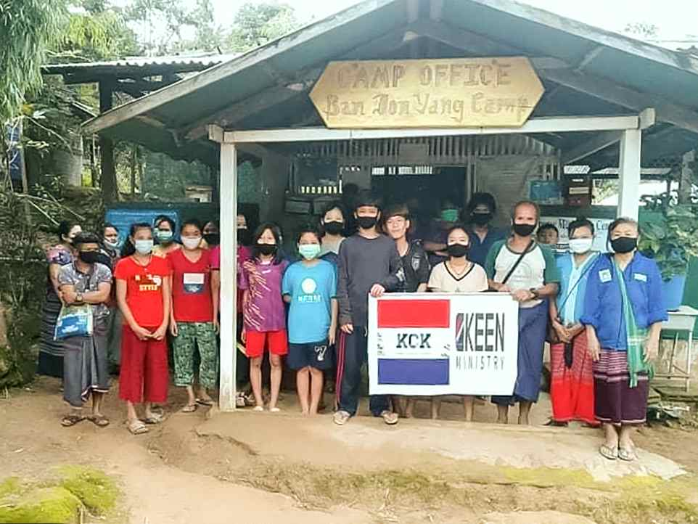
▲ Myanmar evacuation camp to be supported by Hope Water Purifier

GIST (Gwangju Institute of Science and Technology, President Kiseon Kim) International Environmental Research Institute (IERI, Director Kyoung-Woong Kim) decided to participate in 'Myanmar Humanitarian Aid' to provide clean and safe drinking water to refugees in Myanmar by providing Hope Water Purifiers.

In addition, the International Environmental Research Institute began to produce a total of 52 hopeful water purifiers as the Korean National Assembly (a meeting of lawmakers for peace and democracy in Myanmar)* and the science and technology community (Science and Technology Mutual Aid Association, Korea Atomic Energy Research Institute, etc.) expressed their intention to donate 42 hopeful water purifiers.

* Member of Parliament for the Restoration of Peace and Democracy in Myanmar (Steering Committee Chairperson Yong-sun Lee): A gathering of 66 members of the Republic of Korea and opposition lawmakers to organize humanitarian aid TF for Myanmar, international social cooperation TF, public-private cooperation TF, business & industry response TF, etc. Following measures to ensure the living rights of Myanmar students in Korea, the right to study and reside, they are working to promote humanitarian aid from the international community with the health, welfare, and science and technology circles.

The GIST Hope Water Purifier will be delivered to the Myanmar Refugee Camp (IDP) and refugee camps by December of this year in cooperation with the Karen Refugee Committee (KRC) located on the Myanmar-Thailand border.

Myanmar Refugee Committee Chairman Thor Robert (Karen Refugee Agency) said about the water purifier, "This is a necessary relief product for refugees scattered in the jungles of Myanmar," and expressed his gratitude for Korea's solidarity and in sharing it for the relief of refugees in Myanmar.

GIST International Environmental Research Institute cooperates with international research and development to solve environmental problems in developing countries and continues to make significant contributions to the cultivation of environmental experts by strengthening their capabilities and related activities, and it has been actively participating in international climate technology cooperation and response to climate change.

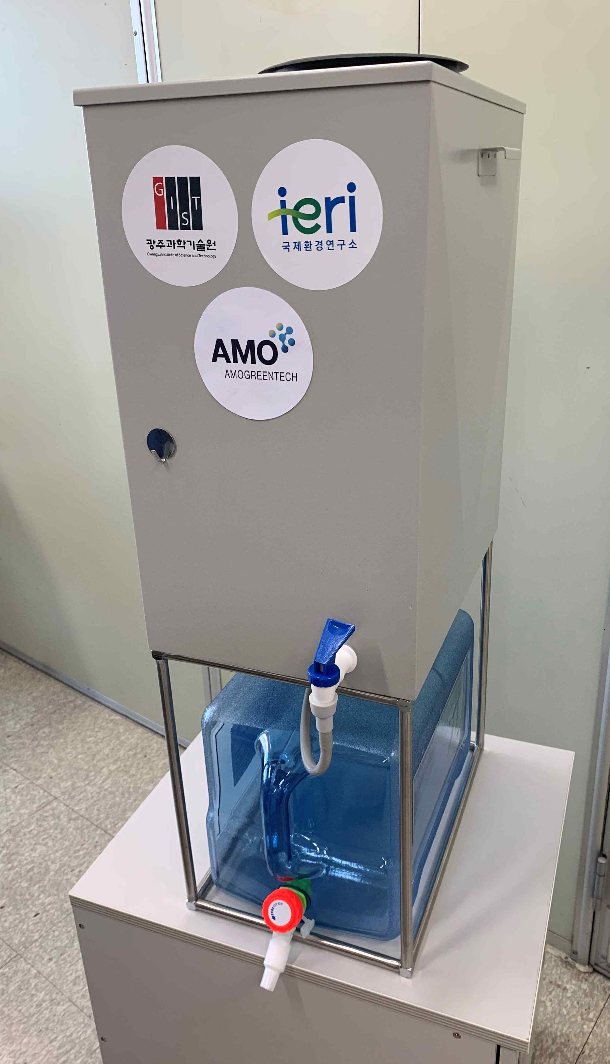
▲ GIST Hope Water Purifier

The Hope Water Purifier is a Gravity-driven Membrane (GDM) filtration water purifying device using the water treatment technology of GIST International Environmental Research Institute and Amogreentech's material technology. It removes particulate contaminants and bacteria present in water with high efficiency. This device does not require a separate electricity supply and can be used continuously for at least 10 years without special maintenance, so it is very useful in disaster areas and refugee areas.

In particular, the Hope Water Purifier, developed with water treatment equipment technology, is a customized small-scale water treatment system that can be optimally combined according to local conditions. Since 2006, 103 units of the Hope Water Purifier have been provided to 17 countries so far.

Director of the Future Talent Bureau of the Ministry of Science and ICT Sang-wook Kang said, "The Hope Water Purifier developed by GIST will be remembered as a good example in which Korean science and technology responded to the people of Myanmar who are having difficulties. It is expected that GIST will be reborn as a symbolic base that not only nurtures future experts in science and technology but also contributes to solving local community problems and responding to global issues."

On the other hand, this support for Myanmar refugees during this period of water purification was proposed and supported by Yong-bin Lee, a member of the National Assembly (Gwangju Gwangsan Gap, Gubangwi, Myanmar National Assembly member's committee member), who heard the news that local citizens in Myanmar who have lost their livelihoods due to the military coup are suffering from water shortages.



