GIST conducts joint research with MIT
in the field of artificial intelligence

- Research agreement with MIT CSAIL signed to carry out AI convergence research worth 20 billion won by 2025 along with final selection for joint research projects

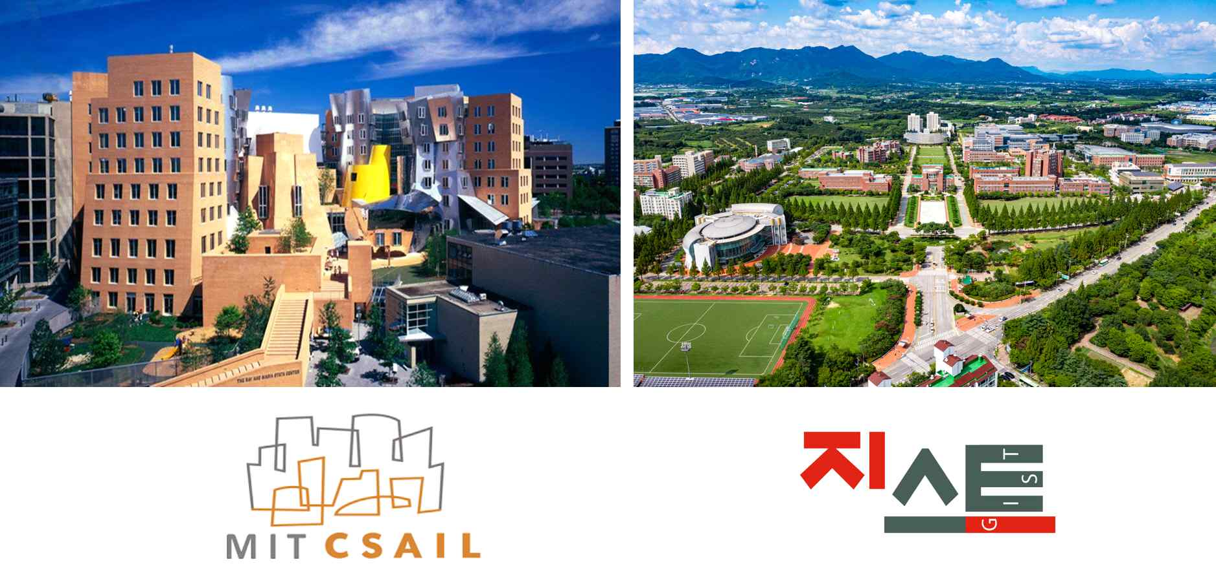
▲ MIT Computer Science and Artificial Intelligence Laboratory (CSAIL) and GIST

GIST (Gwangju Institute of Science and Technology, President Kiseon Kim) recently signed a research agreement with the Massachusetts Institute of Technology (MIT) Computer Science and Artificial Intelligence Research Center (CSAIL, Director: Daniela Rus) for international joint research in the field of artificial intelligence, and six research projects to be carried out for five years were finally selected.

With this agreement, GIST and MIT plan to promote the development of national science and technology and the improvement of research capabilities of both institutions in the field of artificial intelligence through artificial intelligence-based joint research and human resource exchange.

Through this research agreement and joint research project selection, the two institutions will promote joint research worth KRW 20 billion for a total of 5 years until 2025 as part of the AI international cooperation project. Through human resource exchanges with post-docs (post-doctoral researchers) and graduate students who participate in research projects, GIST plans to focus our efforts on nurturing experts in the AI field.

For the joint research of the GIST-MIT AI international cooperation project, a research group consisting of 2-3 research directors and participating researchers from both institutions form a research group in a matching area to maximize the synergy effect of AI convergence research. This is a science and technology research exchange project between Korean and American universities to conduct joint research projects.

Since last April, GIST Professors SeungJun Kim, Jin Hyuk Hong, Kyung-Joong Kim and MIT Professors Wojciech Matusik and Daniela Rus have formed a research team to develop 'HCI + AI for Human-Centered Physical System Design' as a pilot research project worth 600 million won annually.

While carrying out the pilot project, GIST concluded a final research agreement with MIT in August after discussing various ways of cooperation for several months. A total of 27 projects were supported in the task announcement for the additional selection of 5 joint research groups. In particular, the number of projects supported by MIT was 15, which shows their high interest in joint research with GIST.

The additionally selected tasks include convergence research (AI for X) that can create high synergy using AI technologies such as robotics, life science, and energy, as well as computer vision and artificial intelligence fields. In particular, world-class scholars from MIT will participate in the GIST-MIT joint research project as project managers and conduct research for 5 years.

GIST President Kiseon Kim said, "The international cooperation project with MIT is expected to greatly contribute to developing AI experts as well as the sharing of excellent research know-how in the field of artificial intelligence. We will do our best to cooperate to maximize the synergy effect of the creative and innovative research between the two institutions."

Meanwhile, the MIT Computer Science and Artificial Intelligence Laboratory (CSAIL) was created in 2003 when the MIT Computer Science Lab and the Artificial Intelligence Lab merged. It is the largest single laboratory at MIT.

CSAIL has more than 900 researchers and has produced 10 Turing Prize winners, which are called the Nobel Prizes for computing. The annual research cost is approximately KRW 76 billion, and active research is being conducted in the field of artificial intelligence such as algorithms & theory, AI & ML, graphics & vision.

