GIST is planning to build the largest
HPC-AI public infrastructure in Korea

- GIST selected as a public infrastructure construction project for the creation of an artificial intelligence-centered industrial convergence cluster with a total project cost of KRW 14.2 billion

- Industry-university-research support and activation by
building HPC-based AI computing infrastructure

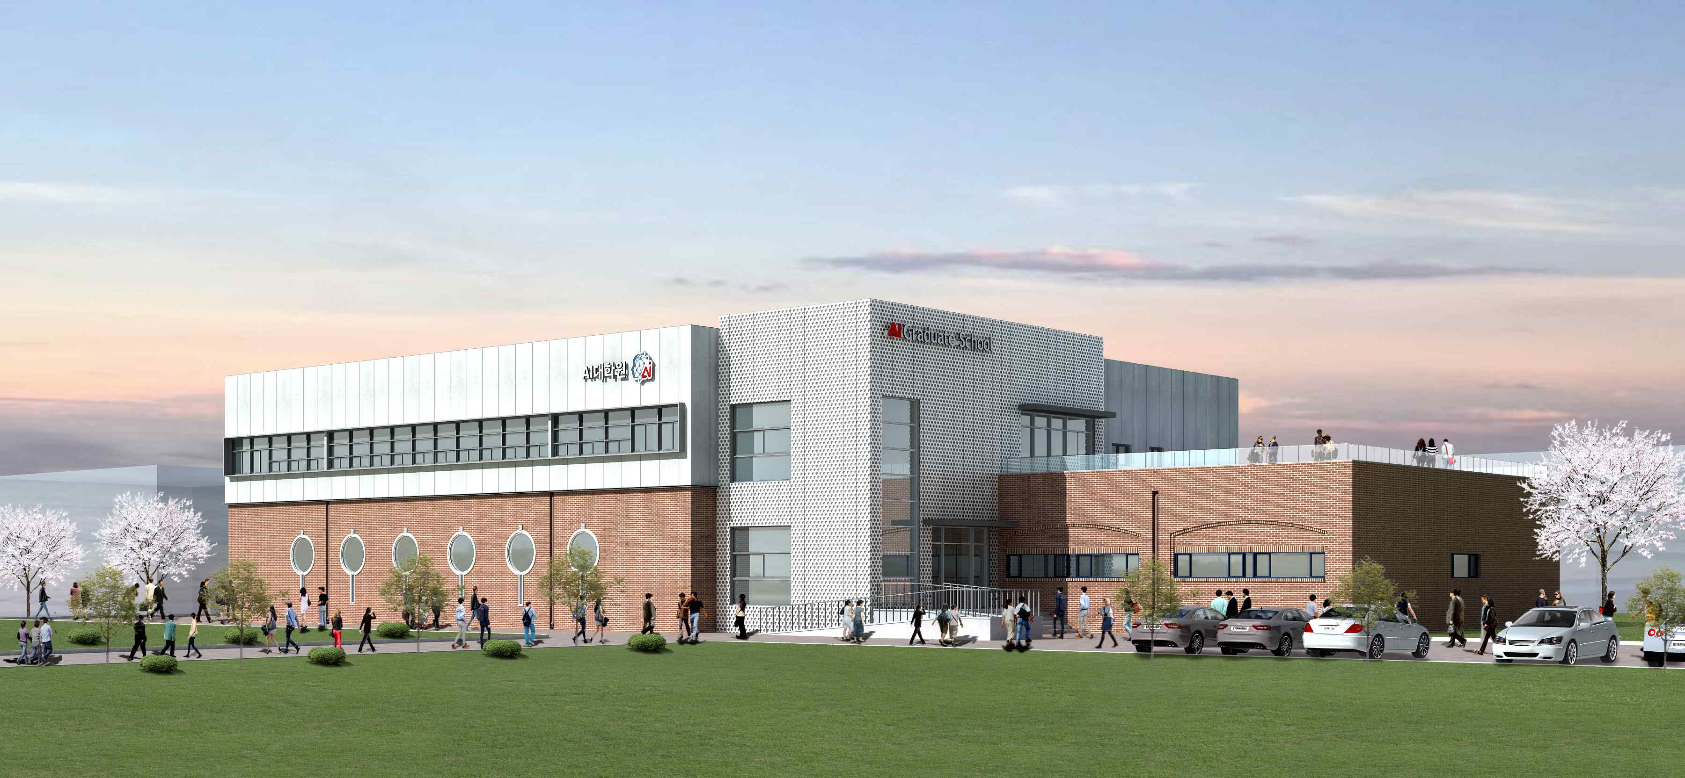
▲ G-I-S-T Data Center

Amid heated competition among global industry-academia research institutes to build large-scale HPC (High Performance Computing)-based AI computing infrastructure, a pilot supercomputing center in Gwangju, an artificial intelligence-oriented city, will be operated in earnest through the establishment of HPC/AI/HPDA (High-Performance Computing/Artificial Intelligence/Hight-Performance Data Analytics) infrastructure* for AI convergence research, education, and corporate support.

* HPC/AI/HPDA (High-Performance Computing/Artificial Intelligence/Hight-Performance Data Analytics) infrastructure: a multi-purpose AI computing infrastructure that integrates/converges high-performance computing and big data analysis into one

GIST (Gwangju Institute of Science and Technology) announced that it was selected as the host organization for the HPC-AI (High Performance Computing-Based AI) public infrastructure construction project hosted by the Ministry of Science and ICT, the Information and Communication Industry Promotion Agency, and the Artificial Intelligence Industry Convergence Project Group.

In August, as part of the artificial intelligence-oriented industrial convergence complex construction project, the Artificial Intelligence Industry Convergence Project Group (Director Chasik Im) announced the largest HPC-AI public infrastructure construction project (business period: 21-23 years, performance management period: 24-27 years) and selected an operating institution.

The final goal of this project is to contribute to the revitalization of the industry-university-related artificial intelligence ecosystem through the establishment of a public infrastructure based on HPC-AI. It is expected to serve as a starting point for international joint research with domestic and foreign industry, academia, and government organizations that are interested in the infrastructure of the artificial intelligence complex located in the high-tech district of Gwangju Metropolitan City.

For the successful implementation of this project, GIST is ▲ building HPC-AI public infrastructure facilities that can be used jointly for the purpose of AI convergence research, education, and corporate support ▲ realizing operational independence through sustainable public infrastructure service operation and maximization of utilization ▲ planning to provide various business opportunities and collaboration between large and small businesses by creating a foundation for data and leading AI model production and distribution.

GIST is currently working on a 100-Rack G-I-S-T Data Center* facility in the AI Graduate School space on campus with the goal of opening it early next year. In addition, HPC-AI public infrastructure that supports GPU nodes with 6 PFlops (32-bit standard) computational capacity and storage nodes with a total storage capacity of 10 PByte, which are tightly coupled and interlocked with 200 Gbps ultra-high-speed fiber optics, and aims for 99.9% utilization based on automated integrated management. Construction and operation of the equipment will be completed in stages by the end of the year.

* G-I-S-T Data Center: Green-Intelligent-Sustained-Technical concept-oriented smart green data center

The established HPC-AI public infrastructure will be used to support AI computing for research and education through cooperation with AI convergence universities and to provide customized HPC-AI computing services for domestic industry-university research institutes and global partners who need large-scale learning.

In addition, in order to achieve operational independence through the creation of a profit model, the company plans to expand the HPC-AI infrastructure capacity by attracting national ultra-high-performance computing regional hub-type specialized centers, upgrade demand-tailored services, and attract sustainable global partners.

GIST AI Graduate School Director JongWon Kim and Director of the Supercomputing Center said, "We will do our best to contribute to the creation of a virtuous AI ecosystem by creating customized services for domestic industry-university-related companies. It is expected that the GIST Supercomputing Center will be able to contribute to basic research and industrial technology development for the growth of the national science network."

As GIST was selected for the public infrastructure construction project following the AI convergence university project announced by the AI Industry Convergence Project Group earlier this year, it substantially contributes to the artificial intelligence-centered industrial convergence cluster construction project, regional innovation and job creation through artificial intelligence, and development of advanced AI specialists.



