GIST International Environmental Research Institute participates in science and technology sessions at the 2021 Yeosu Summit

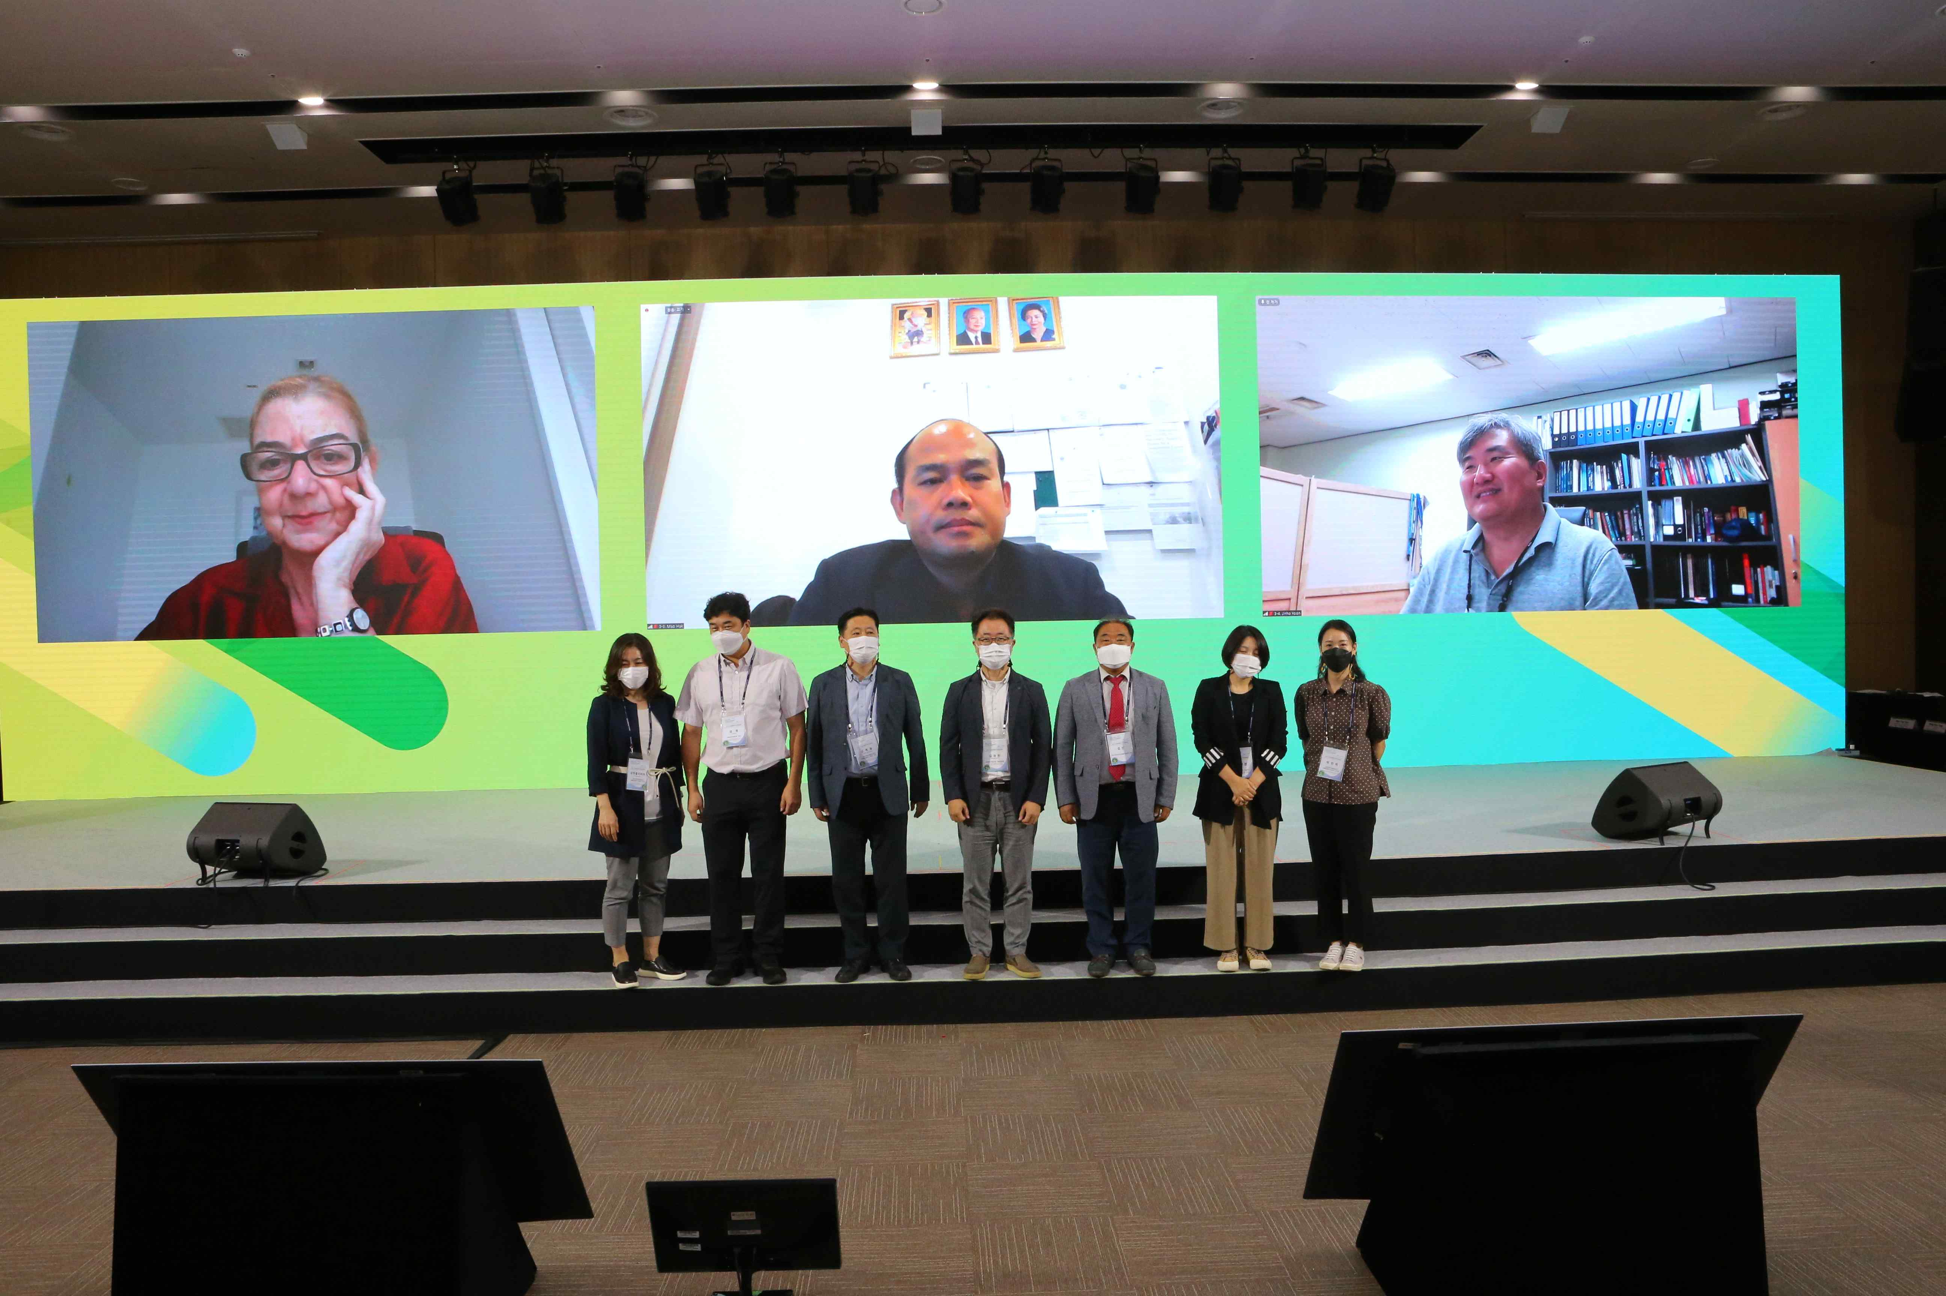
▲ 2021 UEA Yeosu Summit: Science and Technology Session

GIST (Gwangju Institute of Science and Technology) International Environment Research Institute held the 'Climate Crisis Adaptation and Science and Technology' session at the 2021 Yeosu Summit (hosted by Yeosu City and the UEA* Secretariat), which was held at the Ocean Expo in Yeosu on the afternoon of the 30th of last month, sharing its vision for realizing a carbon neutral society.

* UEA (Urban Environmental Accords): 156 member city associations in 51 countries operated by the International Climate Environment Center and hosts the "UEA Summit," a regional-level international conference, every other year.

The adaptation to the climate crisis and science and technology session examined the reality of North Korea, which is vulnerable to the climate crisis and worsening health conditions due to food shortages, marine oxidation, and natural disasters caused by climate change such as temperature rise and sea level change.

In addition, through modeling it warned of the seriousness of the climate crisis by predicting the frequency of large-scale fires and heavy rains caused by climate change that occurs whenever the global temperature rises by 0.5C as well as changes that the utilization of renewable energy and smart farms will bring to daily life in response to climate change.

In addition, global trends and efforts on climate crises, especially the climate change adaptation projects of the United Nations Framework Convention on Climate Change (UNFCCC) and the Climate Technology Center Network (CTCN) carried out in Southeast Asia, as well as the climate change situation and current status in Cambodia, were examined.

An official from the GIST International Environmental Research Institute, which hosted the science and technology session, said, "Through this, we hope that it will contribute to the vision and efforts to realize carbon neutrality and further contribute to attracting COP 28 in the south-central region of the southern coast."



