GIST completes intensive training customized to the specialized field of preliminary startup packages

- Various programs are provided to strengthen the capabilities
of prospective entrepreneurs and to create synergies

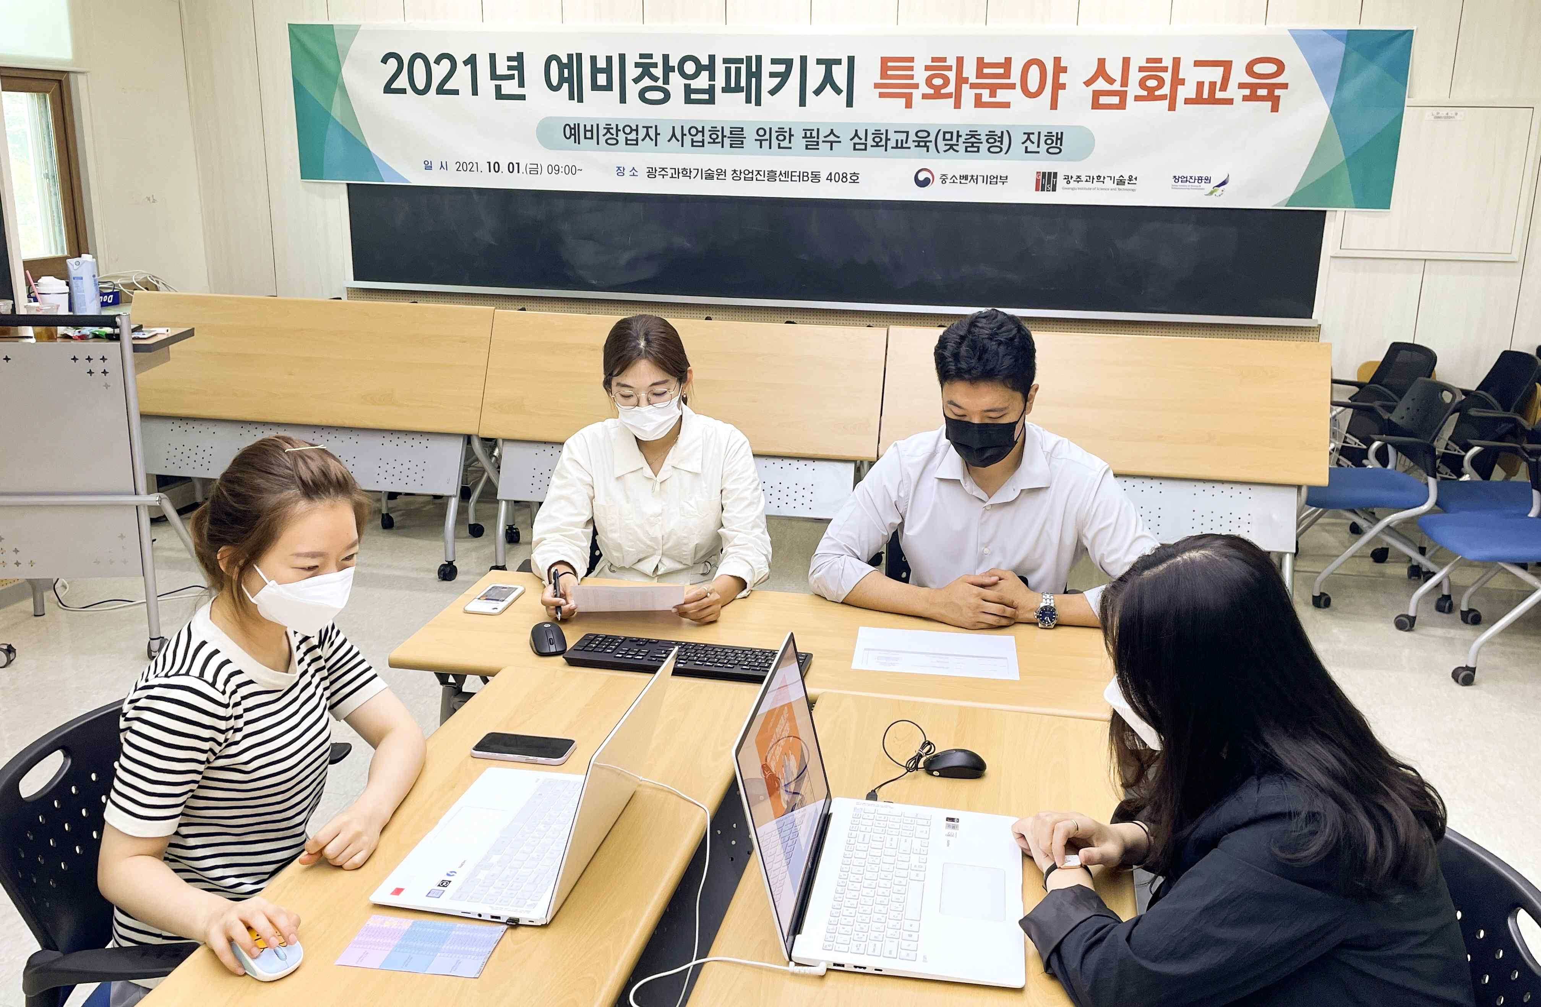
▲ In-depth education for preliminary startup packages in 2021

GIST (Gwangju Institute of Science and Technology) supports and manages projects specializing in pre-startup packages for 2021, and has successfully completed ‘intensive training tailored to preliminary startup packages for 2021’ by actively utilizing the infrastructure of the Gwangju area.

GIST provides material and human resources to achieve business start-up commercialization by evaluating the excellence and commercialization potential of business items with a focus on technology using artificial intelligence.

The specialized field of the preliminary startup package hosted by GIST is the artificial intelligence (AI) field. Following the capacity building training conducted in July for a total of 37 selected prospective entrepreneurs, a customized in-depth course was conducted as a non-face-to-face lecture on October 1 (Fri).

Customized in-depth education was divided into lecture-type and mentoring-type for ▲ Marketing & Branding (Persuasion Communication, TPCM Model) ▲ IR Education (Fitch deck composition and production, IR pitching to persuade investors) ▲ understanding investment and VC investment (investment attraction strategies through actual cases, and advice on startups).

GIST Business Incubator Director Byeong-kwan Cho said, "For high-quality education, instructors with high satisfaction from founders were assigned for in-depth education. Through various start-up education programs, we will do our best to support prospective entrepreneurs so that they can achieve successful start-up commercialization."

As follow-up education, in-depth education for the 2021 preliminary start-up package will be held at the end of October. The training is conducted in such a way that the education planned by the organizations in charge of the preliminary start-up package is put into one online platform and the prospective entrepreneurs select and listen to the education they want.



