GIST Academy hosts the September Breakfast Forum, 'Cognitive Psychology for Happy Old Age: The Benefits of Aging'

- GIST Professor Wonil Choi presents various
and valid methods for meaningful aging

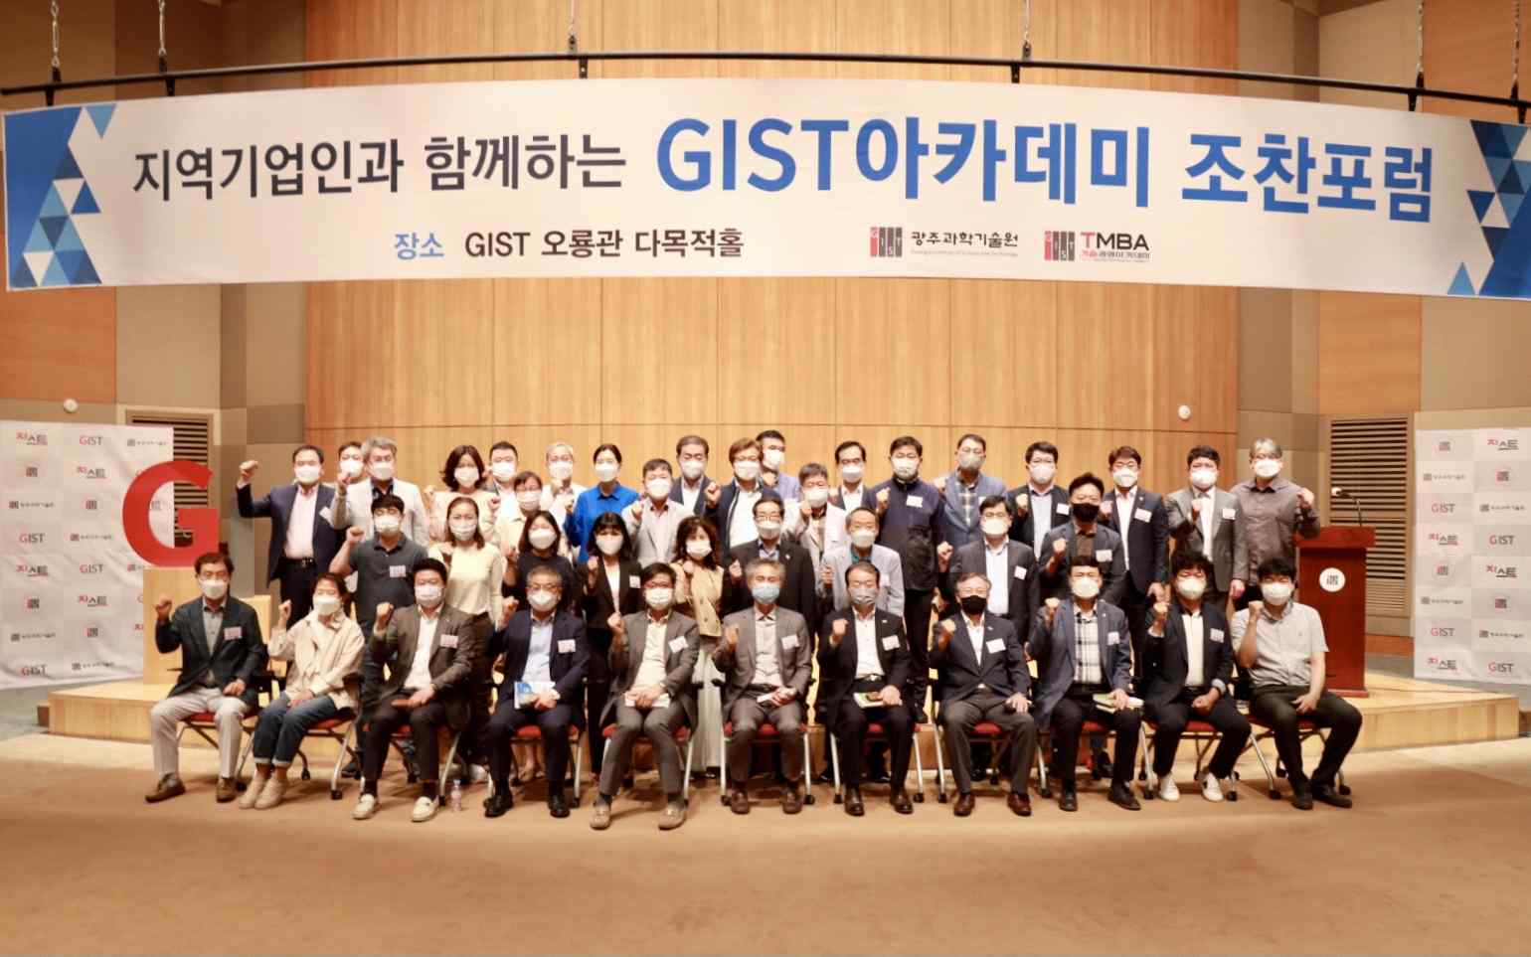

GIST (Gwangju Institute of Science and Technology) Academy held the September Breakfast Forum under the theme of 'Cognitive Psychology for Happy Old Age: Benefits of Aging' at Oryonggwan on September 27 with about 40 representative business people from Gwangju and Jeonnam regions in attendance.

During the forum, GIST Division of Liberal Arts and Sciences Professor Wonil Choi drew a lot of attention by introducing interesting research results on how to live a meaningful life in old age by coping with cognitive and emotional changes due to aging.

Professor Wonil Choi introduced some misconceptions about life in old age and talked about the importance of walking as a physical activity and reading as a mental activity for a healthy and meaningful old age.

He also emphasized that "there are more things that can be done now than you realize for a meaningful life in old age," and explained, "For this, it is most important to have a psychologically healthy mindset."

Professor Wonil Choi published the translated book 'The Benefits of Aging (published by GIST PRESS)' containing various research results and practical guidelines for successful aging.

Professor Choi received his doctorate in cognitive psychology from the University of North Carolina's Chapel Hill campus in the United States and is conducting research on what happens to the eyes and brain when humans think, understand language, and speak. He recently expanded his field of interest to the interaction between humans, machines, and society.

Meanwhile, on the last Monday of every month, the GIST Academy Breakfast Forum provides opportunities for awareness innovation, technology transfer, and industry-university cooperation through lectures by experts from various fields for alumni and local business executives.

GIST Academy operates two courses: GIST Techno Management Business Academy (opened in 2010) and GIST Climate Change Academy (opened in 2016). It is contributing to the vitalization of the local economy and industry-university cooperation by cultivating skills and forming a wide human network.



