GIST completes preliminary start-up package support seminar for finance and credit education in the field of artificial intelligence

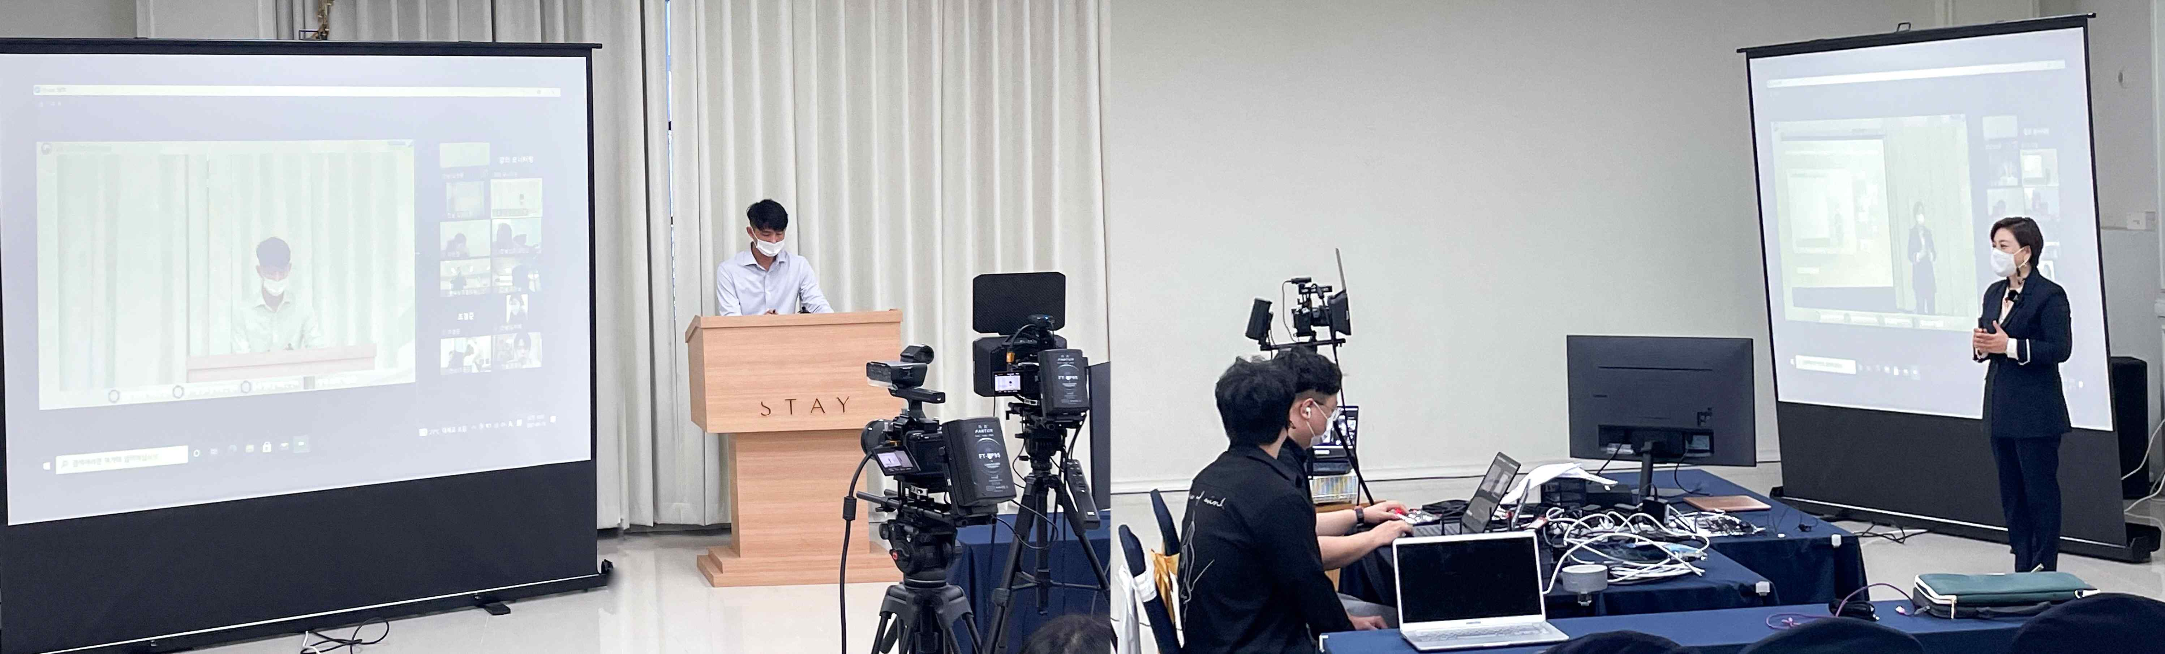
▲ 2021 Preliminary Start-up Package Support Project
Seminar for Finance and Credit Education

GIST (Gwangju Institute of Science and Technology) and five leading organizations in the Honam and Chungbuk regions successfully hosted the '2021 Preliminary Start-up Package Support Project Seminar for Finance and Credit Education,' which was co-hosted by the Gwangju and Jeonnam Small and Medium Venture Business Administrations.

In particular, GIST specializes in the field of preliminary start-up packages, focusing on technology using artificial intelligence (AI), evaluating the excellence of business items and commercialization potential, and providing material and human resources to commercialize start-ups.

The training was well-received and included ▲ financial education and credit management ▲ funding using guarantees ▲ education on using the online corporate systems ▲ specifying the start-up financing method.

GIST Business Incubator Director Byeong-kwan Cho said, "Even though it is a difficult time to start a business than ever before, we will serve as a guide for successful start-ups so that prospective entrepreneurs can quickly succeed in starting a business by reducing trial and error."

Meanwhile, personnel appointments, labor education, and mentoring for the 2021 preliminary start-up package seminar will be held in mid-October as follow-up training. The program covers the HR management system, labor law system and composition, the four major insurances, experiences of senior companies, and sharing employee training know-how.

