GIST signs a business agreement
to revitalize laboratory start-ups

- Angel Investment Association promotes cooperation with Angel Investment Hub in the Honam region to revitalize the "public technology-based market-linked start-up search support project"

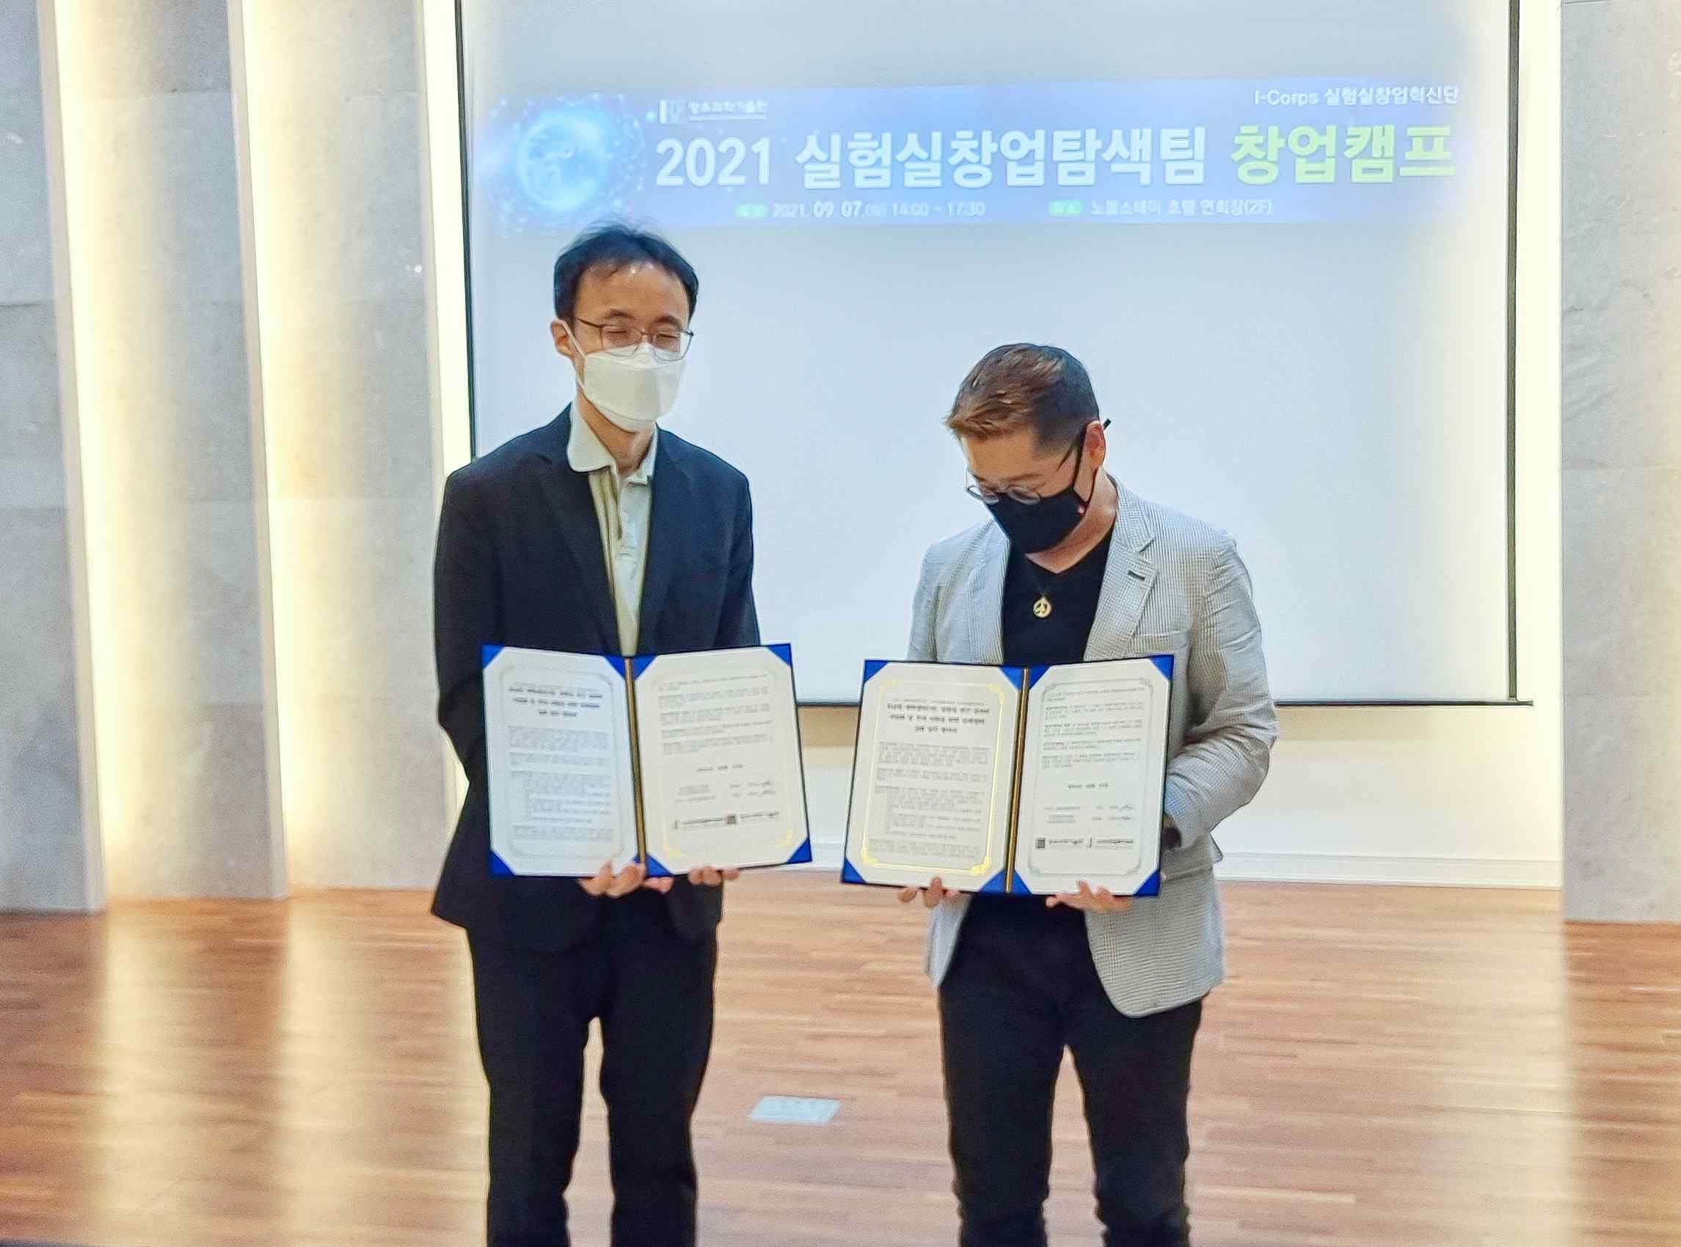
▲ From the left, Professor Jin Ho Kim, head of the GIST Entrepreneurship Education Center, and Il-kwon Seo, head of the Angel Investment Hub
in the Honam region of the Angel Investment Association

GIST (Gwangju Institute of Science and Technology) Institute of Integrated Technology's Entrepreneurship Education Center (Director Jin Ho Kim) recently signed a business agreement with Angel Investment Hub (Director Il-kwon Seo) with the Honam region of the Angel Investment Association to revitalize the "public technology-based market-linked start-up search project."

The agreement is for the purpose of revitalizing public technology-based market-linked start-up search support projects, and includes: ▲ matters for the commercialization and investment support of research results of universities and research institutes in Honam area and vitalization of local start-ups ▲ cooperation in holding startup events such as startup-related festivals, seminars, and investment programs ▲ establishing a human and material infrastructure cooperation network to revitalize local start-ups ▲ mutually agreed upon matters necessary for other contracting organizations.

According to this business agreement, each institution will actively discover and support prospective start-ups in the Honam area, and establish a network that can actually be established in connection with various start-up support programs.



