GIST partners with CJ OliveNetworks to open a research center for AI industry development in Gwangju

- For cooperation in industrial development such as joint research on artificial intelligence for the development of AI industry in Gwangju, providing internships, and preferential hiring of local residents

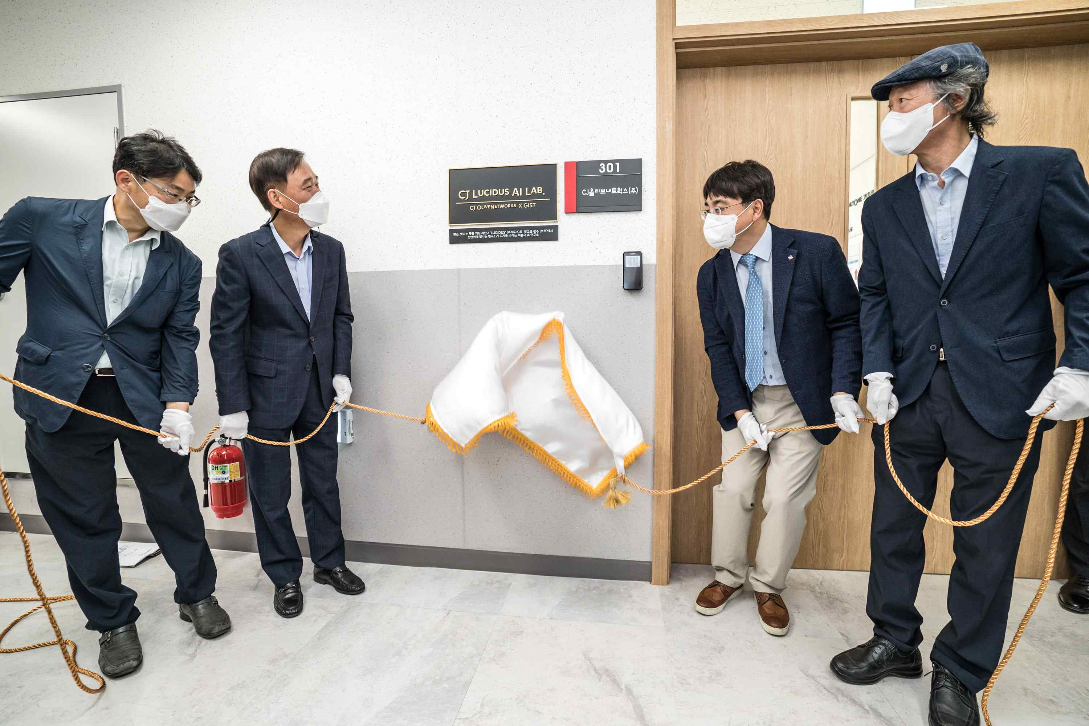
▲ (From left) Ministry of Employment and Labor Director of Vocational Competency Policy Hong-seok Song, Vice Minister of Employment and Labor Hwa-jin Park, CJ OliveNetworks CEO In-hyuk Cha, GIST Acting President Jong-in Song

GIST (Gwangju Institute of Science and Technology, Acting President Jong-in Song) will open a research institute for the development of the artificial intelligence (AI) industry in Gwangju Metropolitan City in partnership with CJ OliveNetworks (CEO In-hyuk Cha).

This research institute is the second research institute following the DT Research Center located at the headquarters of CJ OliveNetworks. It resides in the GIST Industry-University Cooperation Building, and the name of the lab is 'CJ Lucidus AI Lab' with the hopes of becoming a brilliantly shining research institute in the village by using the Latin word 'LUCIDUS,' which means 'bright' or 'shining.'

The opening ceremony of 'CJ Lucidus AI Lab' was held at GIST on August 31 in the presence of major officials, including Vice Minister of Employment and Labor Hwa-jin Park, GIST Acting President Jong-in Song, and CJ OliveNetworks CEO In-hyuk Cha.

Starting with the opening ceremony of the second research center on this day, GIST will strengthen its business competitiveness with CJ OliveNetworks by strengthening the AI technology research field and jointly begin research on AI source technology for the development of the artificial intelligence industry.

In addition, to create local jobs, there will be ▲ cooperation with K-digital training courses ▲ internship opportunities for outstanding trainees ▲ priority hiring in the AI R&D field for specialists in Gwangju.

Previously, in April, GIST signed a business agreement with Gwangju City and CJ OliveNetworks to foster the artificial intelligence industry. The opening of the second research institute was also promoted as part of a three-party business agreement. Currently, GIST is cooperating with the development of the local AI industry by jointly participating in the 'K-Digital Training,' which is a project hosted by the Ministry of Employment and Labor to nurture personnel in the field of new digital technologies.

Based on systems and networks for opening external computing resources, GIST decided to establish an open innovative education system by actively utilizing CJ OliveNetworks' dataset and IT-based curriculum operating system. In particular, it aims to provide an educational environment that can respond to future social job transitions for all citizens interested in artificial intelligence.

GIST Acting President Jong-in Song said, "It is expected that GIST, which has excellent educational and research capabilities, and CJ OliveNetworks, which plays a pivotal role in CJ Group's AI business, will create synergy for AI industry-university development in earnest through the establishment of this second research institute. We will do our best to cooperate to nurture talented people and create jobs for the artificial intelligence industry."

CJ OliveNetworks CEO In-hyuk Cha said, "I believe that the development of the artificial intelligence industry and the nurturing of future specialists in the Gwangju region are directly related to the improvement of national competitiveness. We will conduct AI source technology research jointly with Gwangju City and GIST, who have provided support and cooperation for the launch of the second research institute, and we will also contribute to creating local jobs through internships and recruitment in the AI field."

Ror the successful operation of the K-Digital Platform, prior to the opening ceremony, the government, GIST, and companies (CJ OliveNetworks, Megazone, Dream Ace, Korean Artificial Intelligence Association) will establish a cooperative system and provide various services needed by young people. It was decided to promote activities such as providing job opportunities and spreading a youth recruitment culture.

'Dreaming AI,' a digital talent training course for young job seekers promoted by the GIST K-Digital Platform, contributed to the improvement of job competency and employment potential of local young people, becoming the first member of the 'Youth Employment Support Project' membership to join as a consortium model. GIST plans to foster a total of 11,350 young digital talents over the next five years.



