GIST hosts the 2021 Creative Convergence Contest

- Innovative table tennis robot development and
campus EMS development contest held

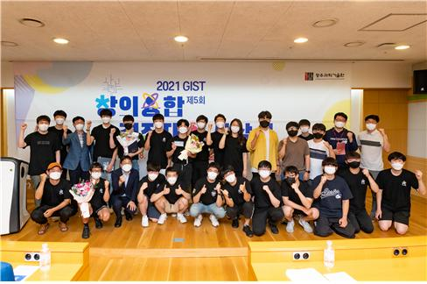▲ 2021 Creative Convergence Contest: Group photo of participating students

GIST (Gwangju Institute of Science and Technology) held a contest to dramatically enhance practical convergence education required in the era of the 4th Industrial Revolution.

GIST Institute of Integrated Technology (President Chanho Park) held the '2021 Creative Convergence Competition' (managing professor: Institute of Integrated Technology Professor Jung Won Yoon) and conducted two tracks: 'Table Tennis Robot Contest' and 'Campus EMS* Development Contest.'

* EMS: Energy Management System

This contest was prepared to provide an opportunity for participating students to develop a sense of cooperation and collective creativity required in the era of the 4th Industrial Revolution by conducting joint research in teams of three or four students. In addition, professors and graduate students from the Institute of Integrated Technology served as mentors for each team and provide practical help such as on-site guidance and advice.

This year 32 GIST undergraduate students formed a total of 11 teams to participate during summer vacation and devoted themselves to the development of innovative table tennis robots and algorithms for two months.

The 'Table Tennis Robot Contest' was a method of competing for rankings by performing challenges. The table tennis robot hit the table tennis ball from the table tennis machine, and the table tennis robot and the participating students played a table tennis match.

The 'Campus EMS Development Contest' is a contest to develop a load prediction algorithm, solar power generation prediction algorithm, and electricity rate minimization algorithm based on the data provided by the organizers and determines ranking by calculating load prediction error rate, solar power error rate, and electricity bill.

The final competition, which selected the final winners of the two tracks, was held on August 20, and the awards ceremony was held on August 23 at the Dasan Building.

▲ 2021 Creative Convergence Contest: Group photo of the awards ceremony

The championship went to the 'King of Table Tennis Kim Tak-gu' team, which consisted of students Lim-um Kim and Chae-hoon Song who won the grand prize with the highest score in the 'Table Tennis Robot Contest' and was awarded a certificate and a cultural gift certificate worth 2 million won.

▲ 2021 Creative Convergence Contest: 'King of Table Tennis Kim Tak-gu'

The Outstanding Award went to the 'Mechanical Engineering Student's Favorite Chicken is Whining Chicken' team (students Joon-young Lee, Bu-yong Lim, Song-min Jung, and Ye-jin Yang). The three teams receiving the Encouragement Award were 'Maron's Disciples' team (students Jin-hyuk Park, Young-bin Shim, Chang-eun Park, Jae-won Kim), 'Weight 2.7g' team (students Ha-rim Park, Boo-nam Cho), and 'Gwangju Electric Power Corporation' team (students Dong-hoon Kim, Kyo-joon Koo, Tae-hyun Kim, and Yoo-jin Ahn).

GIST Institute of Integrated Technology Professor Jung Won Yoon said, "The event was held in the form of a competition using a convergence research theme combining artificial intelligence and hardware (robots), which resulted in very high students' enthusiasm and interest in participation for participation. This is expected to provide a new education platform that can nurture the challenging spirit and convergence specialists needed in the era of the 4th Industrial Revolution."

This event, which started in 2017 and celebrated its 5th anniversary this year, introduces new and diverse methods unique to the GIST Creative Convergence Contest, outside the framework of many competitions held at home and abroad so far. This year, it was held at GIST for two months from July to August 20.



