GIST holds graduation ceremony
for the second half of 2021

- Online-focused degree conferment ceremony with178 graduates

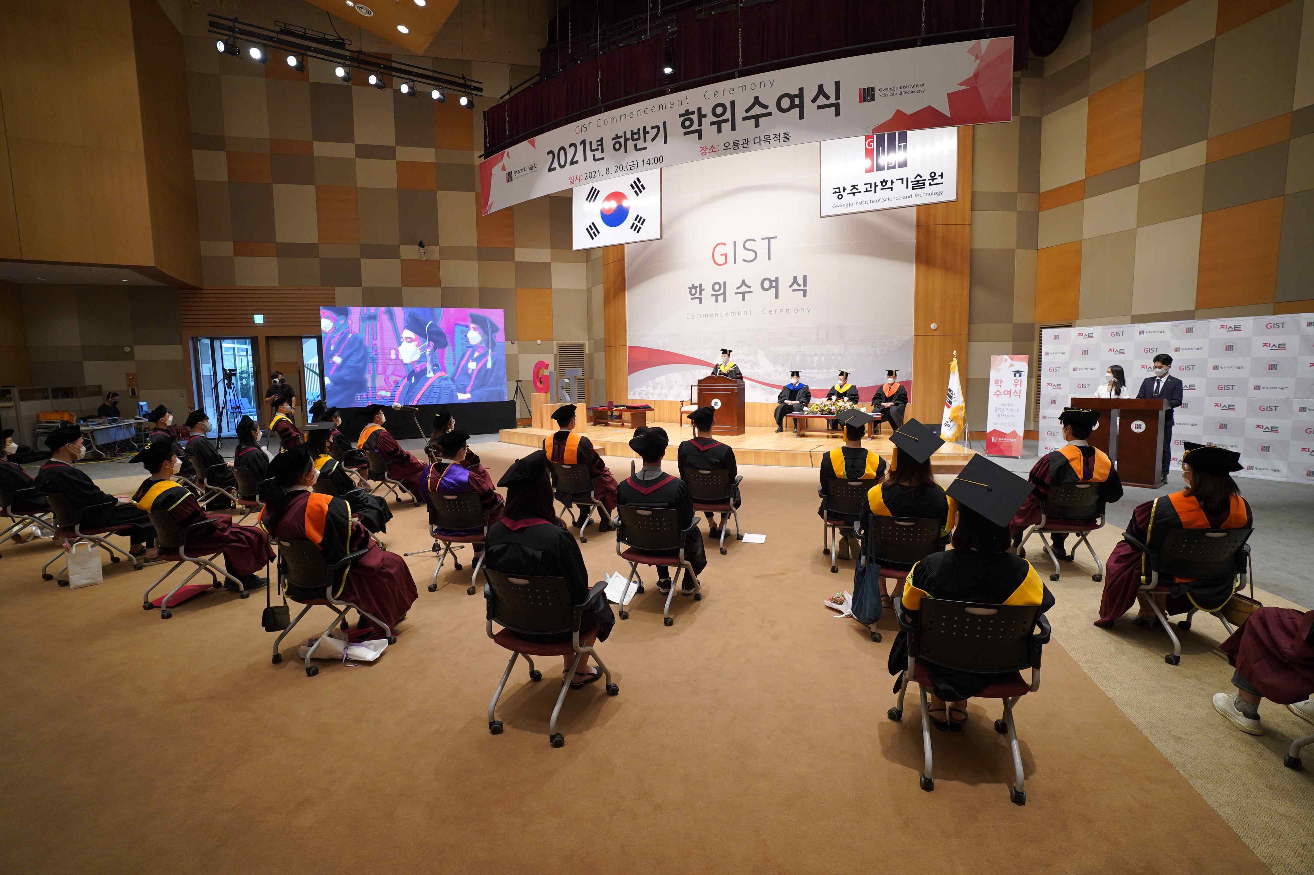
▲ [Photo] GIST holds degree conferment ceremony in the second half of 2021

GIST (Gwangju Institute of Science and Technology) held a graduation ceremony for the second half of 2021 at Oryong Hall on August 20 (Friday) and awarded degrees to a total of 178 students, including 58 PhDs, 74 masters, and 46 bachelors.

Since its establishment in 1993, GIST has produced a total of 6,991 advanced scientific and technological personnel, including 1,589 PhDs, 4,536 masters, and 866 bachelors.

To prevent the spread of COVID-19, the graduation ceremony was held as an online-oriented event with a minimum number of attendees, including major officials, excellent degree conferees, and graduate representatives, just like the degree conferment ceremony in February.

Degree recipients and parents who were unable to attend the event were able to watch the graduation ceremony through YouTube real-time streaming.

At the graduation ceremony, Dean Chunghee Cho said, "In the midst of many changes in academic management due to the aftermath of COVID-19, I am proud and proud of all of you who overcame all the difficulties and received the honor of graduating. After graduation, I hope that you will take on challenges with pride and courage with GISTian's passion and ambition at the starting point to realize your new dream."

An average of about six papers were published in SCI (Science Citation Index) registered journals by 58 PhD recipients during their school years with an average of 2.45 papers as first author and 3.08 papers as co-author.

GIST ranked 4th in the world this year (1st in Korea for 14 consecutive years) in the category of 'citations per faculty,' which shows the academic influence of the institution's research capabilities and research results.

GIST not only plays a key role in the Gwangju AI cluster creation project, but also has been recently selected as an AI convergence university along with the stable operation of the AI graduate school. It is faithfully carrying out its establishment goals.



