GIST Techno Management Business Academy
Golf Club provides scholarships to the Gwangju Metropolitan City Rehabilitation Association
for the Disabled

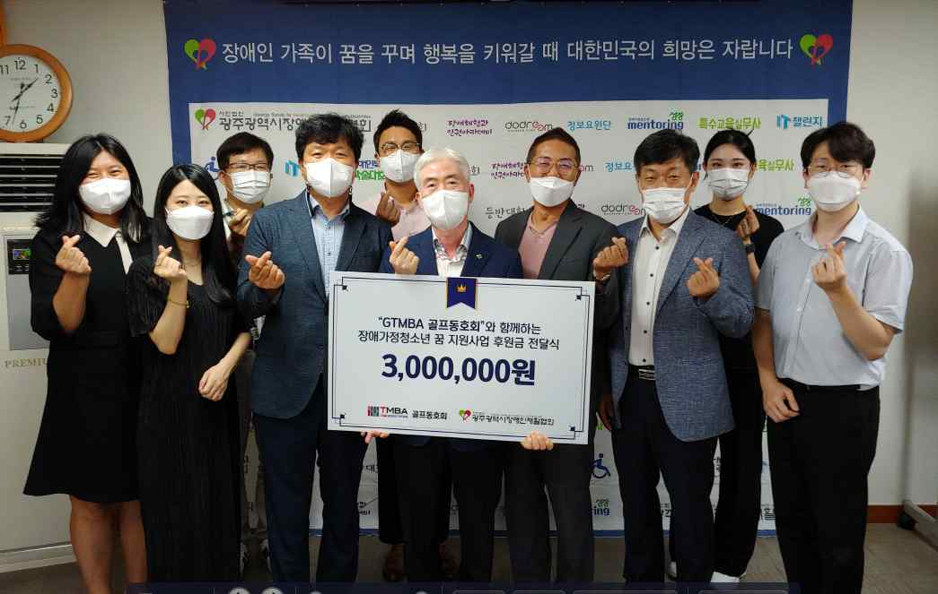
▲ Donation ceremony for the disabled youth dream
support project with 'GTMBA Golf Club'

GIST (Gwangju Institute of Science and Technology) Techno Management Business Academy (GTMBA) Golf Club donated a 3 million won in scholarships to the Gwangju Metropolitan City Rehabilitation Association for the Disabled on August 13, 2021, for youth with disabilities from low-income families.

GTMBA Golf Club was founded in 2020, and Jungam Trading Co., Ltd. CEO Kyung-ho Chung serves as the first president. President Chung has made efforts to exchange and revitalize the alumni through the club, and he decided to sponsor the Rehabilitation Association for the Disabled while contemplating the development of the local community with his alumni and helping local people in need.

President Kyung-ho Chung said, "To help vulnerable people and families with disabilities due to the prolonged coronavirus pandemic, we have gathered the hearts of GTMBA Golf Club members and made the donation. We will continue to pay attention to the neighbors around us and make efforts to continue to practice community sharing."

Gwangju Metropolitan City Rehabilitation Association President Jong-man Na said, "This donation will provide warm comfort and hope to youths from families with disabilities who are experiencing greater difficulties due to COVID-19. I would like to express my gratitude to the GIST GTMBA Golf Club for supporting the dreams of students with disabilities despite the difficult economic situation."

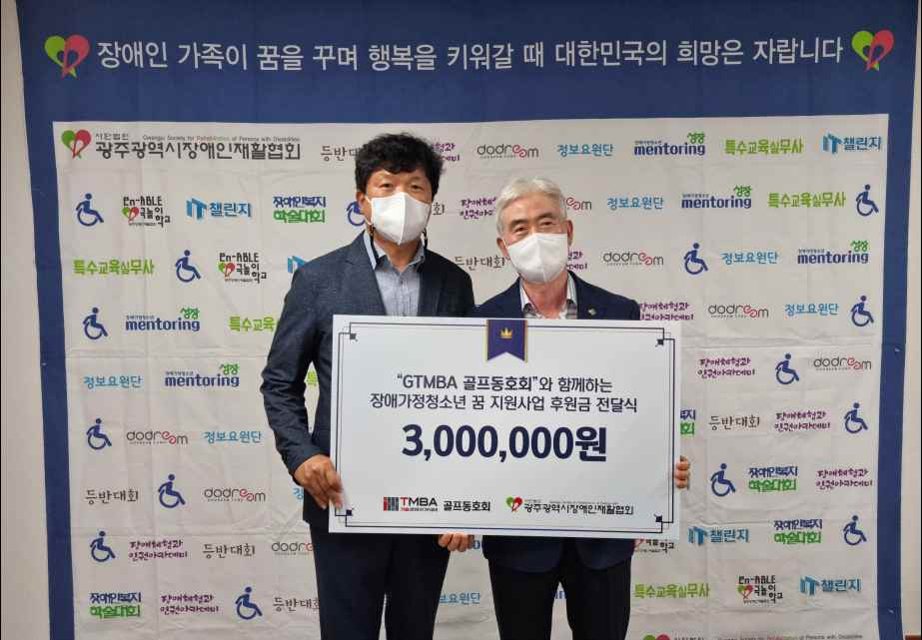
▲ From the left: GTMBA Golf Club President Kyung-ho ChungChung Kyung-ho and Gwangju Metropolitan City Rehabilitation Association President Jong-man Na

The GTMBA Golf Club has sponsored a social contribution project to support low-income students at local children's centers by donating 5 million won to GIST in November of last year as well as sponsoring this scholarship for youths with disabilities.

Meanwhile, GTMBA contributes to revitalizing local economy and industry-academic cooperation by fostering the corporate environment, global management strategy, and cultural awareness through lectures by top experts in Korea and by creating a large human network.

The 11th session, which started in March, will be held every Tuesday at 7:00 pm at GIST's Oryong Hall until December.



