
Gwangju Institute of Science and Technology
Official Press Release — https://www.gist.ac.kr

Section of Dongsun Cho Nayeong Lee
Public Relations Section Chief Senior Administrator
062-715-2061 062-715-2062

Contact Person Bo-young Son, Administrator
for this Article GIST Business Incubator
062-715-6305

Release Date 2021.07.27

GIST conducts '2021 Preliminary Start-up Package (Artificial Intelligence)' competency-building training

□ GIST (Gwangju Institute of Science and Technology) conducted '2021 Preliminary Start-up Package (Artificial Intelligence)' competency-building training for prospective entrepreneurs over two days on July 21st and 22nd.

∘ This program was held as a non-face-to-face online education using Zoom to prevent the spread of COVID-19 for a total of 37 prospective entrepreneurs.



∘ The 'Preliminary Start-up Package' support project of the Ministry of SMEs and Startups is a project that supports commercialization with funds, start-up education, and mentoring to nurture prospective entrepreneurs with innovative technology start-up ideas. Last May, 37 prospective entrepreneurs were finally selected by evaluating the value and commercialization potential of their business plans.

□ The GIST Business Incubator utilizes its infrastructure to help entrepreneurs learn about ▲ intellectual property rights and patent rights and registration procedures ▲Understanding marketing & branding ▲ artificial intelligence beginner/intermediate/intermediate advanced courses ▲ startup management (accounting, taxation, law) ▲ BM establishment advancement and IR pitching strategy ▲ investment attraction cases, and basic education related to start-up was provided in lecture type, practical type, mentoring type, group coaching type, and networking type.

□ GIST Business Incubator Director Byoung-kwon Cho said, "This training is meaningful in that it conducted customized training for each type to strengthen the startup competency of prospective entrepreneurs. Even though it is a difficult time for everyone, we will make every effort to establish an excellent start-up support infrastructure for successful start-ups of prospective start-ups who want to create start-ups."

□ Since 2019, GIST has been selected as the organizer of the preliminary start-up package and produced 74 preliminary start-ups. With sales of 780 million won and investment attraction of 770 million won, it is contributing to the spread of a healthy start-up culture and growth of the local economy and jobs.

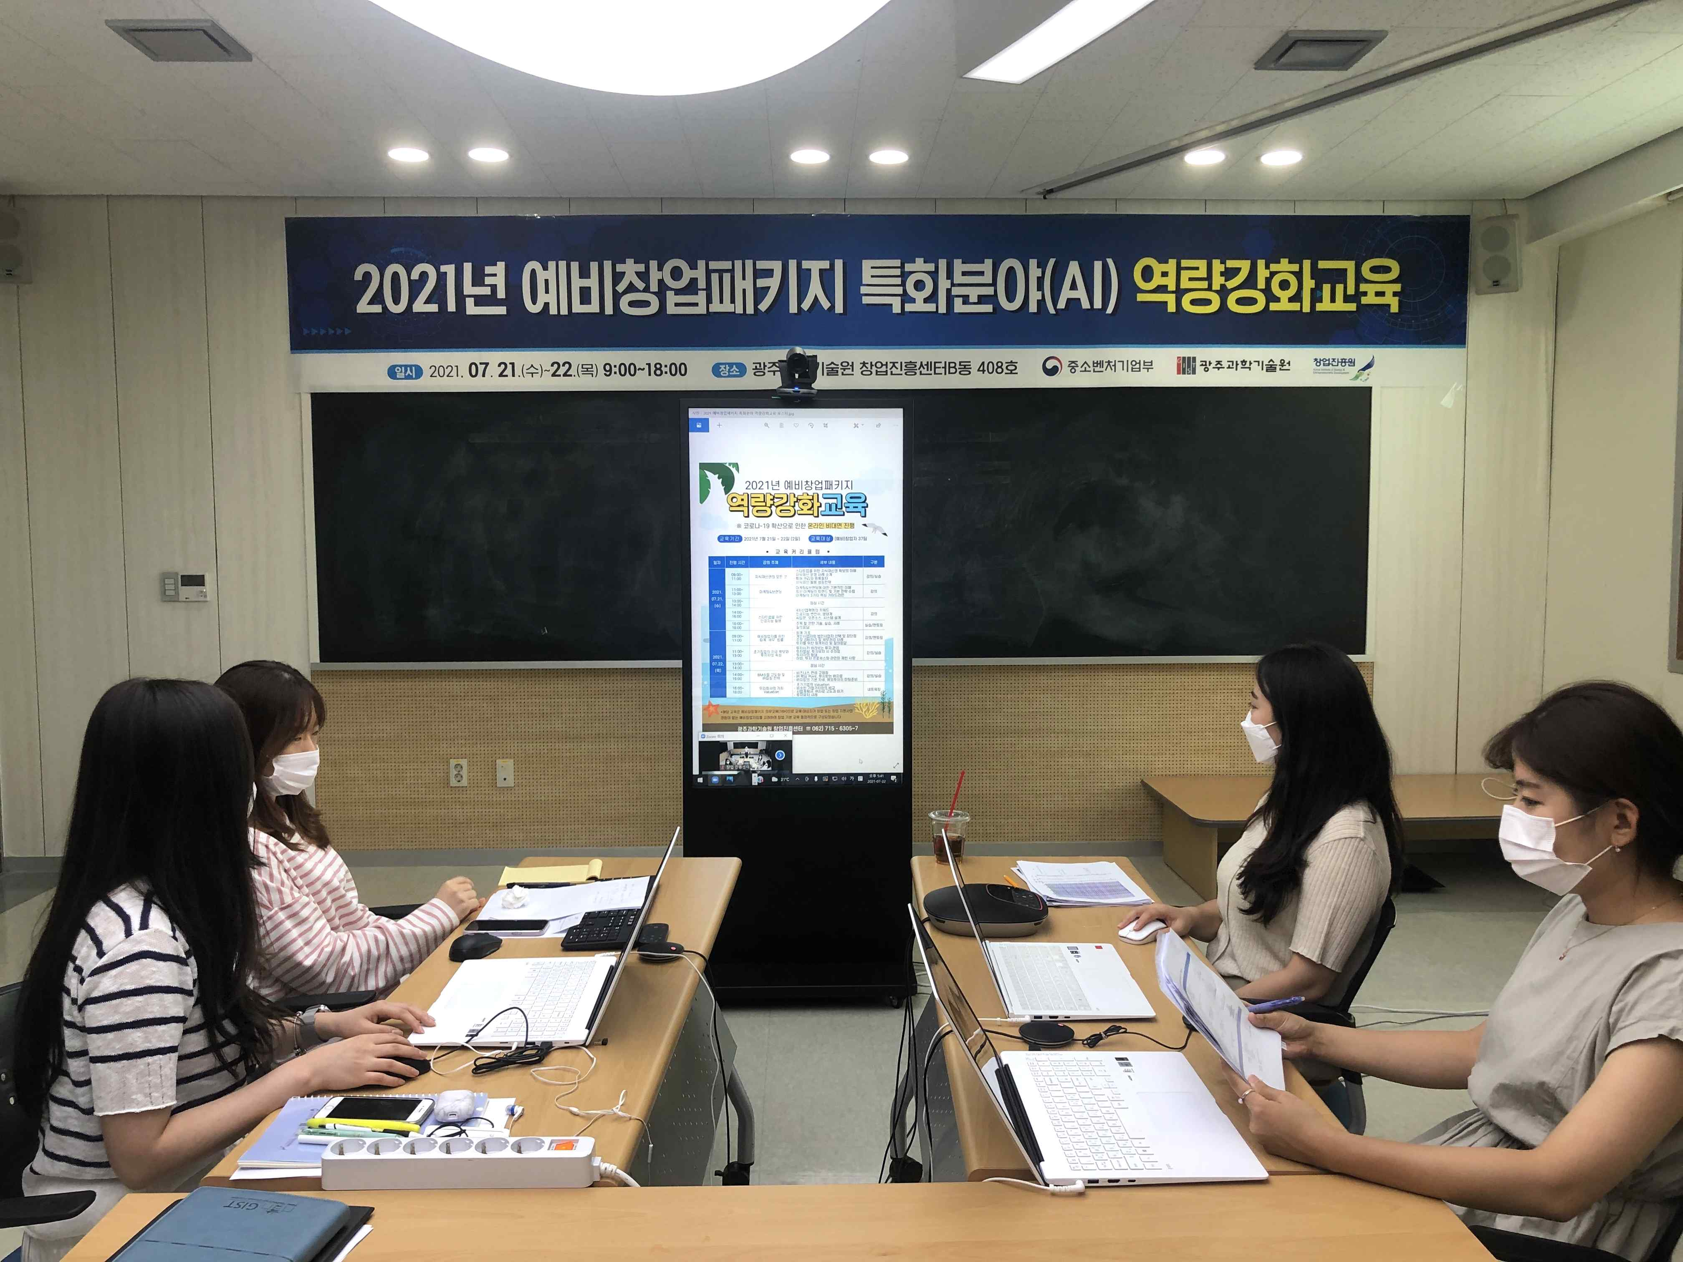
▲ Preliminary Start-up Package Specialized Field (AI) Competency Reinforcement Training in 2021



