
Gwangju Institute of Science and Technology
Official Press Release — https://www.gist.ac.kr

Section of Dongsun Cho Nayeong Lee
Public Relations Section Chief Senior Administrator
062-715-2061 062-715-2062

Contact Person Hyejin Lee, Administrator
for this Article Section of Public Affairs
062-715-2026

Release Date 2021.07.19

GIST Social Contribution Group hosts
2021 Visiting Science Camp in Shinan

□ GIST (Gwangju Institute of Science and Technology) held a "Visiting Science Camp" at Sinui Middle School on July 15 and 16 in Shinan to work with local communities and practice the spirit of spreading science and culture to underprivileged youth.



∘ The 'Visiting Science Camp' is a social contribution program of GIST to contribute to fostering future specialists that will lead the era of the 4th Industrial Revolution by providing interesting science programs and career mentoring to students by visiting the school directly during the summer vacation period.

□ In particular, because GIST was selected as the "2021 College Career Camp Management College" by the Ministry of Education and the Korea Foundation, this science camp was designed to provide opportunities to improve science and technology learning skills and creative thinking through a science experience program that is difficult for young people on the island to access.

□ The science camp program in Shinan with the GIST PIUM Volunteer Group was held with 30 Sinui Middle School students in attendance and includes and was composed of interesting science and engineering classes that can be experienced in person, such as ▲ group challenges ▲ a small world seen through a microscope ▲ cooking, cars, etc.

∘ For a richer visiting science camp experience, School of Electrical Engineering and Computer Science Professor Hong Kook Kim gave a special lecture on the artificial intelligence and the world of computers (Lecture 1: Wonderful World of Computers, Lecture 2: What is Artificial Intelligence?) through real-time online Zoom classes.

∘ A student who participated in this science camp said, "I have always been interested in science, and it was nice to be able to directly experience the GIST professor's lectures and have interesting science experiments. Thank you so much for coming to our school and providing a science camp, and I have dreams of studying at GIST in the future."

□ Vice President for Academic Affairs Young-jip Kim said, "We hope that the GIST Social Contribution Group's visiting science camp will inspire students from underprivileged areas to be curious about science and use the opportunity to grow into future scientists. GIST will continue to spread science culture through beneficial science camps and fulfill its social responsibility as a science and technology specialized university."

□ Since 2010, GIST has been conducting various science camps and learning education services for elementary, middle, and high school students. From this year, GIST's social contribution and career mentoring programs have been integrated and expanded to seek systematic and more efficient operation methods.

∘ The GIST knowledge sharing program includes ▲ LAN mentoring: online learning and career mentoring using Zoom so that participants can participate anytime and anywhere ▲ Visiting Camp: Mentoring conducted by visiting middle and high schools in person ▲ GIST Science Camp: Inviting students to GIST, which is held in three different formats (GIST faculty lecture program, GIST research institute and experience program, etc.), including a science camp.

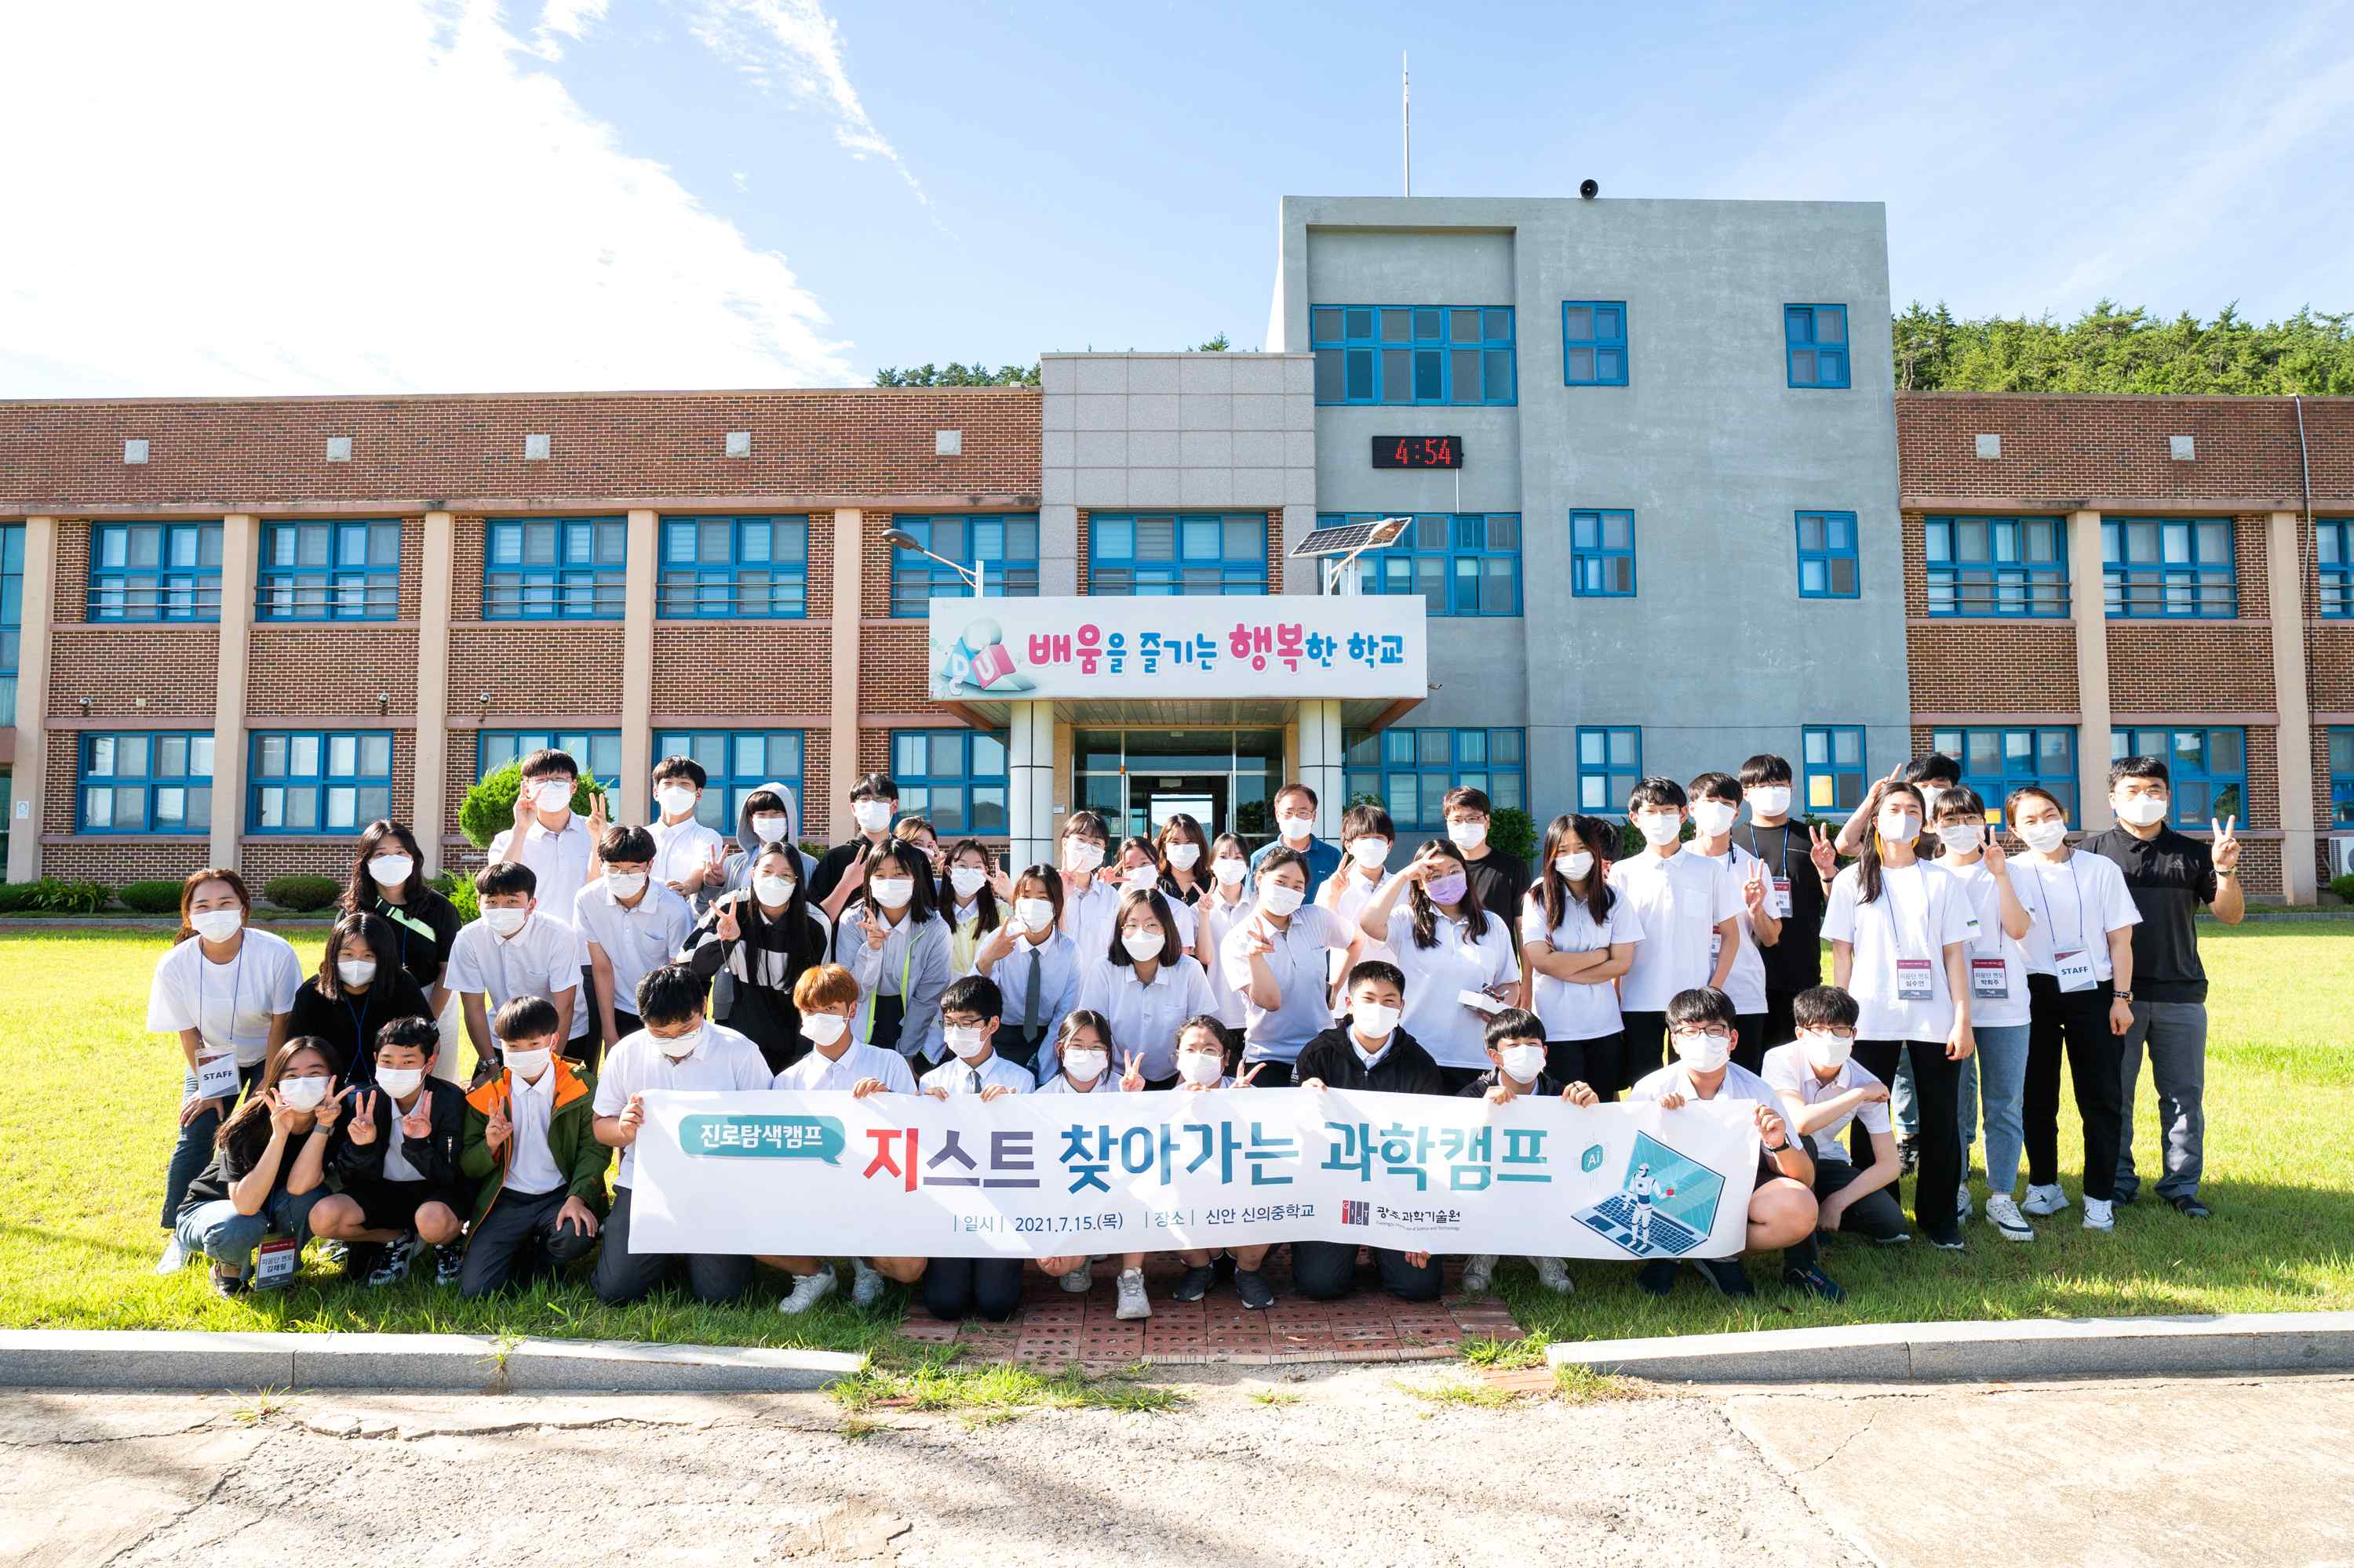
▲ [Photo 1] Group photo of the science camp visited by GIST PIUM

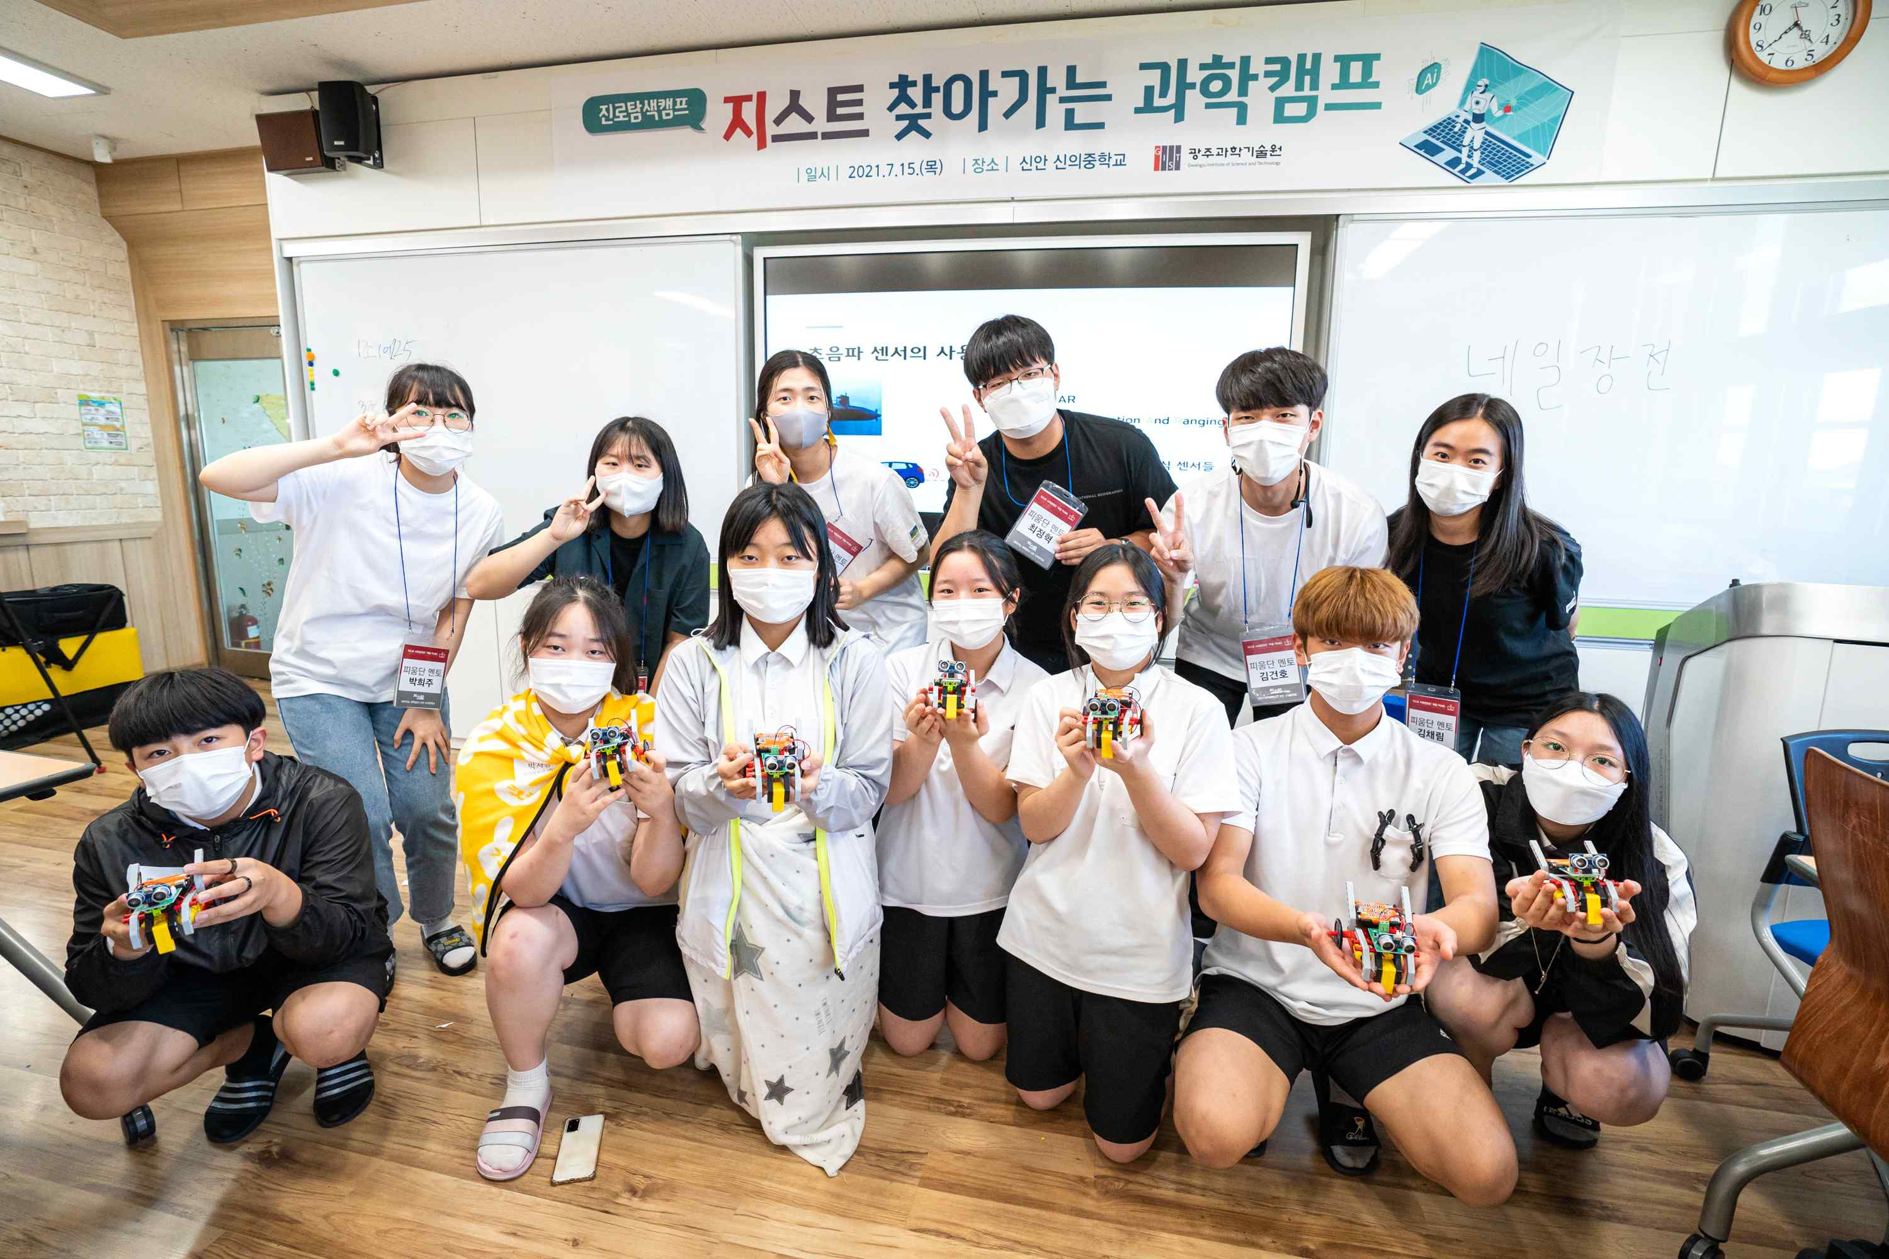
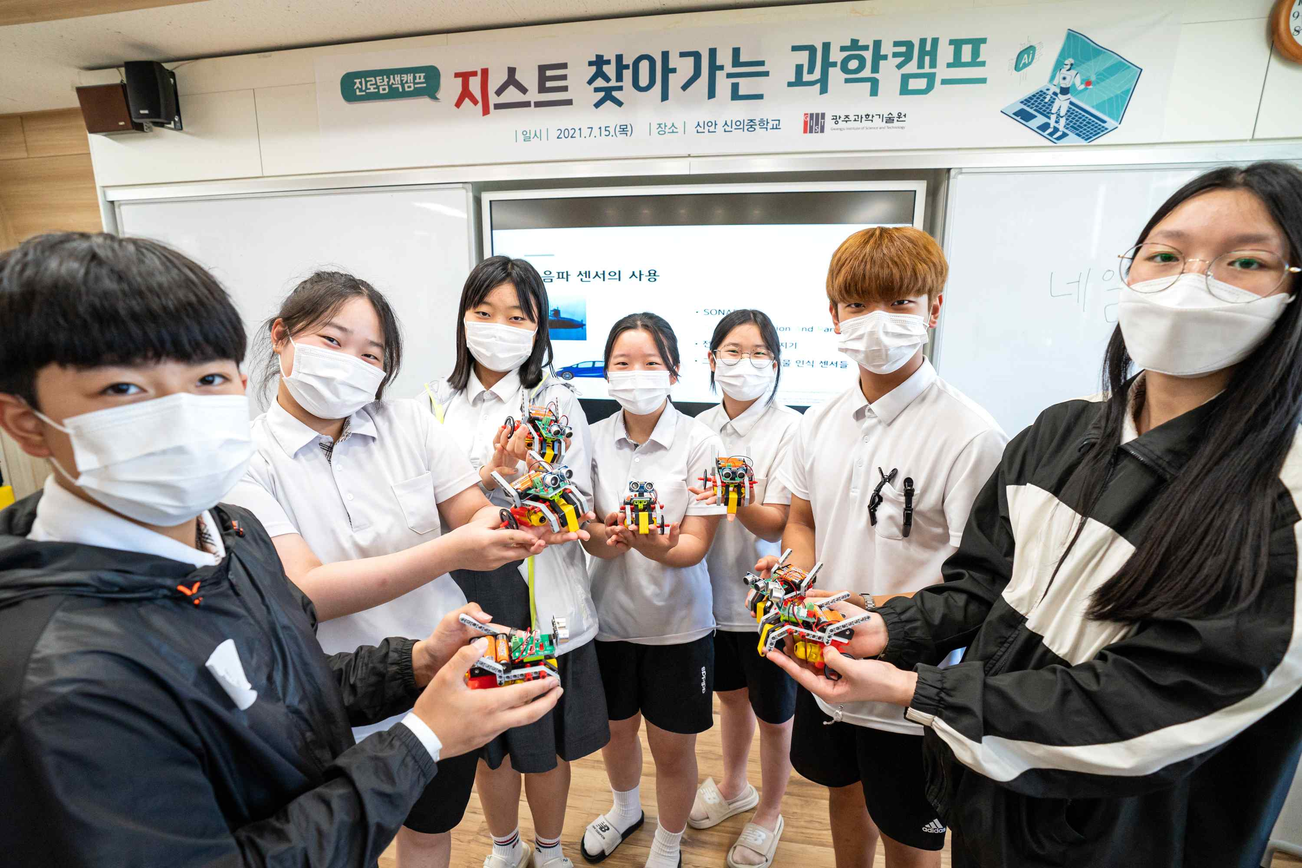
▲ [Photo 2] GIST PIUM's Science Camp Experience Program



