
Gwangju Institute of Science and Technology
Official Press Release — https://www.gist.ac.kr

Section of Dongsun Cho Nayeong Lee
Public Relations Section Chief Senior Administrator
062-715-2061 062-715-2062

Contact Person Bu-kyung Kim, Administrator
for this Article Advanced Photonics Research Institute
062-715-3416

Release Date 2021.07.14

GIST Advanced Photonics Research Institute completes
2021 International Laser Summer School

□ GIST (Gwangju Institute of Science and Technology) Advanced Photonics Research Institute (Director Yeung Lak Lee) recently held the successful 'Summer School On Lasers and Laser Applications (SSOLLA) 2021' for young overseas students and researchers in the field of laser and optical technology.



∘ 'Summer School On Lasers and Laser Applications (SSOLLA)' is an international event held by the Advanced Photonics Research Institute since 2010. It is an experiential program where participants attend lectures from the basics of laser to application and perform related optical experiments during a 7-day camp. This year, to prevent the spread of COVID-19, the event was reduced to 3 days online.

□ This event was attended by 29 students and researchers from 9 countries, including Asia, and lecture programs in 6 areas of laser led by GIST professors, APRI researcher, and Ulsan University professors.

∘ Participants took basic optics courses and lectures on femtosecond (one trillionth of a second) laser spectroscopy, optical fiber design and application, biophotonics, nonlinear optics, optoelectronics, and the rediscovery of light.

∘ From the result of a survey after the program was over, most of the participants expressed their intention to participate more actively when switching to a face-to-face events in the future, saying that this event was very helpful in acquiring knowledge and information about laser-related fields.

□ Director Yeung Lak Lee said, "Since 2010, the GIST Advanced Photonics Research Institute has held the annual Summer School On Lasers and Laser Applications event and has been strengthening the status of domestic optical technology research through active international exchanges with overseas researchers in the field of laser optics. In the future, we plan to contribute to the development of optical science and technology in Korea through close cooperation with relevant organizations in the laser optics field, such as research institutes of participating organizations."

□ The GIST Advanced Photonics Research Institute, which is celebrating its 20th anniversary this year, is the only optical technology research institute in Korea and is the first in the world to produce a super-powerful laser of 20 femtoseconds (1 femtosecond: 1 trillionth of a second) and 4.2 petawatts (1 petawatt: 1000 terawatts). It has been developed and is leading the domestic optical industry research by transferring special optical fiber manufacturing technology to a large Korean conglomerates.

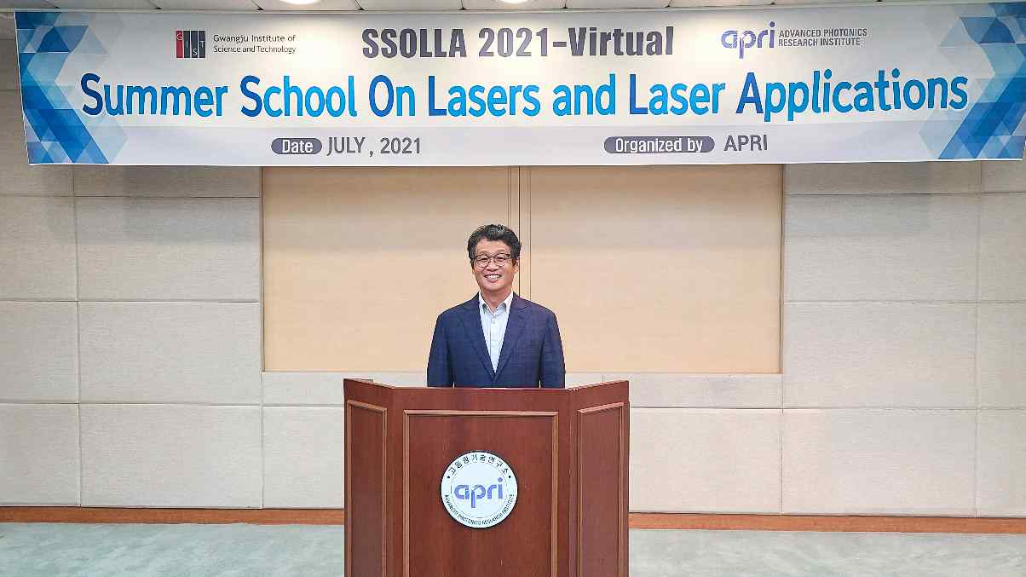
▲ [Photo 1] Director Yeung Lak Lee welcomes the SSOLLA 2021
event at the GIST Advanced Photonics Research Institute

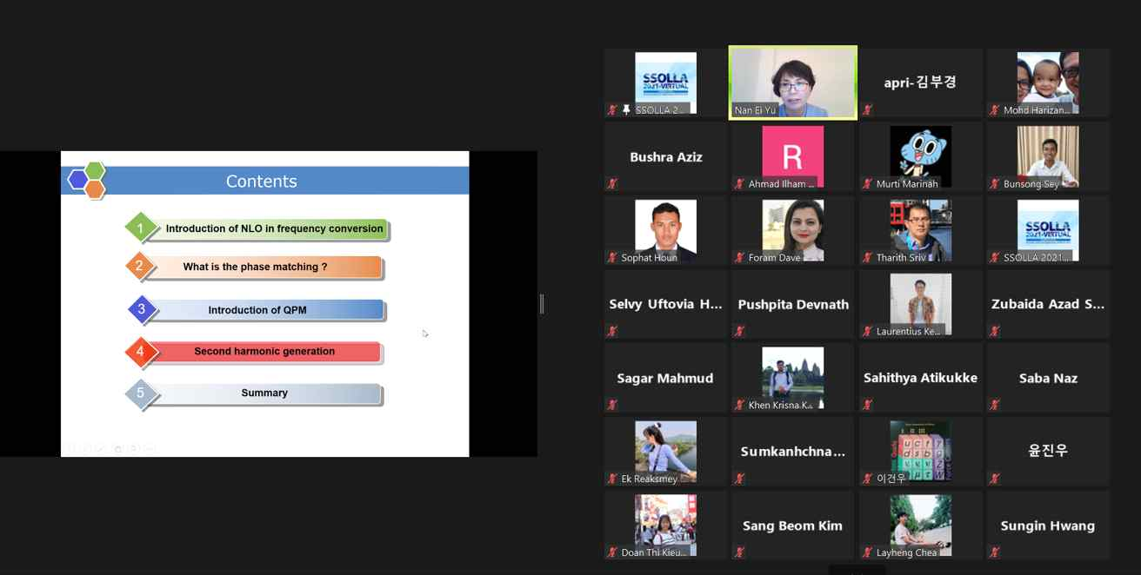
▲ [Photo2] Online Lecture for SSOLLA 2021 at the GIST Advanced Photonics Research Institute



