
Gwangju Institute of Science and Technology
Official Press Release — https://www.gist.ac.kr

Section of Dongsun Cho Nayeong Lee
Public Relations Section Chief Senior Administrator
062-715-2061 062-715-2062

Contact Person Tae-wan Kim, Administrator
for this Article GIST Business Incubator
062-715-6302

Release Date 2021.07.09

GIST holds signing ceremony for the
2021 mock startup program

□ GIST (Gwangju Institute of Science and Technology) held an agreement ceremony for the GIST Sprint for Startup (GSS) program on July 8 at Bldg. B of the Startup Promotion Center to inspire a healthy start-up culture on campus and verify various start-up ideas. To prevent the spread of COVID-19, one team at a time participated in ceremony and signed the agreement.



∘ This program is a flagship program for the GIST Startup Process, which has been implemented every year since 2014. If the GIST Startup Idea Contest is a gateway to discover students who are interested in starting a business, then the GSS program selects ideas to tryout from among the startup ideas proposed in the Startup Idea Contest and enhances their feasibility with support.

□ The GSS program verifies the possibility of a start-up idea, and without the condition or burden of having to start a business, students can directly make an initial product or service in the form of a prototype while conducting a market test and discontinue items with low probability of success. It is designed to move on to the next stage for items that show potential for success.

∘ The '2021 GIST Startup Idea Contest' was held as a pre-program for the GSS program, and the Campus CEO Challenge (CCC) is prepared as a post-linkage program for the GSS program.

□ This program is in the form of a 6-month challenge, and the project period is set from July to December. During this period, a mentoring program to supplement the ideas of prospective start-up teams and help commercialize them is conducted at the same time. If necessary, students can receive support such as design advice, technical advice, legal advice, and marketing advice.

∘ In December, when the program ends, an evaluation and seminar in the form of a report on the final results of participating teams will be held, and there will be a link to the follow-up program and investor meetings.

□ In particular, in this GSS program, additional mentoring is carried out through the program process, such as the participation of the first prize winning team and the incentive prize winning team in the GIST Startup Idea Contest, and many start-ups are expected to be discovered.

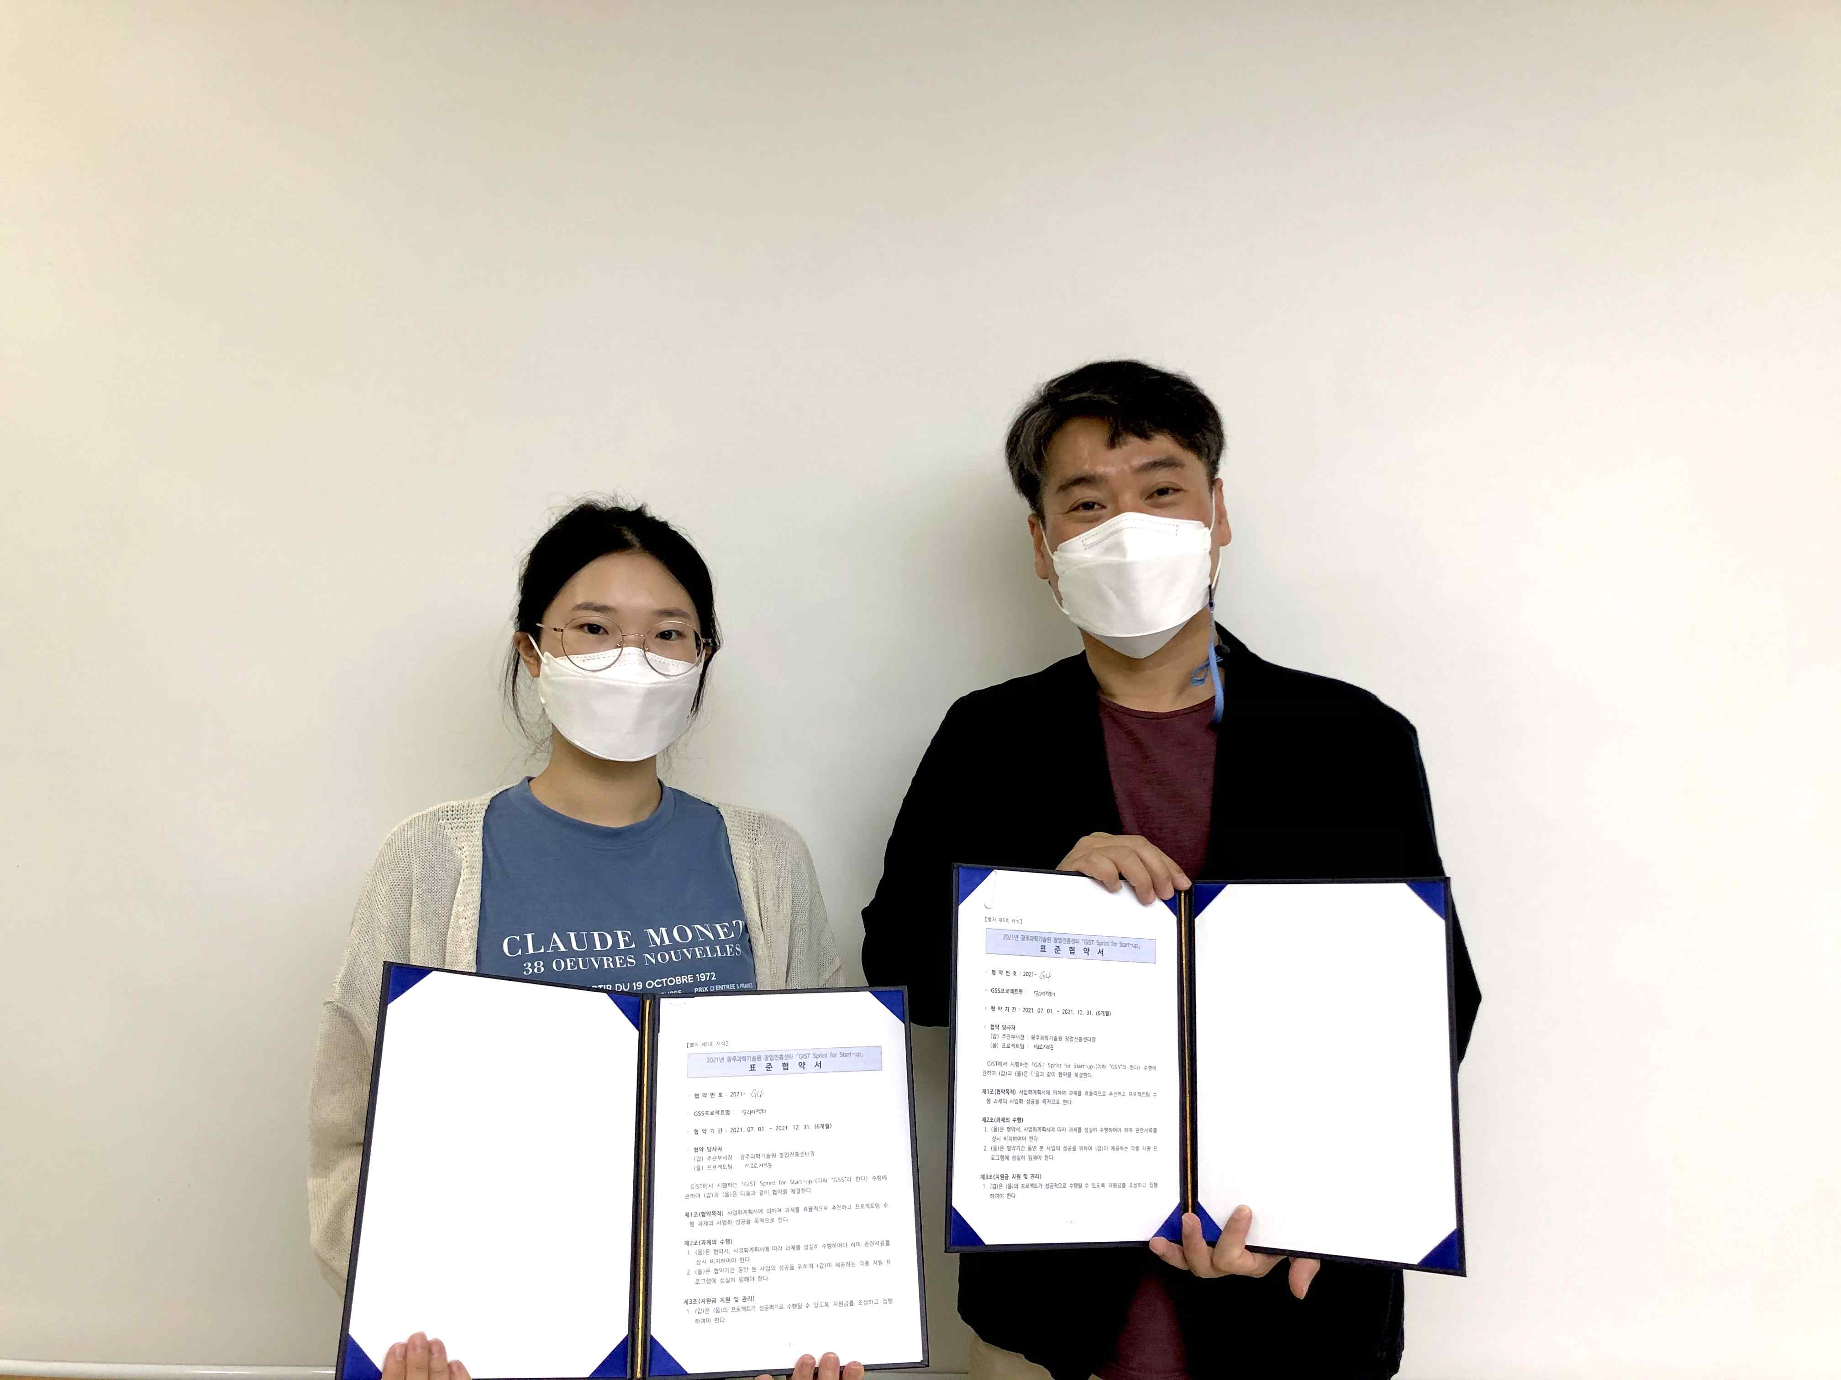
▲ GIST 2021 Mock Startup Program Agreement Ceremony
(Photo of agreement with Joo-young Hong, the winner of
the grand prize in the GIST Startup Idea Contest)



