
Gwangju Institute of Science and Technology
Official Press Release — https://www.gist.ac.kr

Section of Dongsun Cho Nayeong Lee
Public Relations Section Chief Senior Administrator
062-715-2061 062-715-2062

Contact Person Se-mi Park, Administrator
for this Article Section of Public Relations
062-715-2960

Release Date 2021.07.06

GIST publishes an easy-to-understand introduction
to computational electronics

□ GIST (Gwangju Institute of Science and Technology) PRESS has published 'Introduction to Computational Electronic Engineering,' in which School of Electrical Engineering and Computer Science Professor Sung-Min Hong participated as a co-author. This book is an introductory guide for those who are just starting out in computational electronics research or are interested in this field.



∘ The author easily explains the most important principles used in the field of computational electronics, helping researchers to form a basic cognitive framework that can be used in actual research. In addition, practice examples for writing numerical analysis programs are presented, and practice codes implemented with MATLAB are included in the appendix so that researchers can verify their results.

□ The lead author, Professor Sung-Min Hong of GIST, said, "I hope that this book will serve as a useful introduction to the attractive field of computational electronics and serve as a proper guide for researchers who are starting their research in related fields."

□ 'Introduction to Computational Electronic Engineering,' the 8th academic book published by GIST PRESS, can be purchased from online and offline bookstores nationwide from July 1.

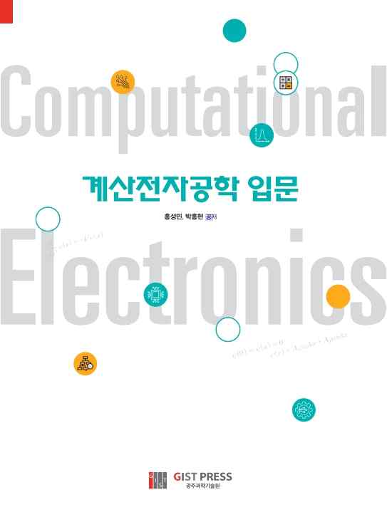
▲ 'Introduction to Computational Electronic Engineering' book cover



