
Gwangju Institute of Science and Technology
Official Press Release — https://www.gist.ac.kr

Section of Dongsun Cho Nayeong Lee
Public Relations Section Chief Senior Administrator
062-715-2061 062-715-2062

Contact Person Soo-min Park, Administrator
for this Article GIST Business Incubator
062-715-6304

Release Date 2021.07.05

GIST conducts '2021 Regional Start-up
Experience Center' training

□ GIST (Gwangju Institute of Science and Technology) will conduct '2021 Regional Start-up Experience Center' training for middle and high schools in Gwangju from June of this year, based on the successful operation of the 2020 local start-up experience center training.



∘ This time, 10 schools applied, including Chungjang Middle School, Unlim Middle School, Pyeongdong Middle School, Gakhwa Middle School, Goryeo High School, Gwangju Jinheung Middle School, Jeil High School, Gwangju Seogwang Middle School, Kyungshin Middle School, and Munseong Middle School. A total of 26 classes will be held from June to November.

□ The local entrepreneurship experience center operates a specialized entrepreneurship experience program by utilizing the infrastructure of the local community. This is a project that supports the operation of school start-up experience education and builds a network in the local area. It provides practical training and entrepreneurship education to middle and high school students in Gwangju that can be practically helpful in career setting and cultivating entrepreneurial and corporate skills.

∘ In particular, the results of the satisfaction survey of last year's participating students in operating entrepreneurship education tailored to the students' eye level and practical education using mandalat (lotus technique)*. It was confirmed that the students' interest in starting a business increased significantly after the training, as the students' direct participation in the practical training showed a high sense of achievement.

* 'Mandalat' is an idea technique developed by Japanese designer Hiroaki Imaiizumi in 1987. It is a thinking technique that helps to come up with various ideas in the shape of a lotus flower in full bloom.

□ In Chungjang Middle School where the entrepreneurship experience education was conducted for the first time this year, the atmosphere was created to naturally learn about entrepreneurship through light entrepreneurship quizzes and lectures prior to this class for first-year students. After that, each group decided on a company name and selected a representative to experience running the company directly. Furthermore, they had time to experience the process of distribution and promotion as well as how to sell more products to consumers through the process of directing ideas sold by the company into mandalat.

∘ A student who participated in the entrepreneurship experience education at Chungjang Middle School said, "Through the process of coming up with new ideas to improve inconvenient objects with friends and applying those ideas, starting a business that was once unfamiliar became interesting and gradually fun."

□ GIST Business Incubator Director Byoung-kwon CHo said, "We aim to spread the right entrepreneurial mindset to young people in Gwangju through various start-up education programs so that they can grow into innovative future specialists equipped with creativity and a challenging spirit. GIST plans to provide continuous start-up education so that students who are interested in starting a business can be practically helpful in setting their career path and cultivating entrepreneurial spirit."

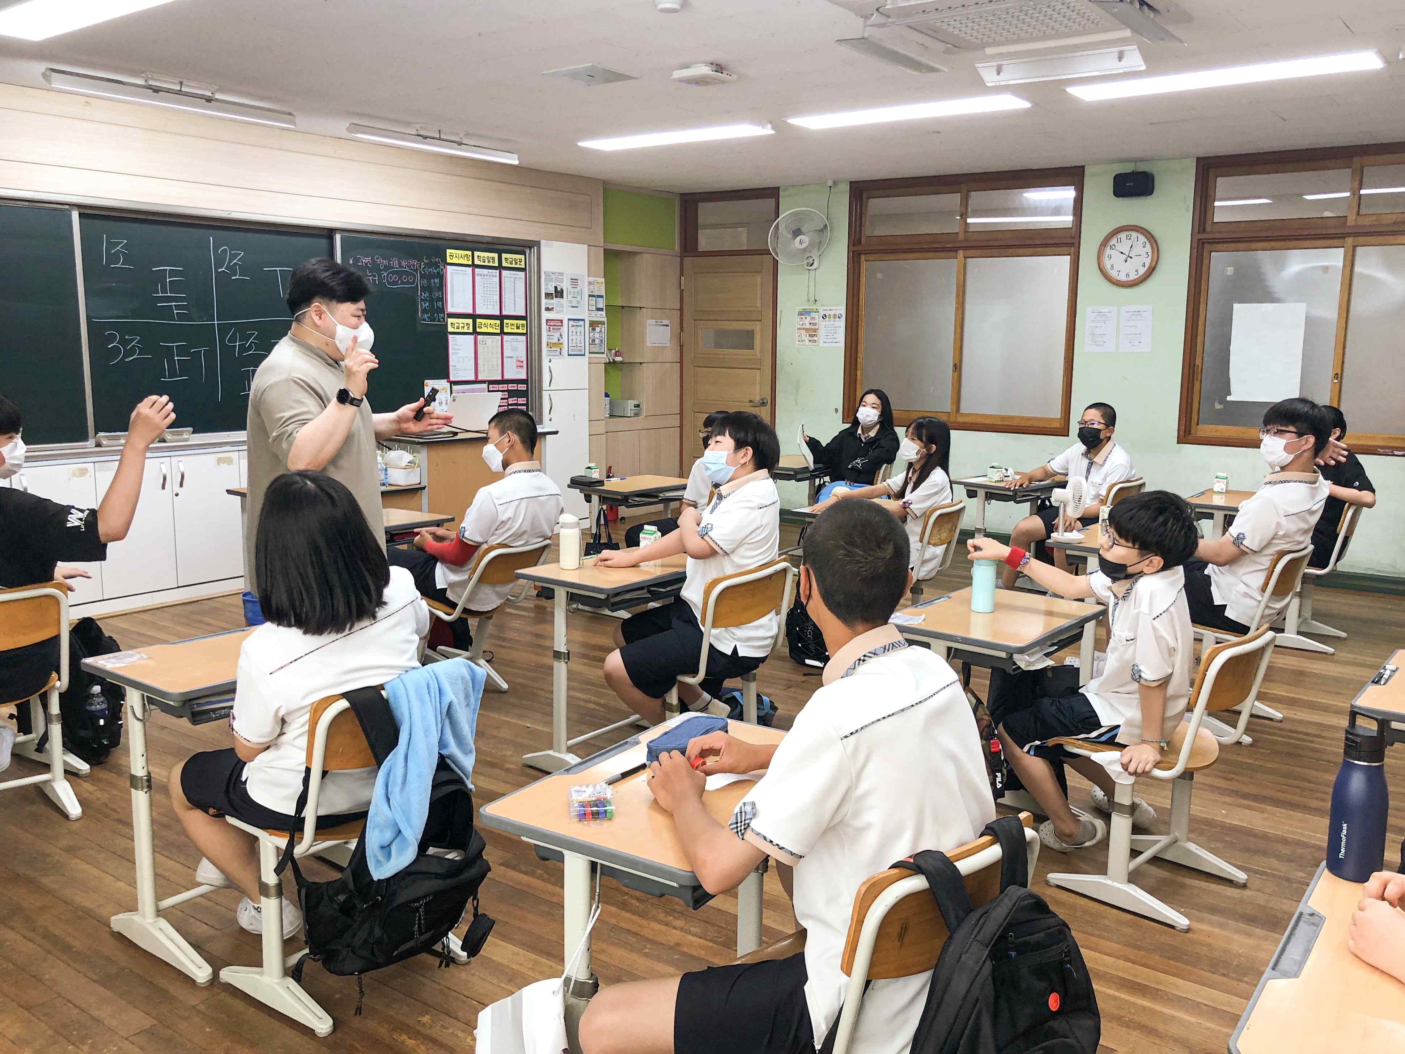
◀ GIST '2021 Regional Start-up Experience Center' training at Chungjang Middle School, Gwangju



