
Gwangju Institute of Science and Technology
Official Press Release — https://www.gist.ac.kr

Section of Dongsun Cho Nayeong Lee
Public Relations Section Chief Senior Administrator
062-715-2061 062-715-2062

Contact Person Se-mi Park, Administrator
for this Article Section of Public Relations
062-715-2062

Release Date 2021.07.01

GIST PRESS translation of 'The Benefits of Aging' was selected as a Sejong Book for the liberal arts category in 2021

□ GIST (Gwangju Institute of Science and Technology) Division of Liberal Arts and Sciences Professor Wonil Choi's translation of "The Benefits of Aging (published by GIST PRESS)," was selected as an excellent book by the Sejong Book liberal arts category this year.



∘ 'Sejong Book' is a project hosted by the Ministry of Culture, Sports and Tourism and supervised by the Korea Publication Culture Industry Promotion Agency. Each year, excellent books in academic and liberal arts are selected, and the books are distributed to public libraries nationwide. This year, 6,467 books were received in 10 fields including literature, social sciences, pure science, religion, and philosophy, and 330 of them were selected as excellent books.

□ 'The Benefits of Aging' is a translation of 'Better With Age,' a book written by UCLA Professor Alan D. Castel, a world-renowned cognitive psychologist and authority in the field of aging psychology, and describes successful aging. It presents an unparalleled insight into how our lives can improve as we age, and how we can enjoy the benefits of old age.

∘ The translator, Professor Wonil Choi, received his Ph.D. in cognitive psychology from the University of North Carolina at Chapel Hill, USA, and is currently teaching psychology as a professor at the GIST Division of Liberal Arts and Sciences. He is conducting research on what happens to the eyes and brain when humans think, understand language, and speak, and recently expanded his field of interest to the interaction between humans, machines, and society.

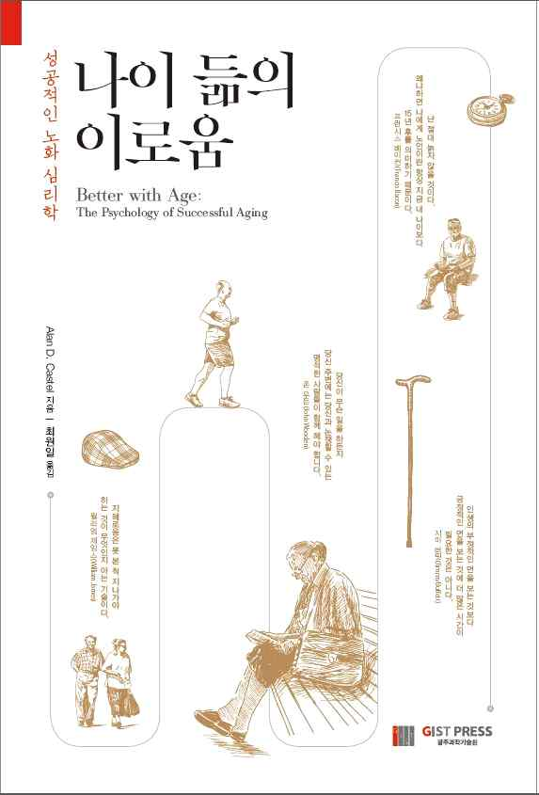
▲ 'The Benefits of Aging' book cover



