
Gwangju Institute of Science and Technology
Official Press Release — https://www.gist.ac.kr

Section of Dongsun Cho Nayeong Lee
Public Relations Section Chief Senior Administrator
062-715-2061 062-715-2062

Contact Person You Seung Su, Administrator
for this Article Section of Public Affairs
062-715-2025

Release Date 2021.06.29

GIST expands cooperation with Marine Energy Co., Ltd.,
for the development of new and renewable energy

□ GIST (Gwangju Institute of Science and Technology) held a business agreement ceremony (MoU) and a donation ceremony on June 28 with Marine Energy Co., Ltd., (CEO Hyung-soon Kim) to foster skilled workers in the renewable energy sector and establish organic cooperation in related industries.

∘ The signing ceremony was held at GIST with Acting GIST President Jong-In Song of GIST, CEO Hyung-soon Kim of Marine Energy Co. in attendance along with other key officials.



□ The main contents of the agreement include: ▲ cooperation in training talented workers in renewable energy such as fuel cells ▲ promotion of industry-academic cooperation such as joint research and technical advice in renewable energy field ▲ field practice support to strengthen the practical skills of GIST students ▲ priority employment support for outstanding students ▲ support for customized practical training such as special lectures by experts from Marine Energy Co., Ltd. ▲ other areas requiring mutual cooperation were included.

∘ Marine Energy Co., Ltd., has pledged 10 million won to the GIST Development Fund, with a cumulative donation of 130 million won.

□ Acting GIST President Jong-In Song said, In order to solve international problems such as global warming and fine dust, the establishment of new and renewable energy has become more important than ever, and a strategy for nurturing new industries in the future is essential. Through this agreement, we will actively cooperate so that GIST's excellent research capabilities and 30 years of field technology and know-how of Marine Energy Co., Ltd., can be harmonized."

□ Marine Energy Co., Ltd., CEO Hyung-soon Kim said, "With this agreement, we will revitalize industry-university cooperation, such as nurturing specialists and joint research in the field of new and renewable energy such as fuel cells. I hope that this will serve as an opportunity for companies and schools to develop co-prosperity by establishing a practical partnership."

∘ Meanwhile, GIST has recently signed business agreements with institutions in Gwangju and Jeollanam-do, such as Korea Energy Technology University and Damyang-gun Office, leading the way for regional development and co-prosperity.

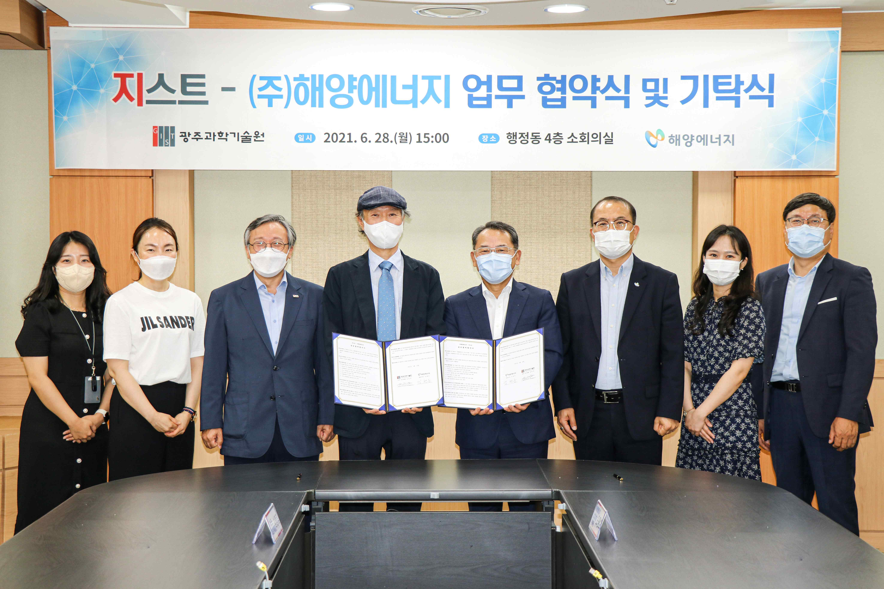
▲ GIST and Marine Energy Co., Ltd., signed a business agreement to revitalize local industries and held a donation ceremony
(From left) GIST Section of Public Relations Administrator Annsun Jung, Public Relation Section Chief Hyo-jung Kim, Vice President for Public Affairs Young-jip Kim, Acting President Jong-In Song, Marine Energy Co., Ltd., CEO Hyung-soon Kim, Management Marketing Director Kwang-ho Oh, Change Innovation Team Manager Min-young Ahn, Change Innovation Team Leader Myung-Geun Cho

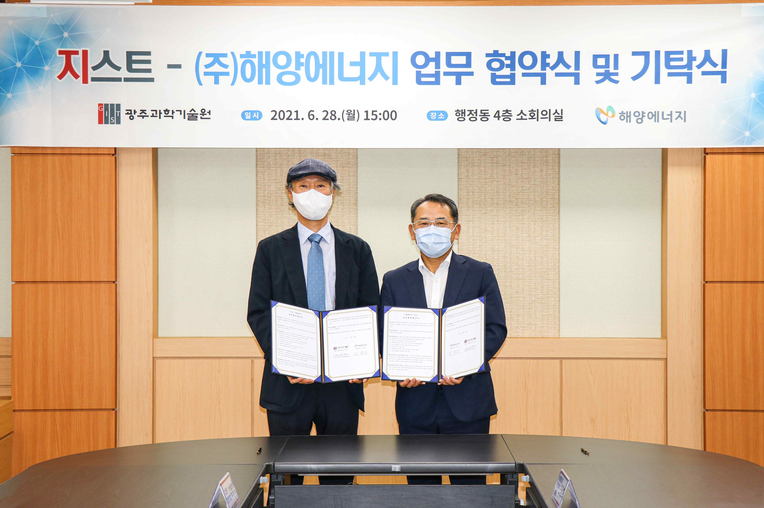
▲ GIST and Marine Energy Co., Ltd., signed a business agreement and held a donation ceremony to revitalize local industries (from left) Acting President Jong-In Song and Marine Energy Co., Ltd., CEO Hyung-soon Kim



